How Do People See Me and What Do They Think of Me?
Sometimes, when we are feeling down, or low, we tend to think badly of ourselves. It is important we remind ourselves of the good traits and characteristics we hold as individuals. We are all different and all have something positive to offer the world.
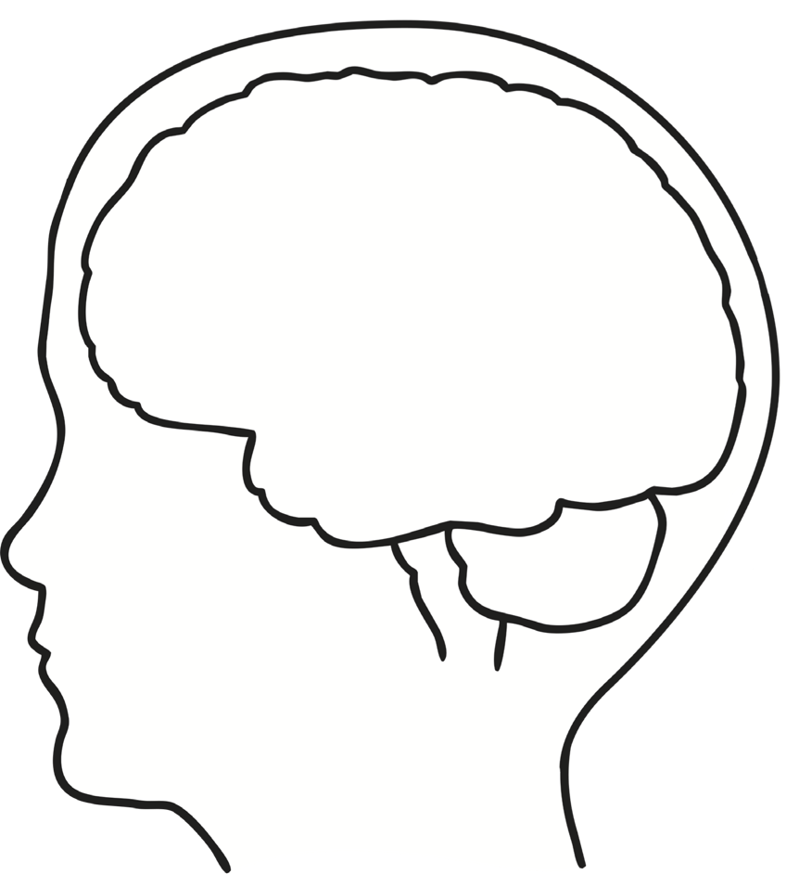
Please circle or tick the statements you think about yourself.
I am clever
I don’t listen
I have lots of friends
I follow the rules
I am good at sport
I copy what others do
I know what I want to do
I don’t care about my education

I am kind
I am helpful
I don’t say how I feel
I cause trouble
I am angry
I get others into trouble

I can be trusted
I am good fun to be with

Now, let’s think about what your friends might say about you. Consider the ways you might help them, or the traits you offer as a friend. You can use some ideas from the previous activity, but try to think of your own as well.

Tip: if you are finding this hard, phone or text a friend and ask them!

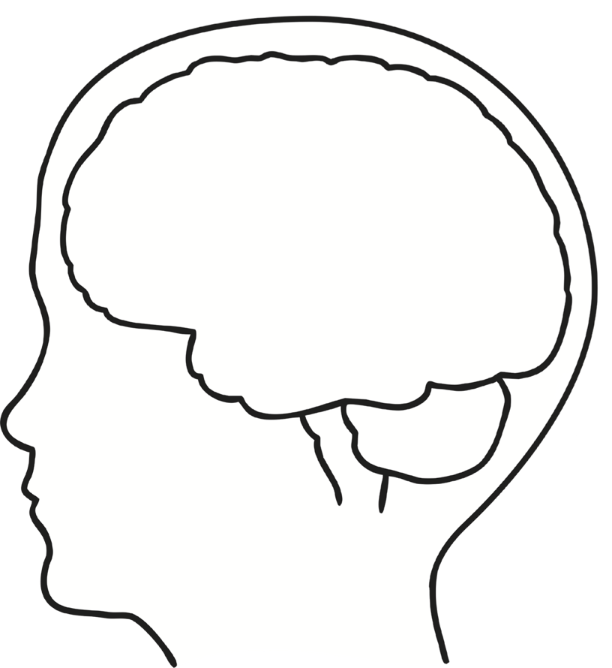

Finally, let’s think about what you think your teachers might say about you. Again, think positive – we (teachers) have a lot of good things to say about you!

