Time
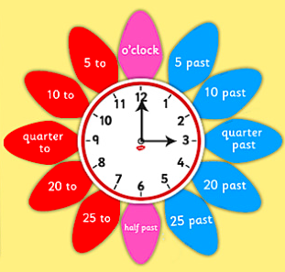

Remember that the longer hand is the minute hand (this shows you whether it is o’clock or minutes past or to) and the shorter hand is the hour hand.
You can practise telling the time on this clock:
https://www.topmarks.co.uk/time/teaching-clock
You can learn more about the 24 hour clock here:
https://www.bbc.co.uk/teach/class-clips-video/maths-ks2-using-timetables/zn2hy9q

Then try the activities below. The more chillies, the more difficult the task. Try as many activities as you like!

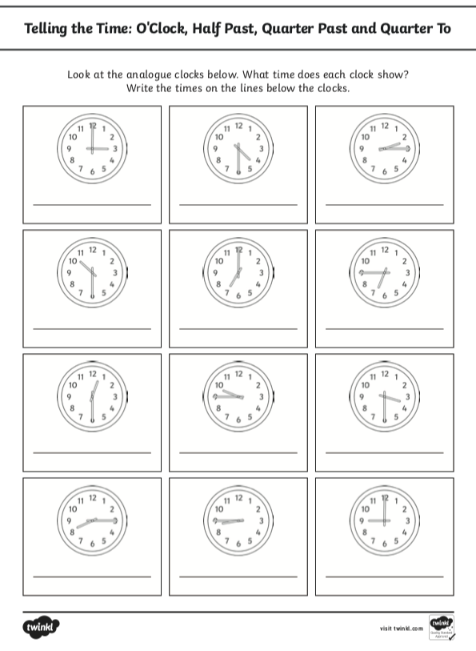

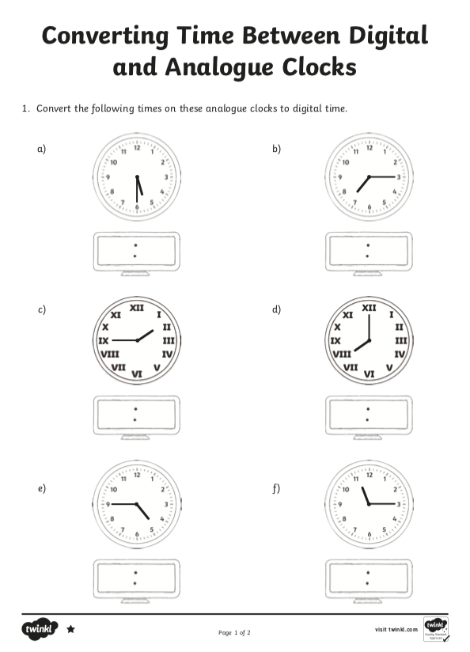
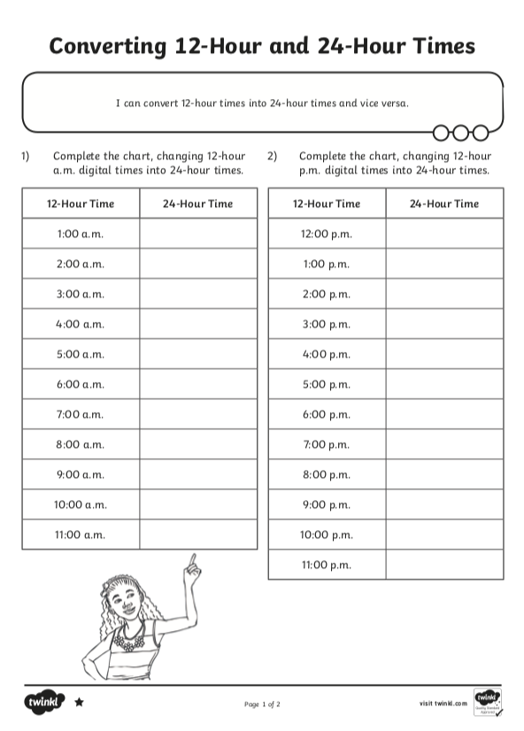
Remember, you can email pictures of your work to me using our class email address!

