How do humans breathe?

This week we will learn about how humans breathe and the important gases that are involved in this process.

Watch the video to find out about how humans breathe:

How do humans breathe?

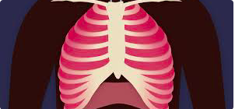

Can you answer the questions about how humans breathe? Write down your answers or tell someone else.

- All living things need oxygen to survive. True or false?

- What is the point of breathing?

- What gas does the human body get rid of into the air?

- When you breathe air into your nose and mouth, where in the body does it go next?

Remember, you can email your work to me using our class email address!

