

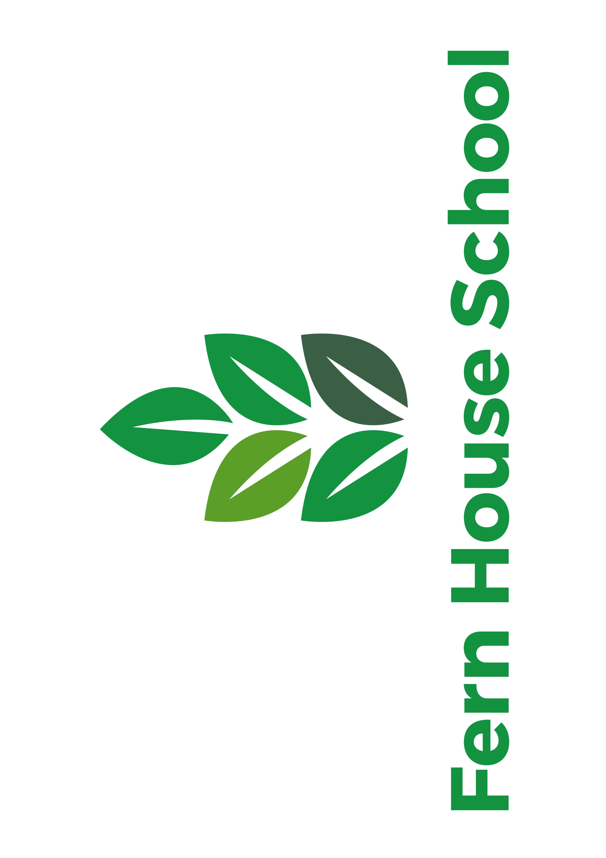

**Fern House School**

Chesterfield Road|Enfield|EN3 6BG

Tel 01992 760680

Fern House School Christmas Newsletter 2020



**Wishing you a happy festive period from all at FHS**

It’s not been a usual kind of year and there has been lots of challenges for us all to over come. We would like to thank all our pupils, families and staff for all the support over the last 12 months we know how tricky it has been for everyone. Please see our website for further guidance on Covid-19 if need be

We hope that you have a restful and enjoyable holiday period in whatever you choose to do. We all hope that 2021 will bring a return to normality and we can see our loved ones and be back in school / work full time.

We would like to remind you all that school returns on 05/01/2020.

We wish you a prosperous 2021!!

Despite the strange times we are living in, we have done our best to try and keep the festive spirit alive at Fern House School. We had our virtual pantomime and we had our Christmas jumper day on 17th December. Thanks for everyone for taking part and well done to pupils and staff for wearing some awesome Christmas Jumpers. The school raised some money from your kind donations which we have given to MacMillan Nurses, thanks so much to you all!

Stay Safe and see you all in 2021

It is with a heavy heart we say a fond goodbye to Danny. Danny has been with Fern House School and Cedar Class since September and is leaving to pursue his dream job as a deputy headteacher in an ASD provision. We wish him all the best in his new role

we wish you a safe festive period

and a very happy new year!