Ancient Egypt
Last week, your activity was to look at the two images below and ask and answer questions. This week, we will find out more about life in Ancient Egypt.

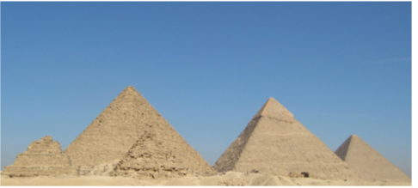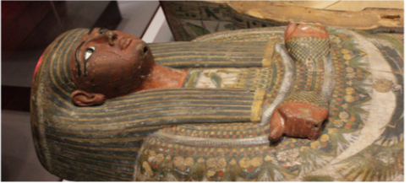

First, go to the PowerPoint Presentation to find out more.

This BBC Bitesize video will give you lots of information about life in Ancient Egypt: https://www.bbc.co.uk/bitesize/topics/zg87xnb/articles/zr4s8xs/

Now, complete the activity below to compare your modern life with the life of the Ancient Egyptians.

