Spruce Science Home Learning

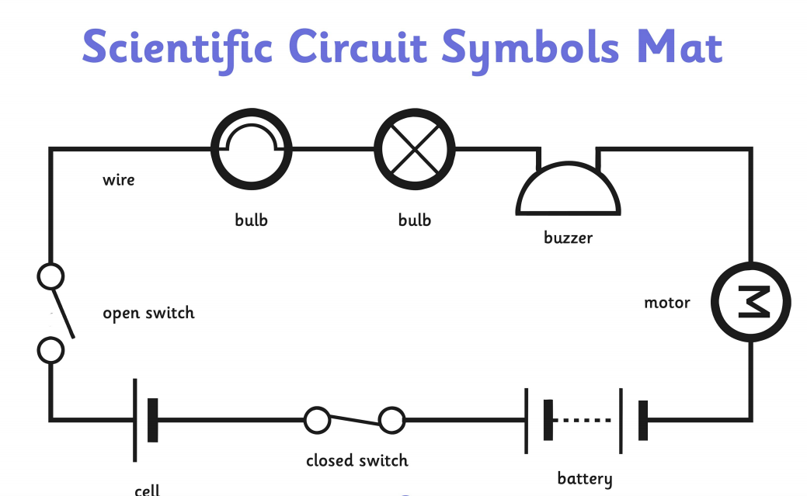
We have been learning about electricity in science. Below is a scientific symbol map for different components used in circuits. There are 3 different tasks. Choose one to complete (they get progressively harder). Use the mat to help you

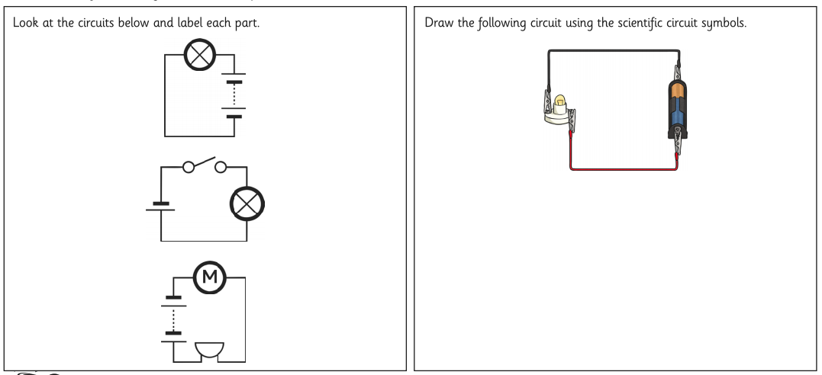
Task 1

Task 2

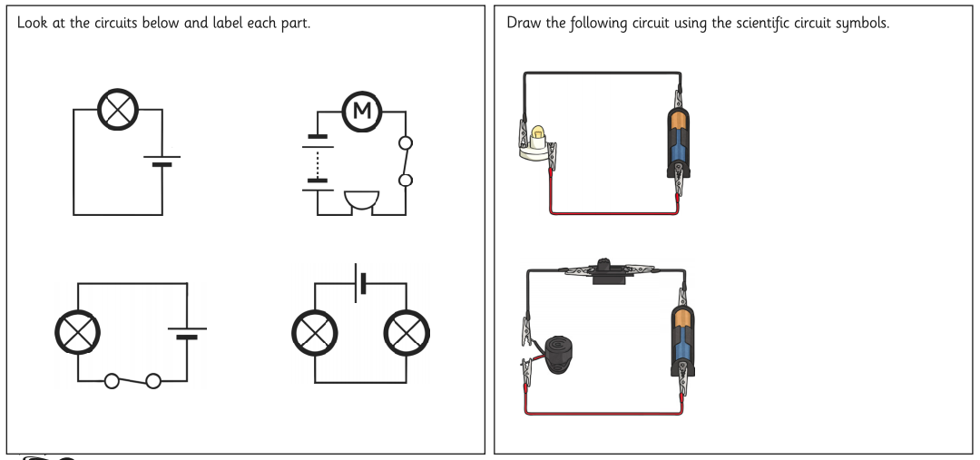

Task 3

