Ancient Egypt
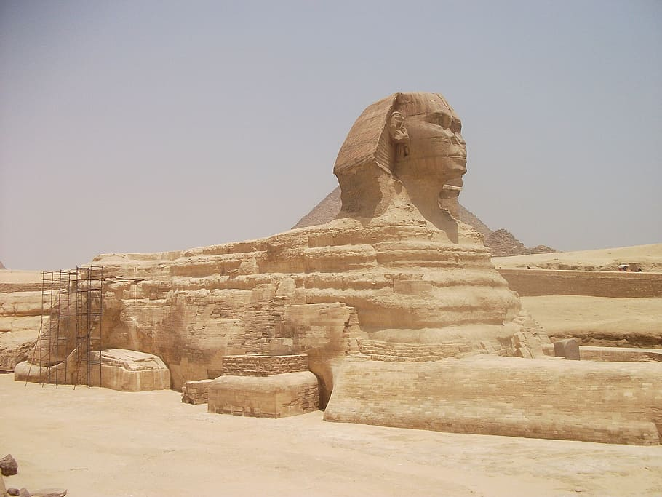

This half term, we will be studying the exciting topic - Ancient Egypt! The PowerPoint will give you a great introduction, so watch that first.

There is a link on the PowerPoint for more information - if it doesn’t work, you can click on the link here:

Introducing Ancient Egypt | History - Lost Lands

Now, complete the activity. You can choose one sheet or complete them both. Answer the questions about the Ancient Egyptian artefacts.

