My lockdown experience

What I liked:

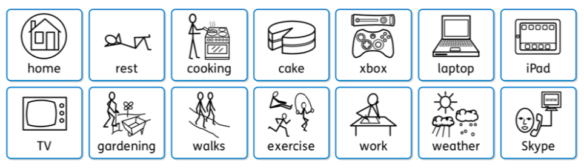
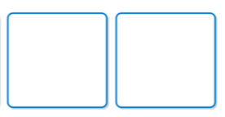

Please provide details if necessary:

Any significant events:

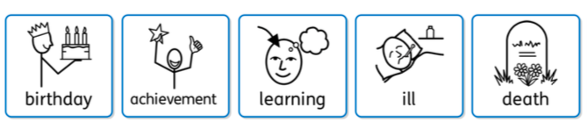

Please provide details if necessary:

What was difficult: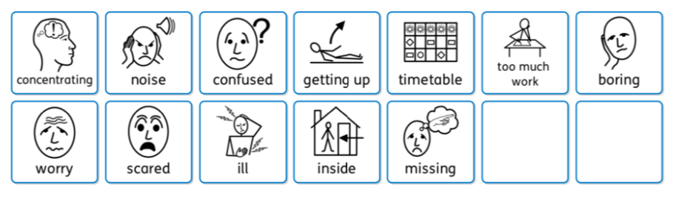

Please provide details if necessary:

How did I learn best:

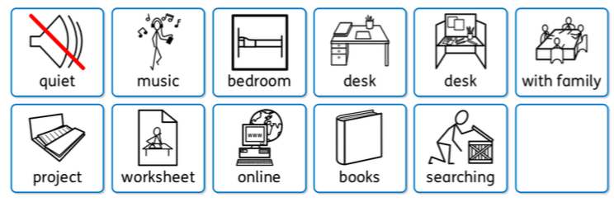

Please provide details if necessary:

What I am worried about, going back to school:

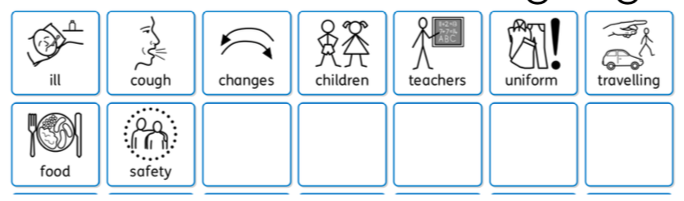

Please provide details if necessary:

