Home Learning – Maths – Statistics

Learning Objectives:
To be able to interpret and present data using bar charts, pictograms and tables.
To be able to solve one-step and two-step questions [for example, ‘How many more?’ and ‘How many fewer?’] using information presented in scaled bar charts and pictograms and tables.

Tally Charts

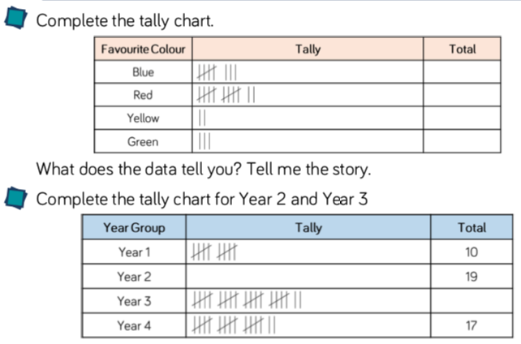

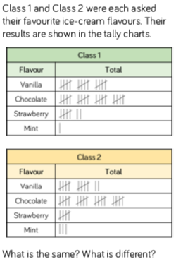

_______________________________________

_______________________________________

_______________________________________

_______________________________________

________________________________________

________________________________________

________________________________________

________________________________________

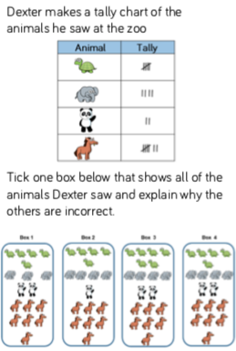
Pictograms

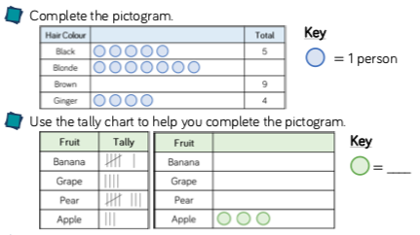
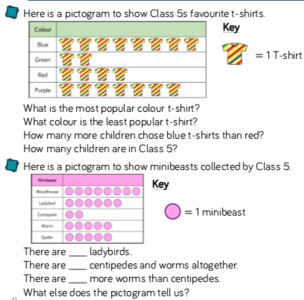

Block Diagrams
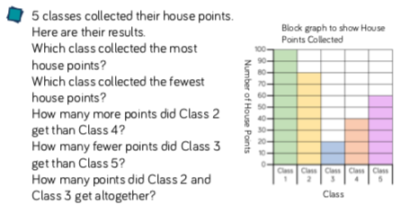

Bar Charts

