Apostrophes for possession

Click on the link to watch the video:
https://www.youtube.com/watch?v=zNFPnVz7JB4&t=30s

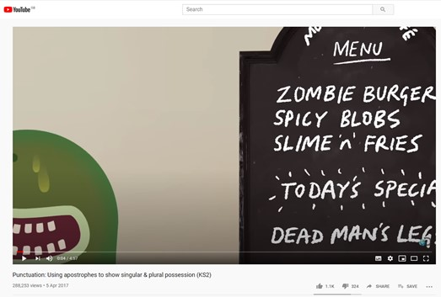

Once you’ve watched it, try and complete the activity booklet!

