Ancient Egyptians - Mummification

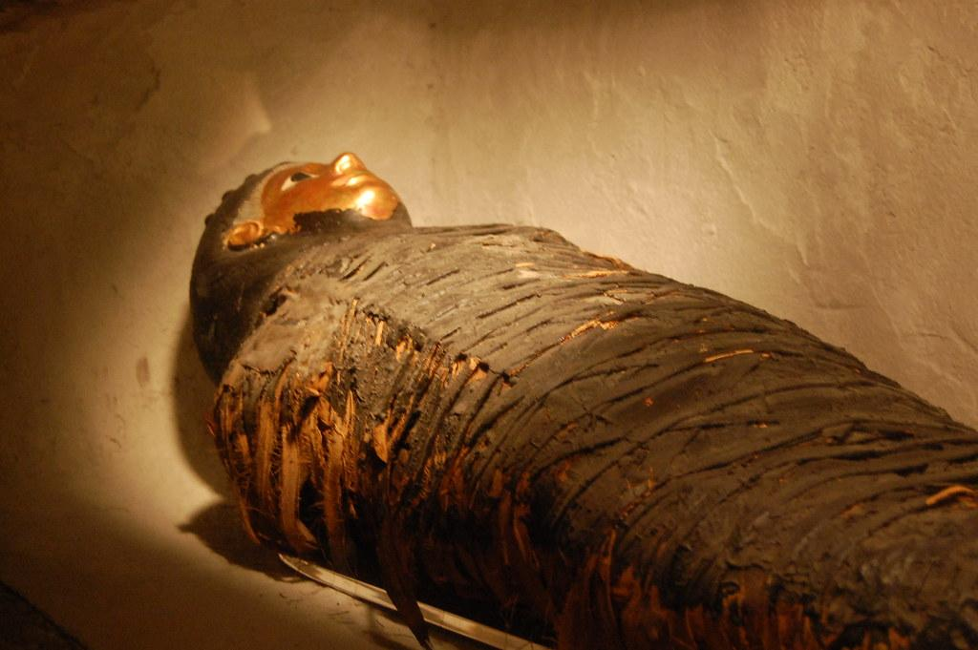

The Ancient Egyptians believed in life after death and they thought that a person who had died would need their body. For this reason, they wanted to preserve the body for the after-life. They would treat the bodies using a process called ‘mummification’.
The PowerPoint will give you more information about how they mummified bodies.

There is so much information online about this interesting topic. If you want to know more, check out these links:

More information on mummies:
http://www.primaryhomeworkhelp.co.uk/egypt/mummies.htm

https://www.bbc.co.uk/teach/class-clips-video/history-social-studies-ks2-mummification-in-ancient-egypt/zdcrkmn

https://www.bbc.co.uk/bitesize/articles/zrcg2sg

To see real life mummies in the British Museum:
https://artsandculture.google.com/streetview/british-museum/AwEp68JO4NECkQ?sv_h=182.66601491124203&sv_p=-8.256494247725925&sv_pid=WjB5K-nsMXK_q9EffBwDoQ&sv_lid=3582009757710443819&sv_lng=-0.1274337889263393&sv_lat=51.51988925226868&sv_z=1.0000000000000002

Activity

Sort the instructions into the correct order to explain how the Ancient Egyptians mummified bodies.

