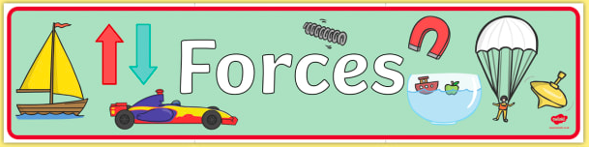

Pushes, pulls and twists.
Watch the video on BBC Bitesize to learn about pushes, pulls and twists:

https://www.bbc.co.uk/bitesize/clips/z9nkqty
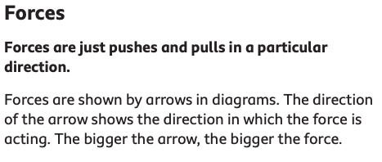

Now look around your home. Find things that move with a push. What do you have to pull? Can you find something that twists?

You could make a list, table or even a poster.

Examples:
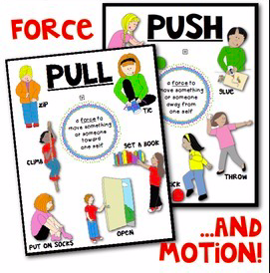

Push | Pull | Twist
skateboard | drawer | bottle lid

Now, use what you know to answer the questions below.

