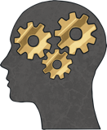
The word cognitive means the process of thinking and other mental processes – or, simply, things we do with our minds. Our cognitive functioning includes memory, judgement, reasoning and emotional responses.

Our thoughts, feelings and behaviours are all closely linked and each one affects the other two. It can be shown in a diagram using a triangle.
Thoughts

Feelings
Behaviours

Let’s look at this example of a Cognitive Triangle below.
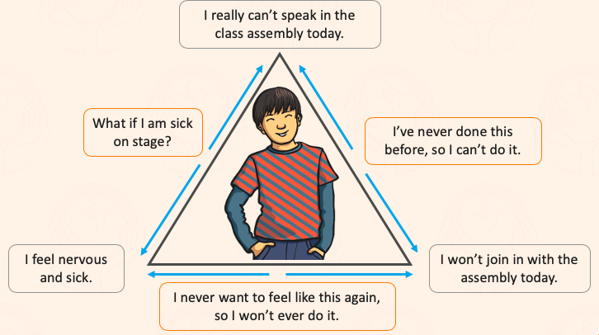
A cognitive triangle can be positive or negative. If it is negative (like the example above), it can be hard to break the cycle. Recognising that we are having negative thoughts and how they are impacting on our feelings and behaviour is the first step to changing it into a positive triangle.

You are all now going to have a go at fitting a scenario of your own into the cognitive triangle– thinking about how our thoughts, feelings and behaviours can all be linked and can affect each other.
