Spruce Maths – Perimeter

Watch the videos below

https://www.bbc.co.uk/bitesize/topics/zvmxsbk/articles/zsr4k7h

https://www.youtube.com/watch?v=6mopAgqjkVM

There are 3 different activities below. Complete 1 activity. Each activity has multiple pages.

Activity 1 – I’m not too sure about find the perimeter
Activity 2 – I’m okay with finding the perimeter
Activity 3 – I’m good at finding the perimeter, I want a challenge!

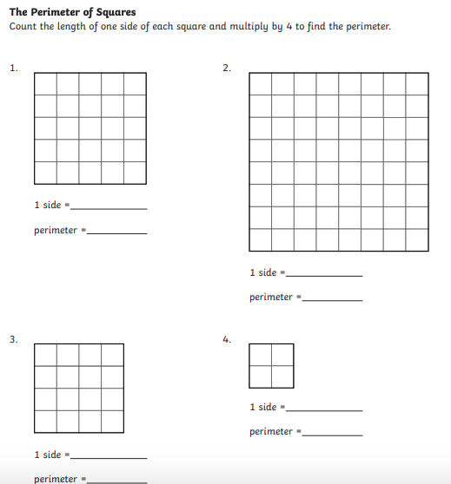
Activity 1 – Page 1

Activity 1 – Page 2

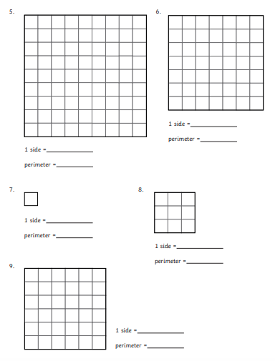

Activity 1 – Page 3

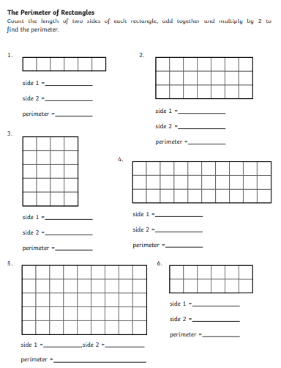

Activity 2 - page 1
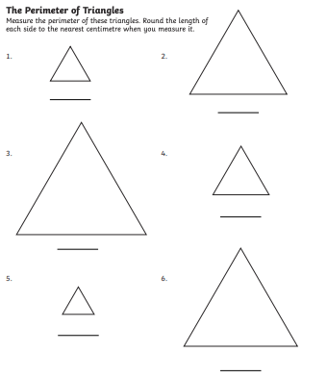

Activity 2 – Page 2

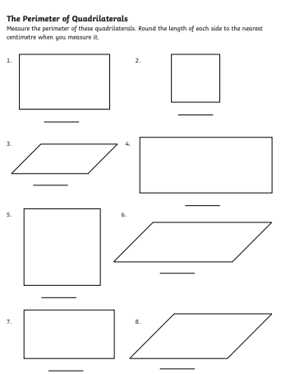

Activity 2 – Page 3
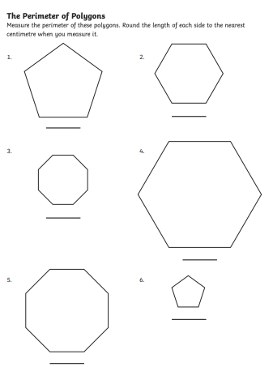

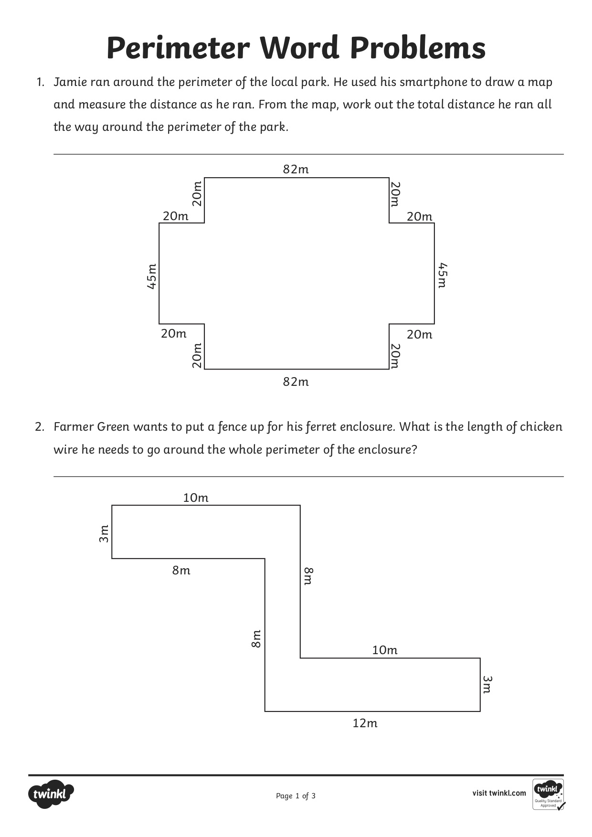
Activity 3 – Page 1

Activity 3 – Page 2
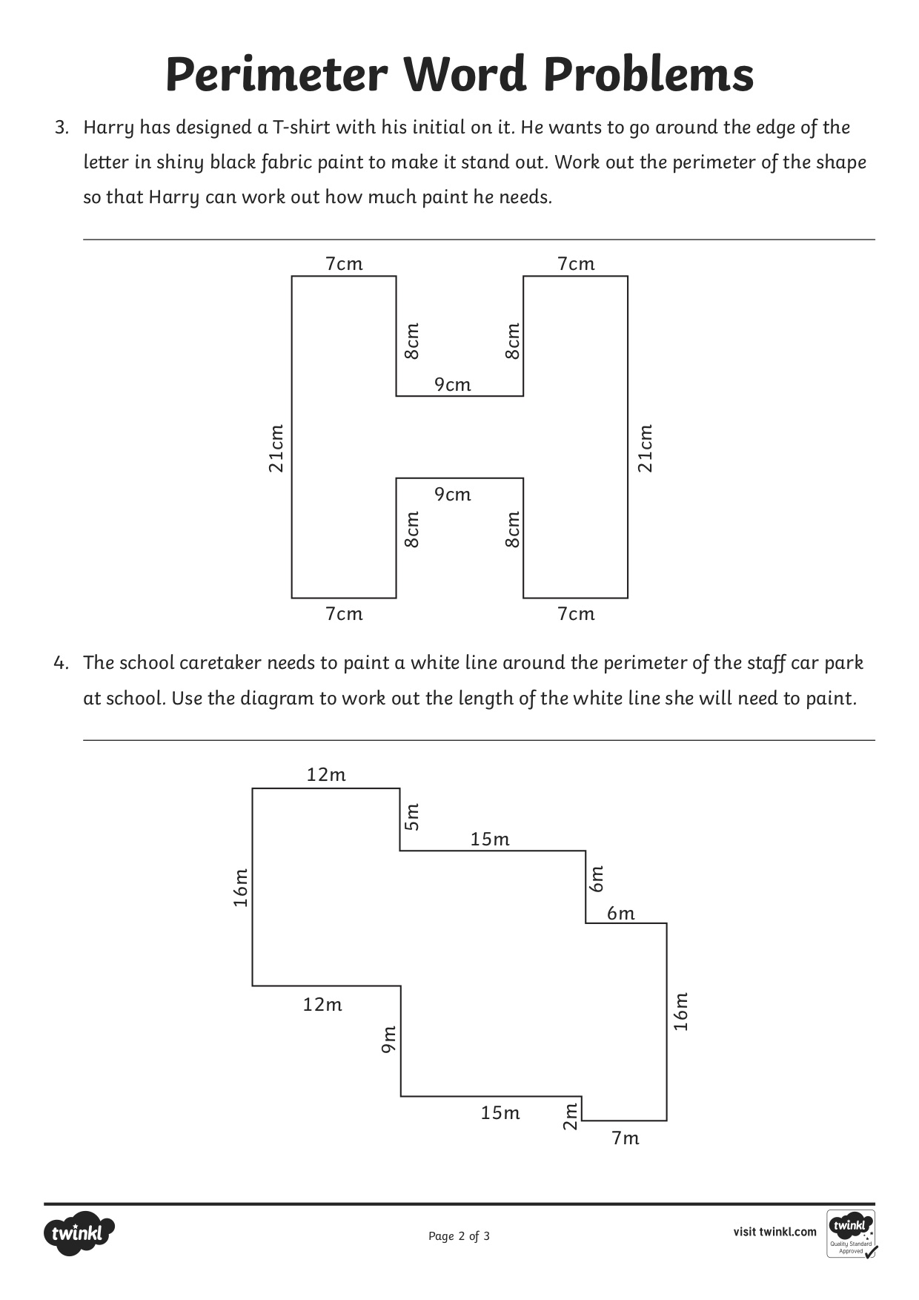

Activity 3 – Page 3
