Maths Starter:

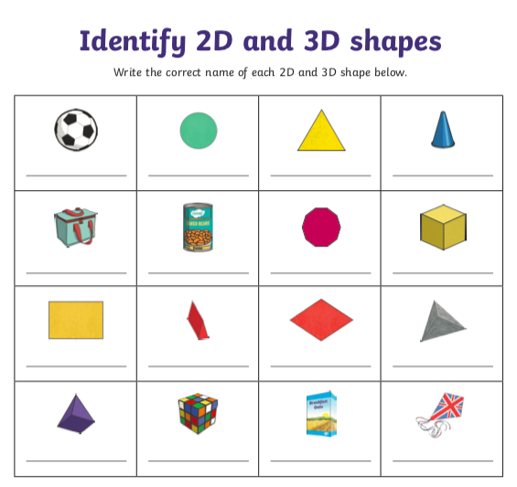

Now look at the PowerPoint on horizontal and vertical lines. Then choose from the activities on the next page.

Activity 1

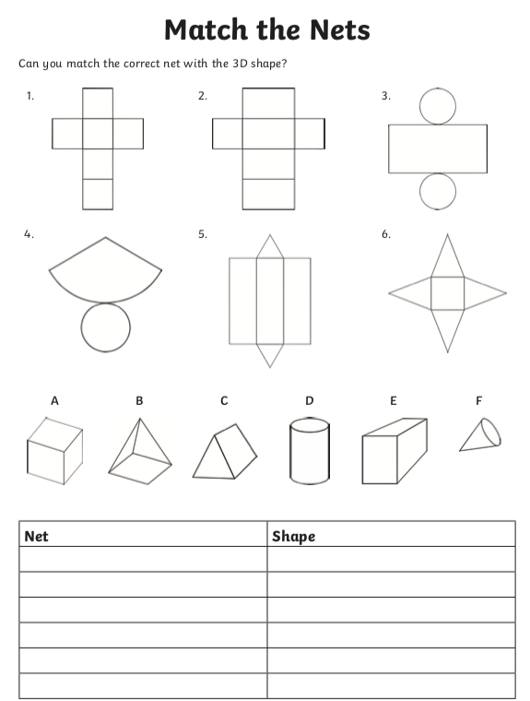

Activity 2

Find the lines of symmetry

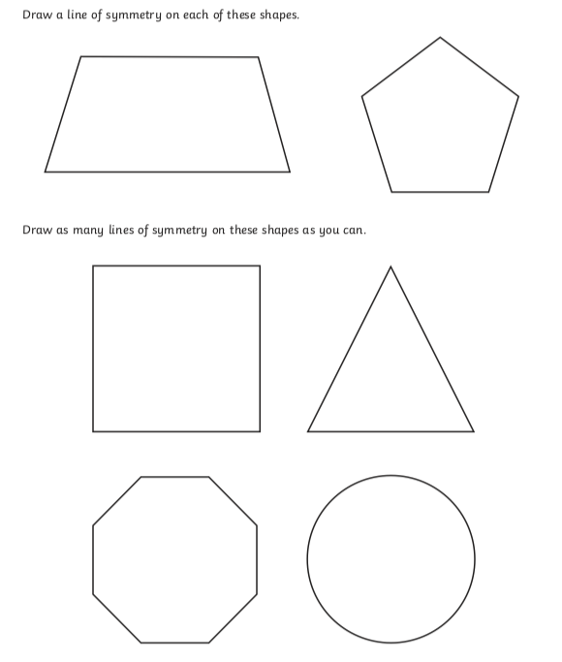

Activity 3

