Repeating Patterns
Look at the repeating patterns below. Can you repeat the patterns with the correct shapes?

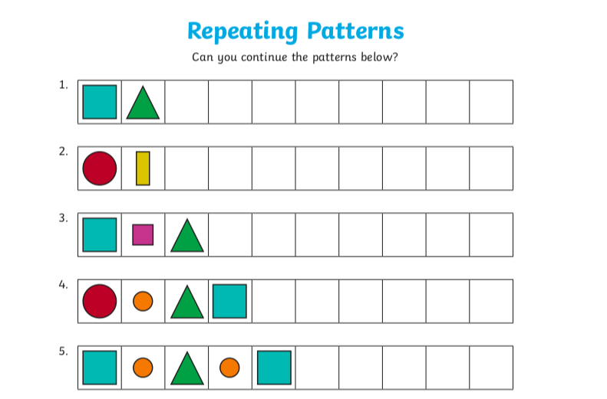

Now choose from one of the activities - or try them all! The more chillies, the more difficult the task is.

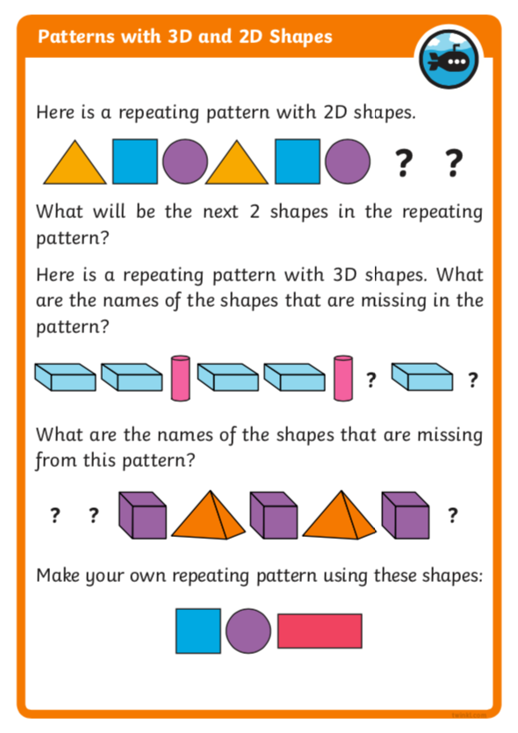

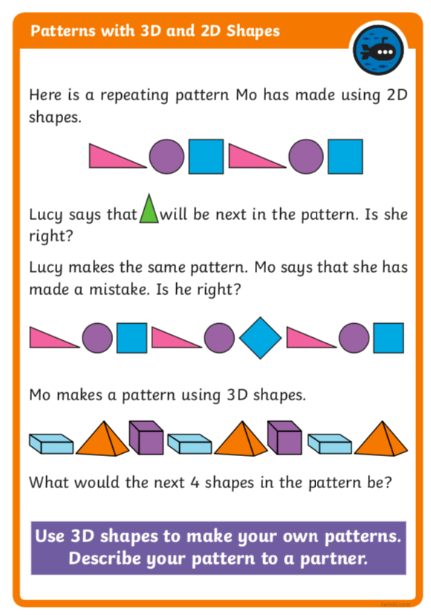

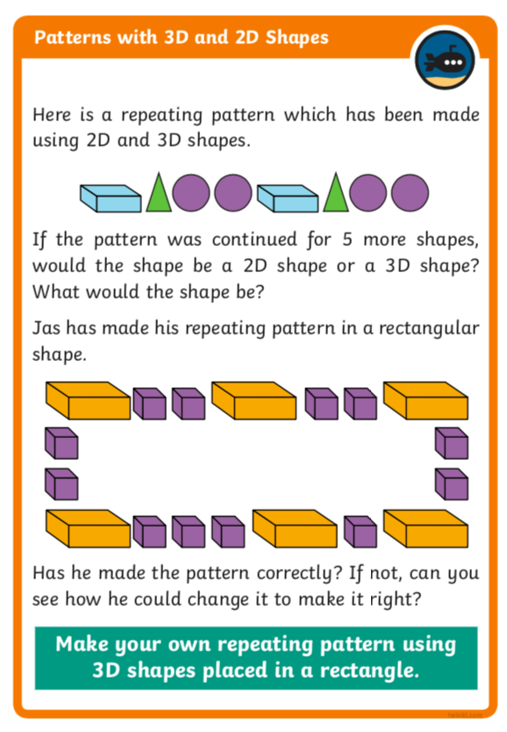

Challenge
Was that easy? If you really want to challenge yourself, try this:

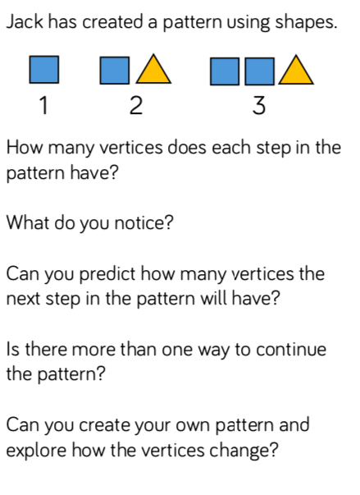

For more maths challenges you can use this website:
https://nrich.maths.org/primary

