Time Tables Number Search

Choose one of these activities to complete.

Level 1 - 10 times table

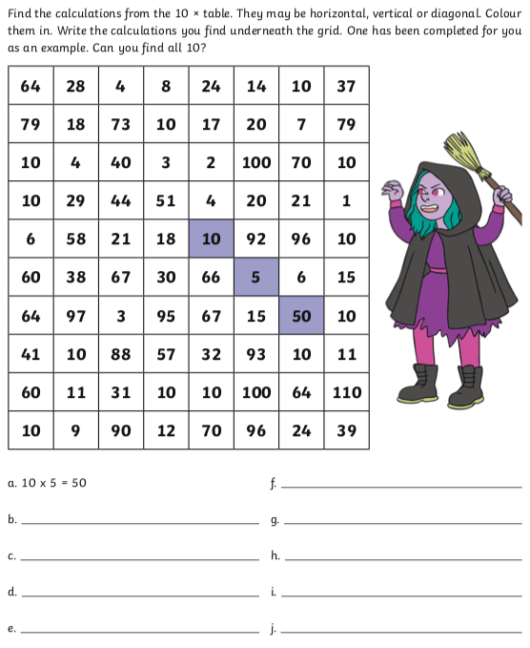
Level 2 - 3 times table
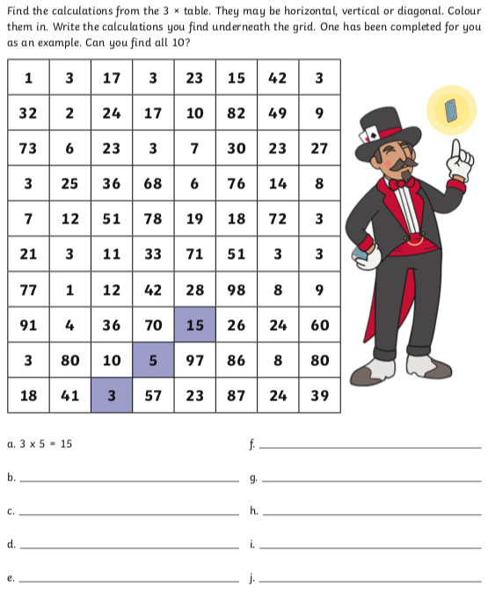

Level 3 - 6 times table

