Spruce PSHE
This week we are continuing to focus on your wellbeing.

On the website on Spruce’s home learning page, there is a document called ‘making a difference from home’ This week I would like you to complete the community spirit pages on page 4 and 5 and then complete the tasks.
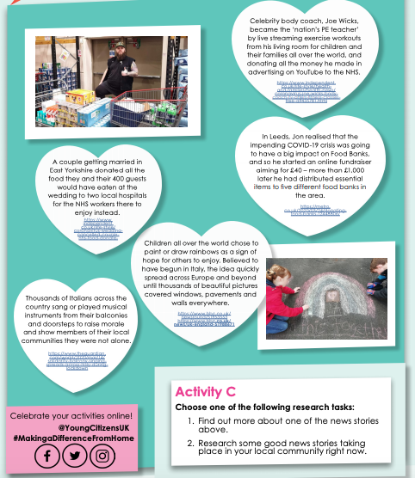
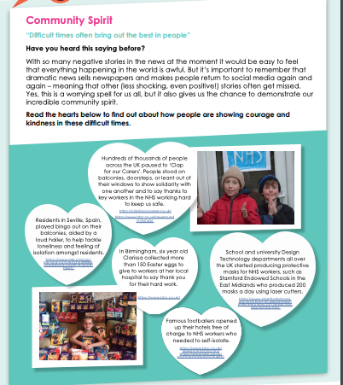
I have inserted screen shots below of the pages you need to look at, if you can open the document on a computer or tablet, the links on the pages should work!

