Maths - Statistics

Watch the video for a reminder about tallying and graphs. Then complete the activity on the next page.

https://www.bbc.co.uk/bitesize/clips/zkf34wx

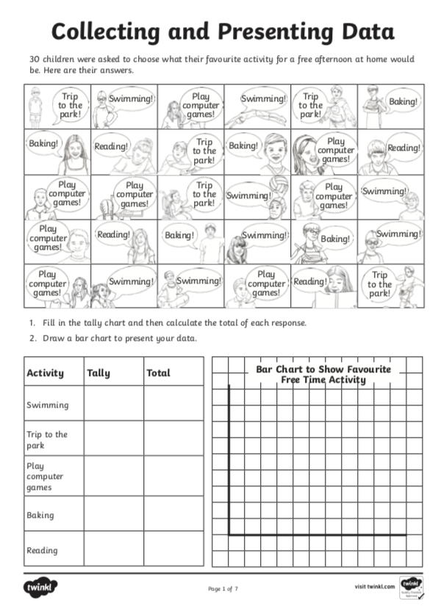
What activity is most popular?

________________________________________________________

What activity is least popular?

________________________________________________________

How many more people like swimming than reading?

________________________________________________________

