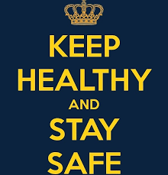

Hello Pine Class pupils! I hope you are excited about today’s, Keeping Healthy and Staying Safe. We are going to be recapping all we have learned about our brains so that we know how to keep them healthy.
Read through our learning objective to start off…

Learning Objective | To explore our brains.
9.11.20 | I can:
 | 1. tell you the three main parts of the brain.
 | 2. tell you what each part does.
 | 3. think of times I have used the three parts of my brain.
 | H | M | I

First of all, try answering these questions to see how much you can remember, and then we will check the answers.

1. What does your brain help you to do?

2. What are the three main parts of the brain called? (Don’t worry if you forgot how to spell them!)

3. What does the front part of your brain help you to do? We decided it was like a wise, old ________________.

4. What does your hippocampus help you to do?

Now read through the information and check your answers.

Our brains help us to…

-stay focused -learn -stay calm -be kind

-make good choices -problem solve -remember

And lots of other things!

As you learn about your brain you will realise that you are able to change the way you behave and respond to situations, if you choose to do so.

Our brains

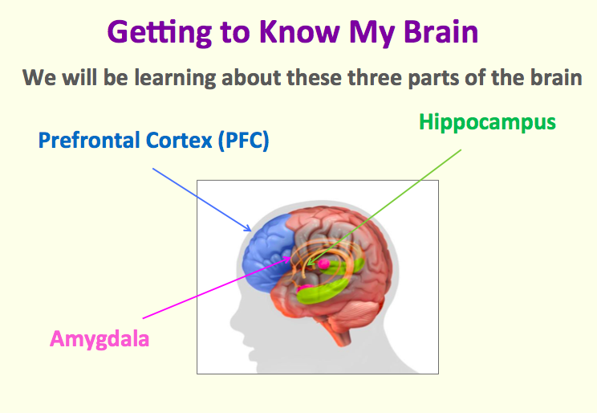

Prefrontal cortex- this part of our brain helps us to think, learn and make good choices. It allows us to read, write, predict, problem solve, make friends and understand things. This part of our brain is like a wise, old owl.

Can you think of some times when you have needed to use your prefrontal cortex?

Hippocampus- this is the part of the brain that helps us to make memories, remember things that we have learnt and recall happy memories. We have two types of memory stores. Can you remember them? ________and _______. This part of our brain is like an elephant-an elephant never forgets!

Can you think of some times when you have needed to use your hippocampus?

Amygdala- this is the part of the brain that is in charge of how you feel and behave. It is a bit like a guard dog, which protects us from threats.

When you feel happy or relaxed, the amygdala sends the information you are learning to the other parts of your brain (like to your pre- frontal cortex and hippocampus!) so that you can learn and think clearly.

BUT... When you are feeling frightened or angry, you might have noticed that it is tricky to concentrate. This is because when you feel this way, your amygdala stops information passing along to the rest of your brain. We made amygdala bottles in class to represent this.

Can you think of a time when your brain felt all shaken up and confused?

What helps you calm down so you can think calmly?

We will be discussing this at school so be ready to share your ideas! Now check back in with the learning objective- do you feel confident or do you have more questions for me?

Well-done everyone- great lesson! I’m looking forward to hearing all of your ideas at school.

