Maths - Money

This week, our maths work is all about adding money amounts. This is an important life skill that you will need so it is a good idea to practise with real coins. If you need any help, BBC Bitesize has many great clips to choose from:
https://www.bbc.co.uk/bitesize/topics/z8yv4wx/resources/1

As always, the more chillies the more challenging the task. Look out for a ‘4 chilli challenge’ this week!

Activity 1

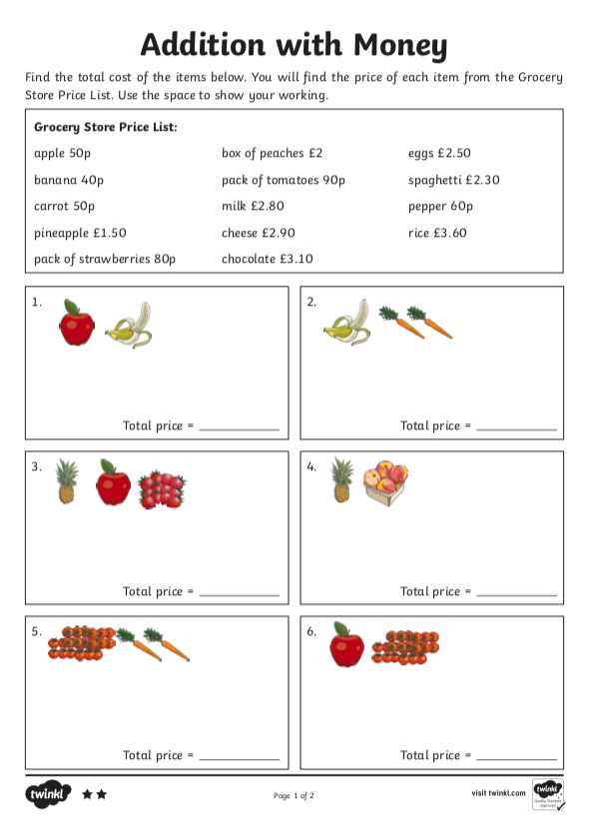

Activity 2

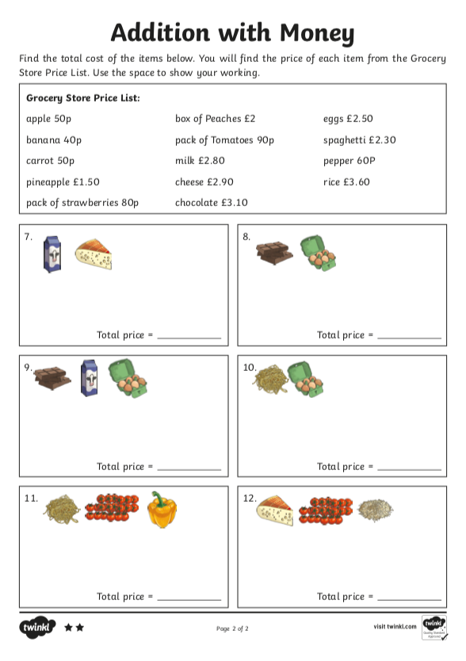

Activity 3

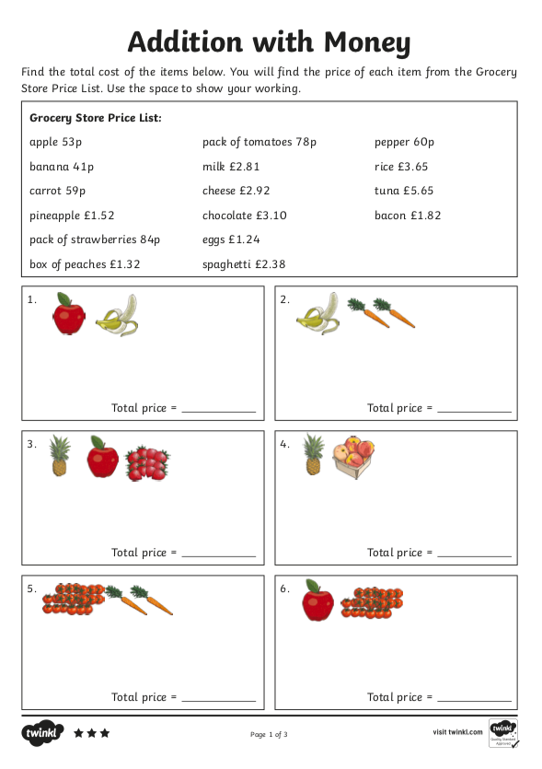

Activity 4

