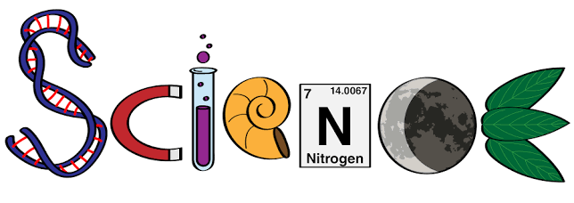
Hello Pine Class scientists! I hope you are excited about today’s science lesson. We are going to be finding out about Darwin’s theory of evolution.

Evolution is the process of change to animal and plant species over long periods of time- how plant species and animals have developed from generation to generation. Plants and animals produce offspring of the same kind. These offspring are similar but not exactly the same as their parents.

Read through our learning objective to start off…

Learning Objective | To explore the theory of evolution.
10.11.20 | I can:
10.11.20 | 1. Find out who Darwin was.
10.11.20 | 2. explore how Darwin came up with his theory of evolution.
10.11.20 | 3. explore some examples of animal evolution.
10.11.20 | H | M | I

First, watch the video on Oak National Academy all about Darwin and his theory of evolution and complete the activities set in the video:

Video at: Oak National Academy KS2Subjects Science Humans and animals over time What is the theory of evolution?

https://classroom.thenational.academy/lessons/what-is-the-theory-of-evolution-6ru32d?activity=video&step=1

Once you have watched the video and answered the questions about evolution and how giraffes have adapted, start to think about how humans have adapted and how the theory applies to us. Use the pictures below to explore the changes:

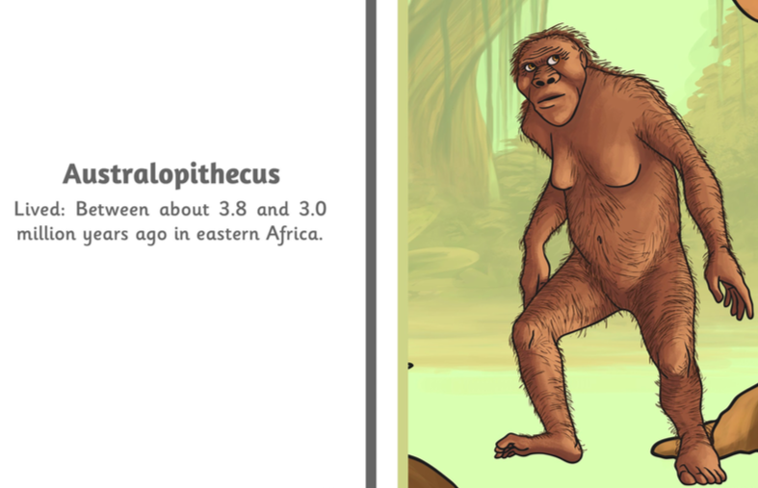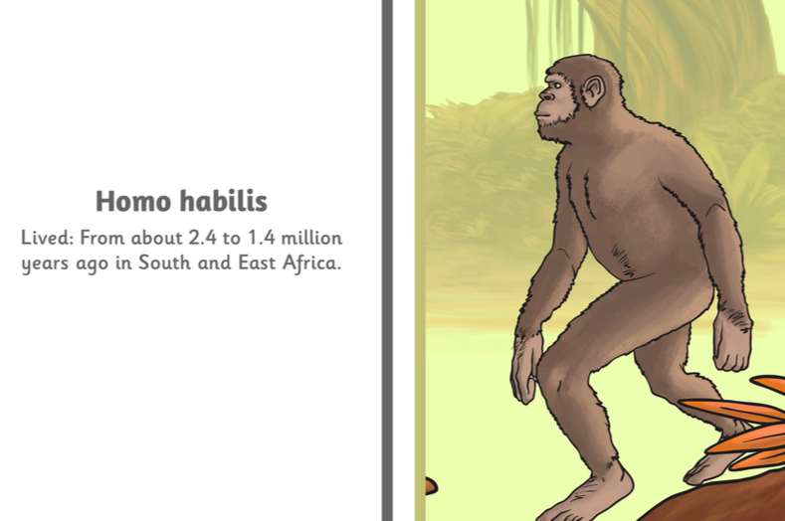

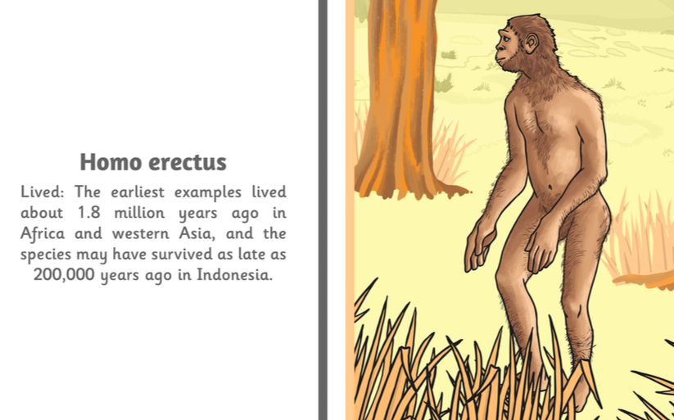

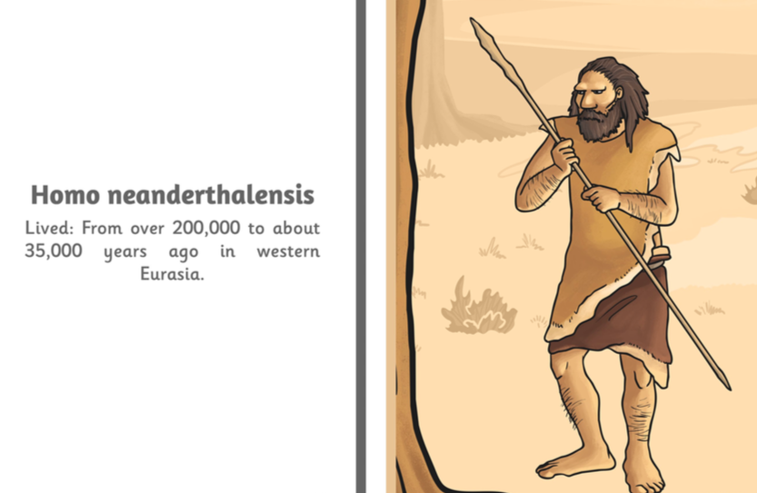
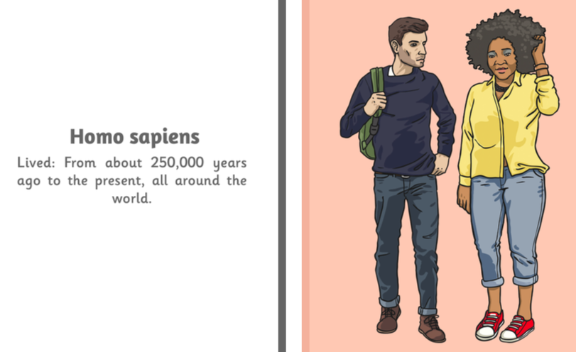

What do you notice?
Can you learn any of the names?
Can you copy any of the pictures and write notes about your observations, just like Darwin?

We will be discussing this at school so be ready to share your ideas! Now check back in with the learning objective- do you feel confident or do you have more questions for me?

Well done scientists- great lesson! I’m looking forward to hearing all of your ideas at school.



How does my life cycle differ to that of frogs (3 lessons)
Why have so many pop stars died at 27? (dangers to the body – physical and mental health)

