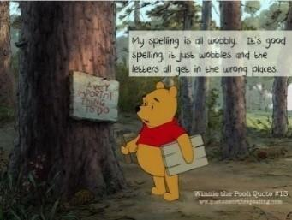
Pine class spelling homework

1. Say the word and count the sounds. For example, answer has four sounds (a, n, s, er) because we don’t hear the ‘w’ and the ‘er’ make one sound.

2. Say the word again and spot the tricky parts. For example, in answer ‘w’ is the tricky part because it is a silent letter.

3. Cover the word and see if you can spell it correctly

These activities will help you to remember how to spell the words.
If you find it tricky, don’t worry- I can help you next week ☺

Spellings | How many sounds are in the word? | Which is the tricky part? | Cover and copy the word
heard

heart
height

history

imagine

increase

important

Pine class maths homework

Use the grid to help you:

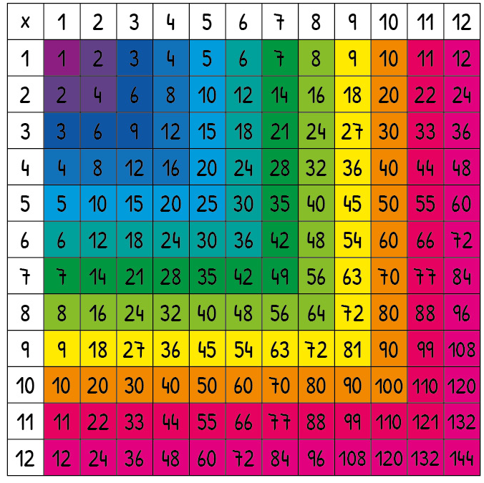

Short multiplication:
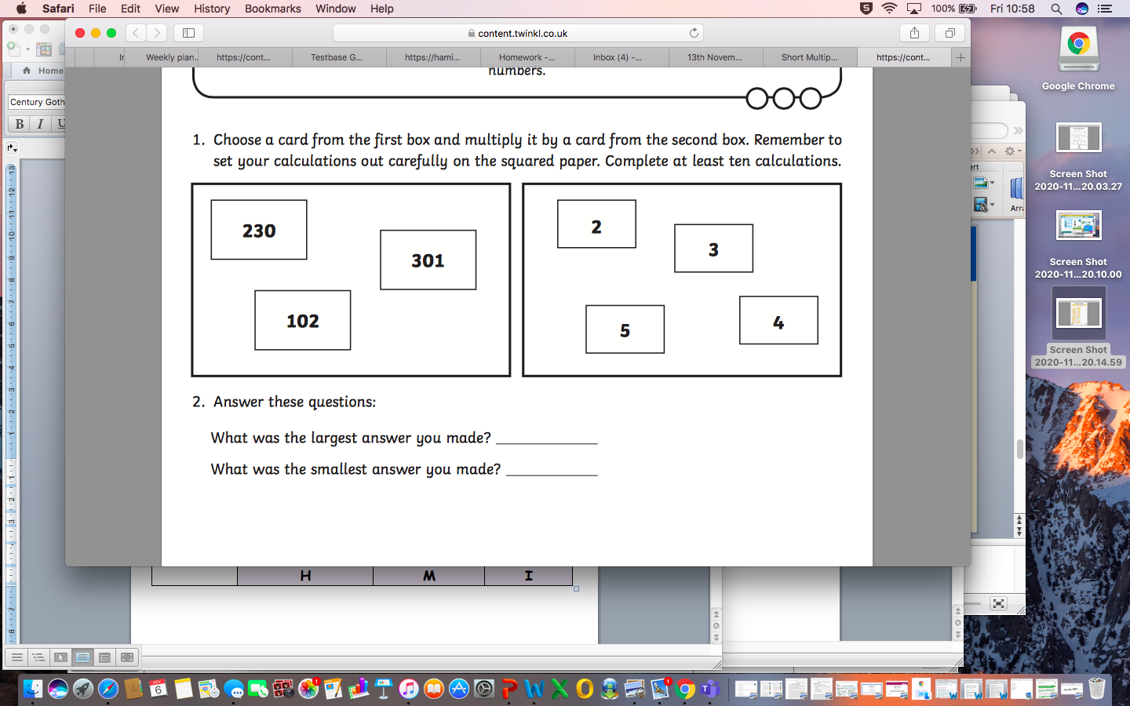

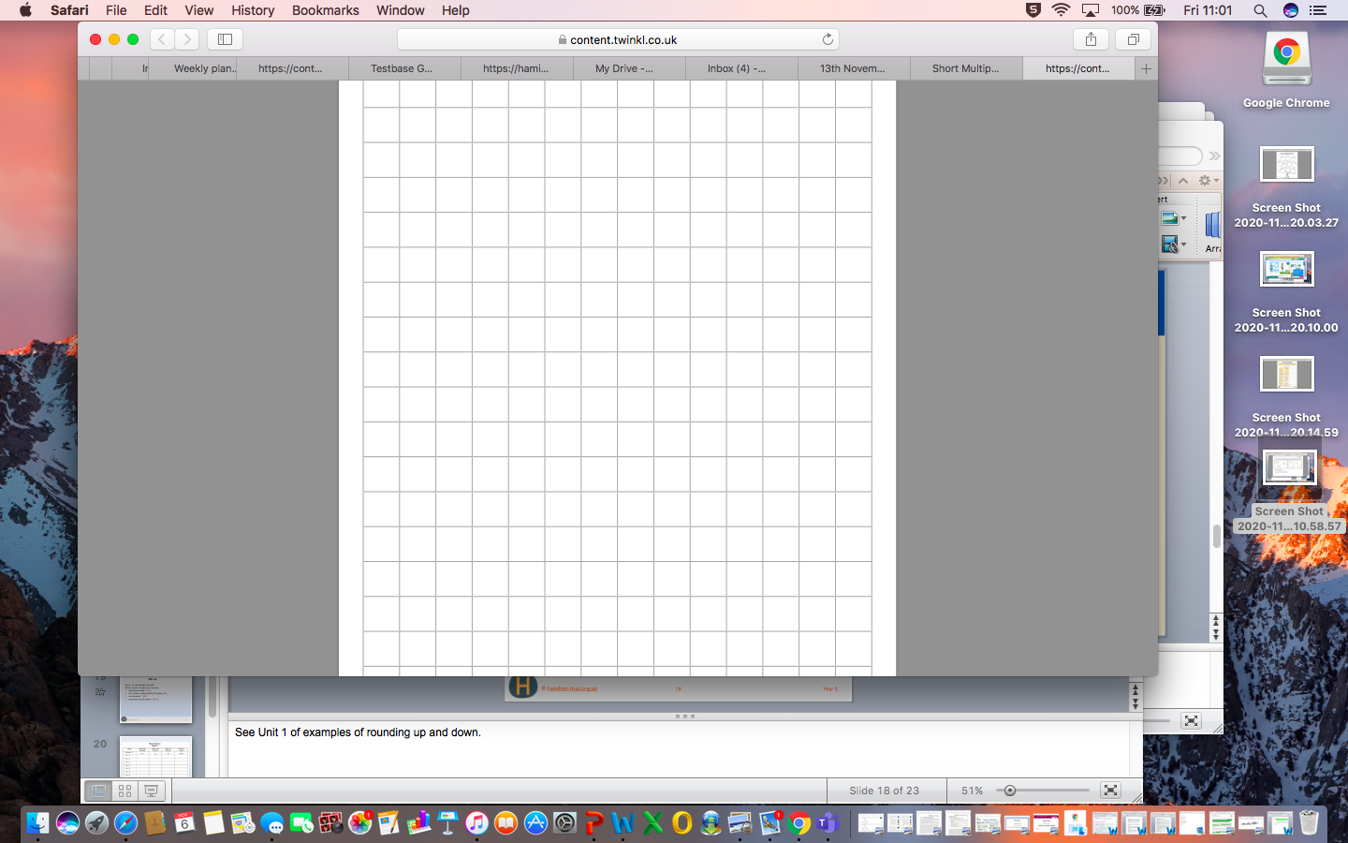

Long multiplication:

We tried these in class- see how you get on.
Remember to put a zero as a place holder and to add the numbers together at the end!
Don’t worry if you get stuck- I can help you in school.



