Phonics Play is a great website where you can play phonics games to help you practise the sounds:
https://new.phonicsplay.co.uk

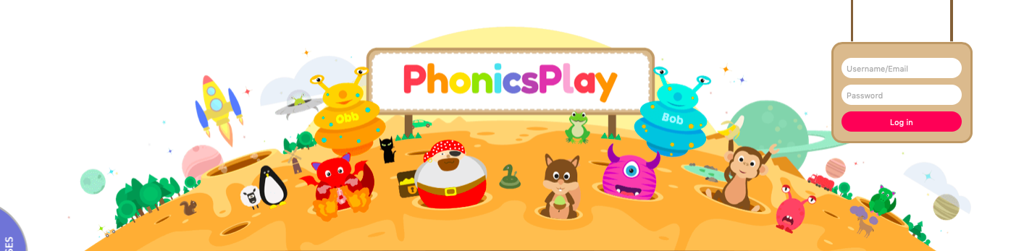

Use this login information to gain access:



