Niamh’s reading group

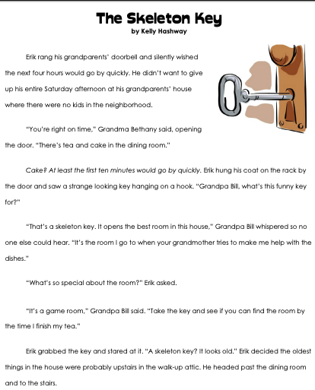

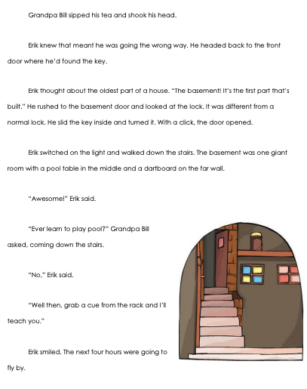

Questions

- What is the setting of this story?

- Why didn’t Erik want to visit his grandparents’ house at the beginning of the story?

- Grandpa told Erik that the skeleton key opened…
- a trunk with secrets
- the basement door
- the attic door
- a game room

- Why did Erik thin the key would open the attic door?

- Choose the best definition for the word underlined in the sentence.

Erik and his grandfather played a game of pool.

- A hole in the ground filled with water
- A game where a large ball is shot into a goal
- A game where a stick is used to shoot balls across a table

