Niamh’s Reading Group 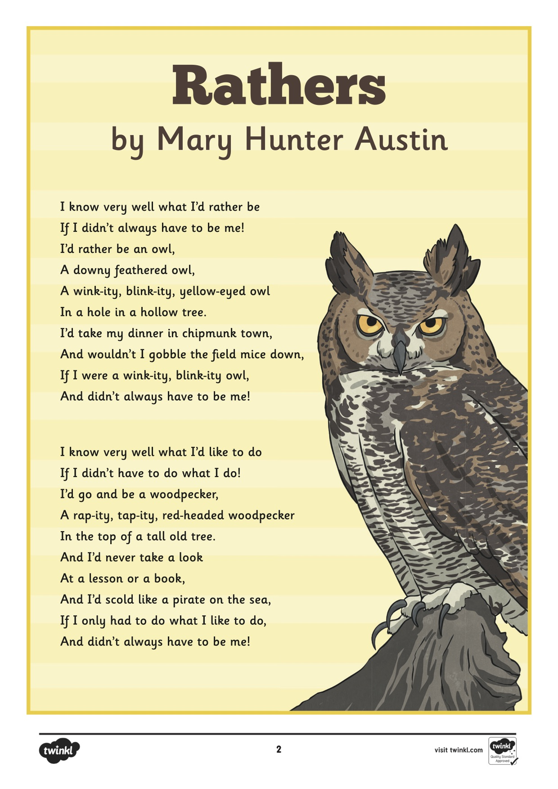

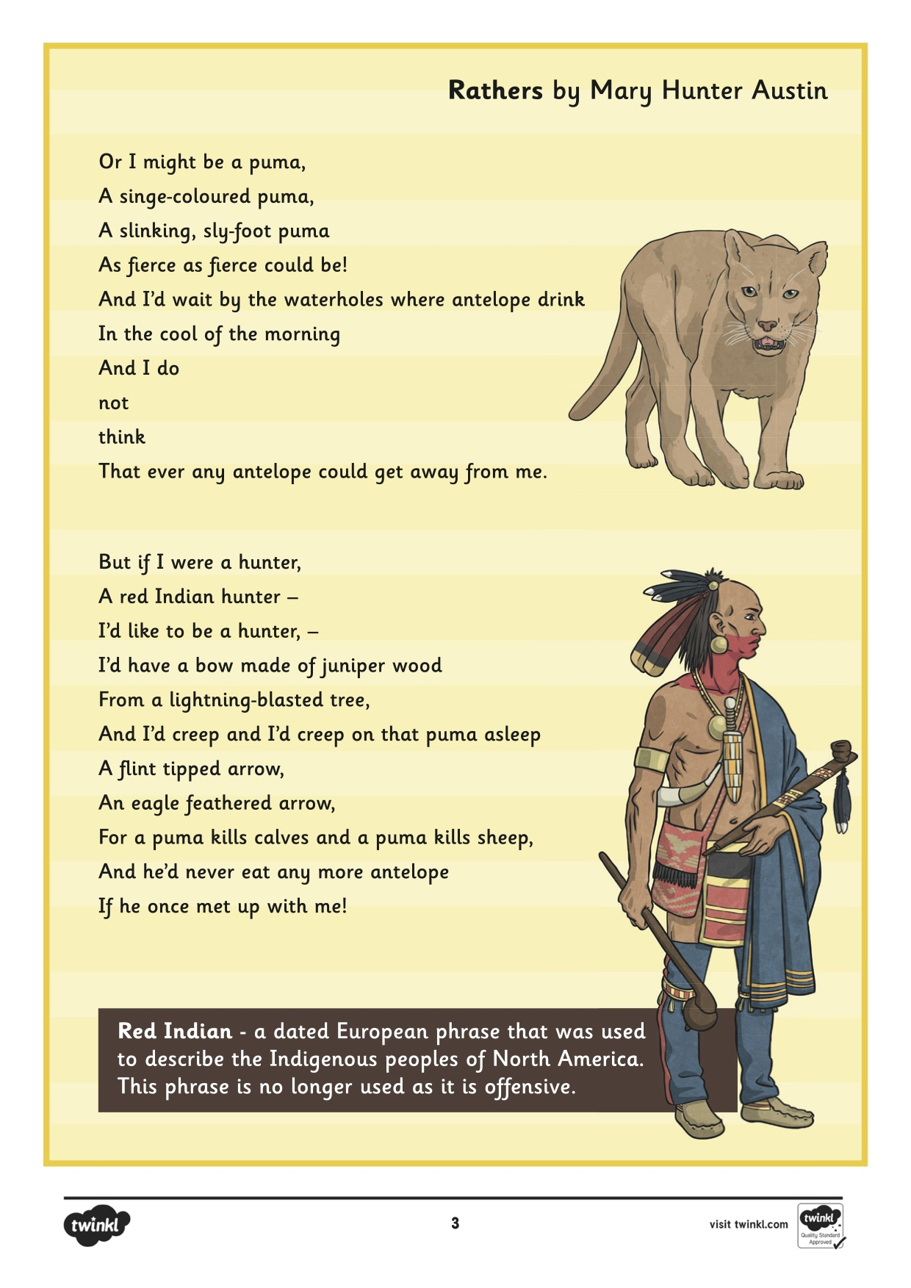

Questions

- In this version of the poem, which animals did the author want to be? Give 2 examples

- Where would the poet live, if she became an owl?

- How would you describe a woodpecker’s character?

- How does the puma move in this poem?

- Do you think the poet is happy being herself? Explain how you know.

- Wheat does the poem tell us about life in the wild? Use the text to explain your answer.

