Niamh’s Reading Group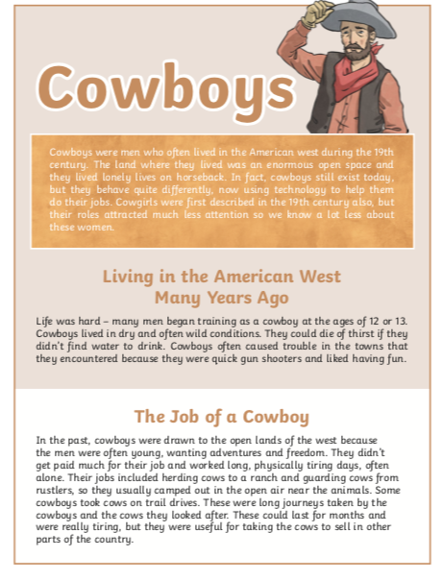

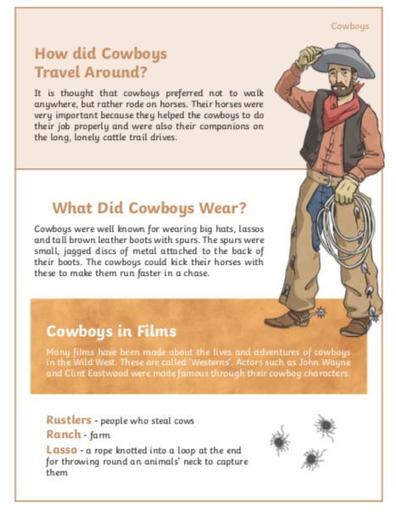

Questions

- Explain what a cowboy is

- What ideas are we given about cowgirls?

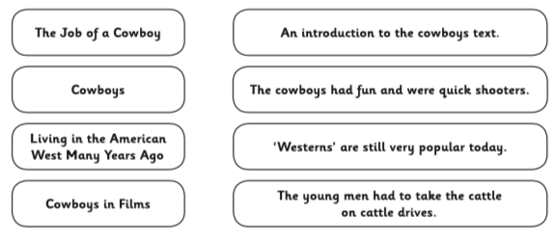
- Draw a line to match each heading with the correct information

- Find and copy one phrase in the introduction that tells us cowboys did not live in cities.

- What is a trail drive?

- Name one characteristic a cowboy might have.

