Niamh’s Comprehension Group

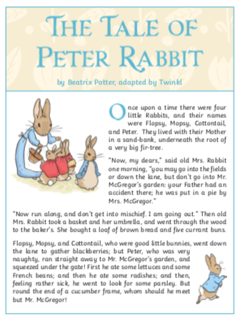

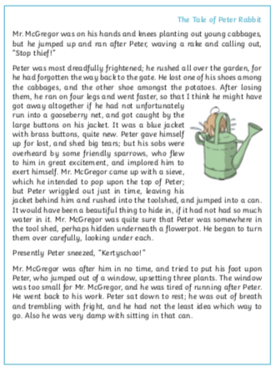

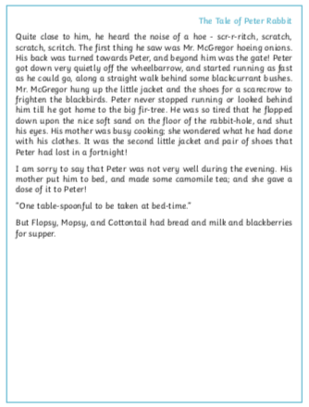

Comprehension Questions

- What were he names of the four little rabbits?

- What happened to Peter Rabbit’s father?

- Why were the rabbits left alone?

- Find and copy a phrase that tells the reader that Flopsy, Mopsy and Cottontail were well behaved

- Where did Flopsy, Mopsy and Cottontail go after mother had left?

