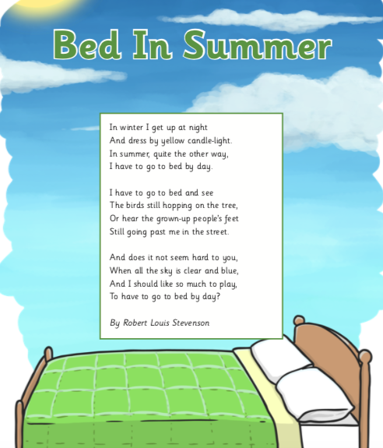

Questions – Bed in Summer
2a Give/explain the meaning of words in context.
2g Identify/explain how meaning is enhanced through choice of words and phrases.

- Look at the verse beginning: In winter I get up at night.
Find and copy a phrase that indicates that it is dark.

- ‘I have to go to bed and see
The birds are still hopping on the tree.’ (verse 2)

How does this show us the poet’s feelings about going to bed?

- Use the text below to answer questions 3a and 3b
And does it not seem hard to you,
When all the sky is clear and blue,
And I should like so much to play,
To have to go to bed by day?

- Underline the verb that shows what the poet would prefer to be doing.
- Find and copy the phrase that suggests that the poet does not want to go to bed.

- What is this poem about?

- Choose the best word or group of words to fit the sentences below and put a ring around your choice.

