2d Making inferences from the text / explain and justify using evidence from the text.
2h Make comparisons within the text (effect).

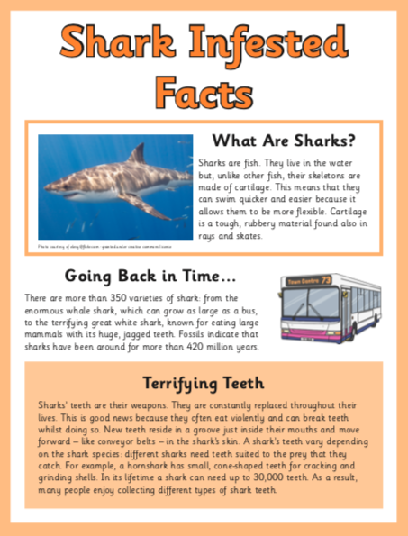

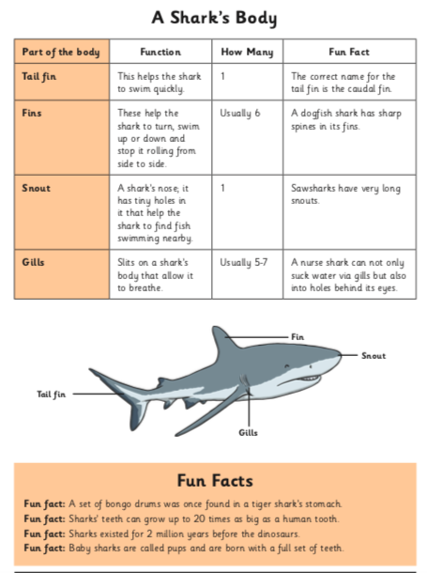

- Why do you think the sawshark has its name?

- How does having many rows of teeth help a shark to survive?

- Look at the section headed: A shark’s body. Find and copy one phrase that shows that a nurse shark has gills that perform 2 jobs.

- What ideas are we given about how a shark’s body is adapted to help it survive?

