Niamh’s Reading Group.

Niamh’s Comprehension Group.

This follows the normal way we complete comprehension.

- Look at the picture and title before you read the text. Think about what you can see, the title, what you can infer and what the text might be about.
- Read the text and underline any words you are not sure the meaning of and ask an adult or look them up.
- Think about what you can infer from the text.
- Answer the comprehension questions.
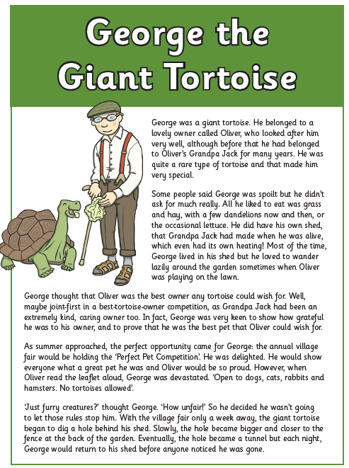

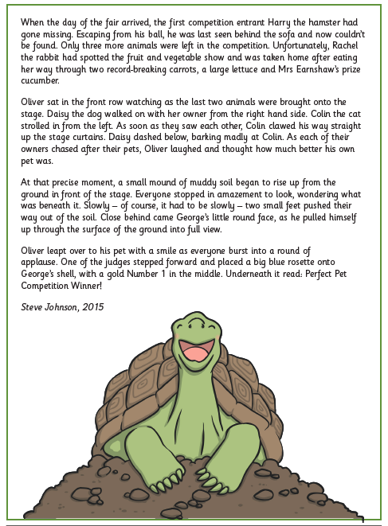

Questions
2b Retrieve and record key information/key details from fiction and non-fiction.

- Who was Oliver? Circle one.

A giant turtle | A giant | A cat | An owner

- Which one of these did George like to eat? Tick one

Tulips |  | Biscuits
Grass and hay |  | Sandwiches

- Who was Jack?

- Where did George live?

- How did George feel towards his owner? Circle one.

Angry | Patient | grateful | unhappy

- Look at the text again.
Find and copy the information from the text to complete the fact file below about George.

Name | George
Type of Tortoise
Owner
Favourite Foods

- Who could not enter the ‘Perfect Pet Competition’?

