Niamh’s Comprehension Group.

This follows the normal way we complete comprehension.

- Look at the front cover before you read the text. Think about what you can see, the title, what you can infer and what the text might be about.
- Read the text underline any words you are not sure of the meaning and ask an adult or look them up.
- Think about what you can infer from the text.
- Answer the comprehension questions.
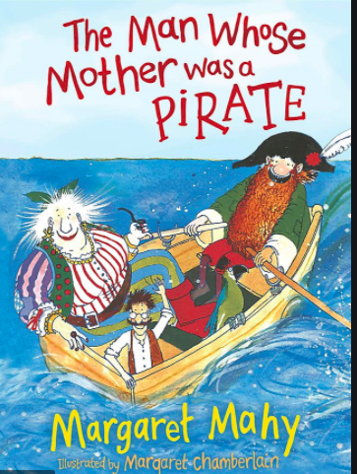

3

Questions
2d Making inferences from the text / explain and justify using evidence from the text.

- How can you tell the little man hasn’t seen the sea before?
- “The fume and the foam of it never left him again” What does this tell you about how the character feels about the sea.
- What does ‘ “Say, ‘Aye, aye, sir!’” Roared the captain’ imply about the captain?
- How can you tell the sea is calm?

