Deductive – Use your detective skills to hunt for clues, to the answers, in the text!
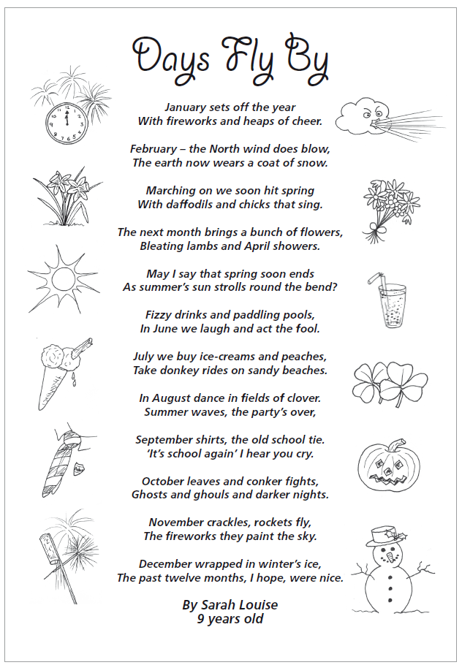

Days Fly By

Warm up questions – Answer these questions before reading the text

  - How many months are there in a year?
  - How many verses do you think there will be in the poem? Why?
  - Now count them. Were you correct?

Vocabulary check:

- Underline the first letter of each month. What type of letters do we call these?
- Why do you think each month starts with this kind of letter?
- Highlight the word “wrapped”. Which picture shows something “wrapped” up? Draw your answer.
- Show someone how you can ‘wrap up’ warm in a hat, gloves, coat and scarf n a cold winters day. If you can’t show someone then draw your answer.
- Why do you think Sarah Louise ‘wraps’ December in ice?

Main questions – try and answer these in full sentences:

- Look at the key below. Put a coloured dot next to each verse (so if you think a verse is a Spring verse, you put a pink dot next to it).
Pink = Spring | Orange = Summer
Brown = Autumn | Blue = Winter

- Why did you choose this dot and not another?
Month | Dot colour | I chose this colour dot because the verse talks about:
January
February
March
April
May
June
July
August
September
October
November
December

- Does Sarah Louise think the North Wind is cold or warm? What tells us this in the next line?
- Does Sarah Louise think Summer is a fun time? Yes or no? Read the verse again – how do we know that she thinks this?
- Does she think that October is a scary month, yes or no? Why?
- Where does Sarah Louise usually go for her holiday in July, the countryside or the seaside? Draw your answer. Why do you think this?
- Does Sarah Louise think November is a month full of:
  - Colour
  - Sound
  - Both
- How do we know that she thinks this?

Evaluative questions:
- Look at the title of this poem. Do you think Sarah Louise thinks time passes fast or slowly? Why?
- Choose a verse from the poem and draw a picture to represent this verse. Can anyone guess which verse you have chosen?
- Why did you choose this verse and not another?
- Think about some of the reasons why different people like different times of the year.

