Deductive – Use your detective skills to hunt for clues, to the answers, in the text!
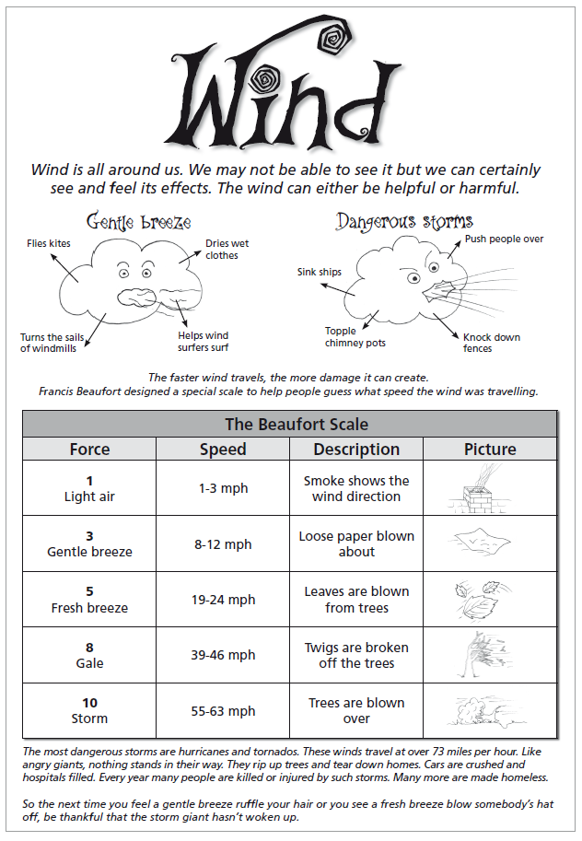

Wind

Warm up questions – Answer these questions before reading the text

  - When you are out and about or, inside your house, can you see the wind, yes or no?
  - If you can’t see the wind, how do you know that it is there?
  - Make a list of things that show you that the wind is there?
  - Which ones do you think you will see in this report?

Vocabulary check:

- Highlight the word ‘ruffle’.
- How might someone ruffle you tr hair? What type of wind do you think would ruffle your hair?
- Highlight the word ‘topple’. Draw a picture of a house where the chimney has ‘toppled over’.
- How do you think the Beaufort scale got its name?

Main questions – try and answer these in full sentences:

- Look at the thought clouds in the introduction and read what they say.
- Try to work out what type of wind I would be feeling if I saw the following:
What is happening? | Gentle breeze | Dangerous storm
A sailing boat on a lake
Roof tiles flying off a roof
Frosted breath drifting away on a cold day
A flag fluttering in the wind
Waves crashing on some rocks

- Now look at the Beaufort scale.
- What number would you give the wind if you saw the following?
Wind force
Some litter blowing around
A man’s hat blowing off
A lorry blowing over
Flowers swaying in the wind
An umbrella blowing inside out

Evaluative questions:
- How does the writer describe a dangerous storm? Draw your answer.
- What does a person look like when someone is waking up?
- Does the writer think a storm appears suddenly or does it take time? Why do you think this?
- Do you think likening a storm to an angry giant is a good idea? Why?
- What did you like or dislike about this page? Why?

