George and the Dragon by Hannah Raven
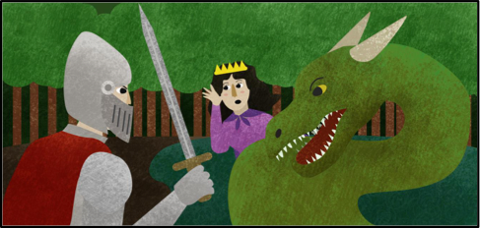
In a land far, far away, a small village lived in fear of an almighty dragon. The dragon lived beneath the water of a cold, murky lake. It had a green, scaly body and he terrified the villagers with his deafening, fire-breathing roars. The evil beast attacked the village every day.
At first, the King gave the dragon all the food in the village, but the dragon still attacked. Next, the King tried giving the dragon all the animals from the farms, but the dragon still decided to attack. Then, the King tried giving the creature all of his gold and sparkling jewellery, but the dragon continued attacking. In a final attempt to stop the dragon harming the village, the King agreed to feed one man or woman to the dragon each month. To make it fair, the King scratched every villagers name onto a stone and put them in a pot. Each month, the king would pull a stone out of the pot and the villager whose name was on the stone would be sacrificed to the evil dragon.
One month, the King pulled out the name of his daughter, the Princess. Everybody was in shock and the scared King begged the villagers to save his daughter.
Trotting towards the village, on his elegant, white horse was a brave knight called George. He was fearless and was always looking for new adventures. George could hear the commotion in the village and decided to investigate.
“This cannot happen to the Princess!” demanded George. “I will slay this dangerous dragon and bring back your Princess.” The villagers clapped and cheered for George as he set off towards the lake.
As George approached the lake, he tied his horse to a nearby tree, not wanting him to get hurt. George pulled on his heavy armour. Through the crisp, spring leaves he could see the Princess sobbing on the muddy bank. Gripping his sword tightly, he pulled it from his belt and walked towards her.
All of a sudden, the surface of the water began to ripple as the green dragon rose out of the lake. Water splashed everywhere as he came to the surface. His green scales shimmered in the sunlight as his beady, yellow eyes caught sight of the Princess.
George charged towards the dragon, as it began moving closer to the King’s daughter.
“ROOOOAAAAR!” yelled the dragon. His mouth was so wide open that George and the Princess could see his spear-like teeth.
With his sharp sword, George pierced the skin of the dragon’s belly and he fell to the ground with a crash. George had defeated the dragon. With all his strength, he pushed the creature back into the lake, never to be seen again. He turned and helped the Princess to her feet.
“Thank you, George,” she said kindly “You saved my life.”
George and the Princess rode back to the village where the King was delighted to see his daughter. From then on, the villagers were able to live peacefully once more.
© Copyright Deepening Understanding LTD 2019 Photocopiable for educational purposes only


