Cal’s Ice Cream

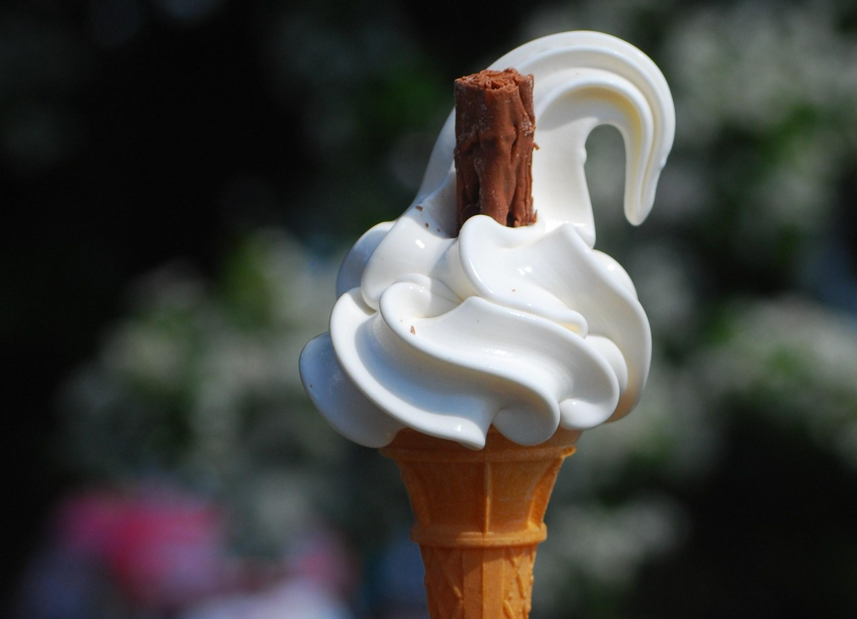

Cal has an ice cream. It is blue and it is cold. It drips and drips. He licks and licks. He sips and sips. Now his lips are blue. That was a good ice cream!

- Circle in the text what Cal does after the ice cream drips.

- Underline in the text why his lips are blue.

- Colour the ice cream to show what colour it is.

