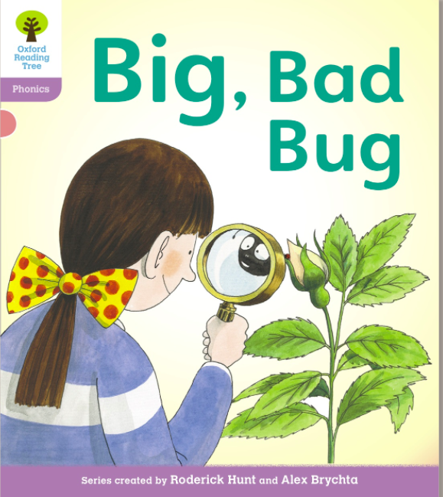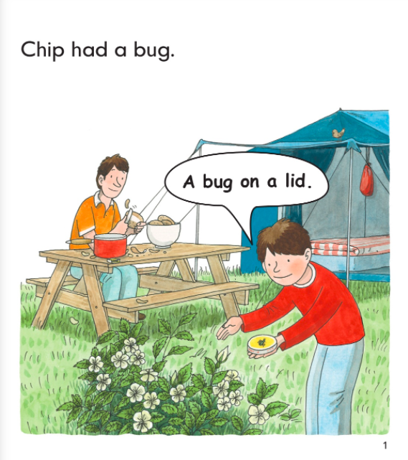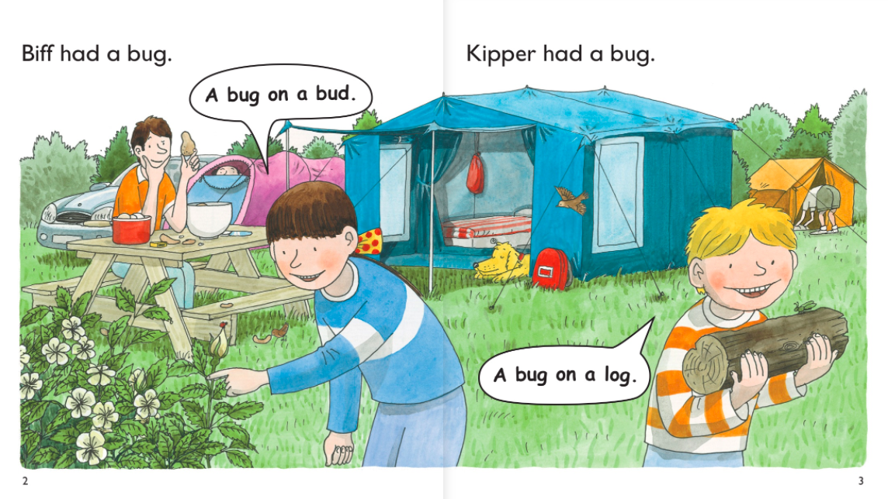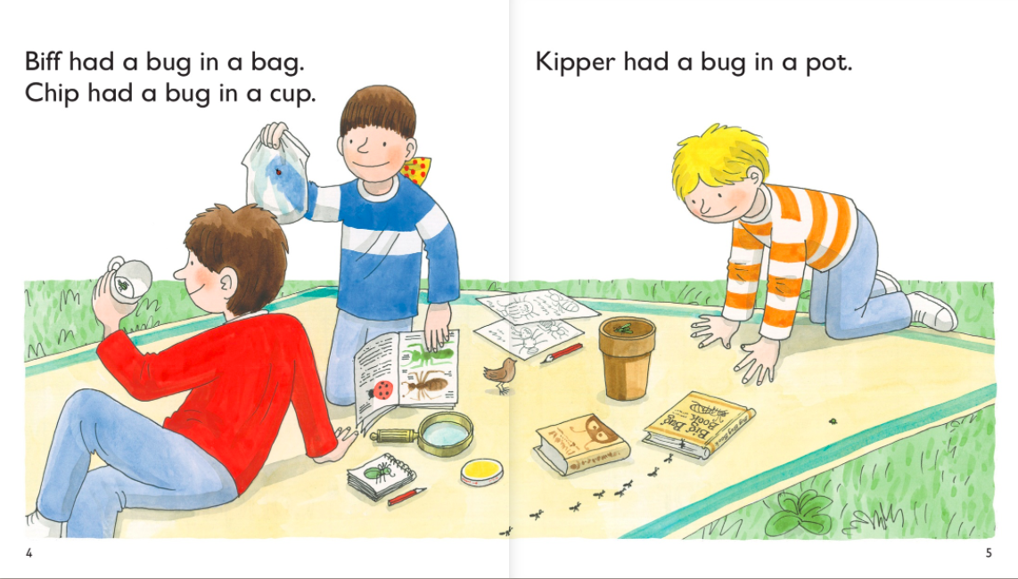

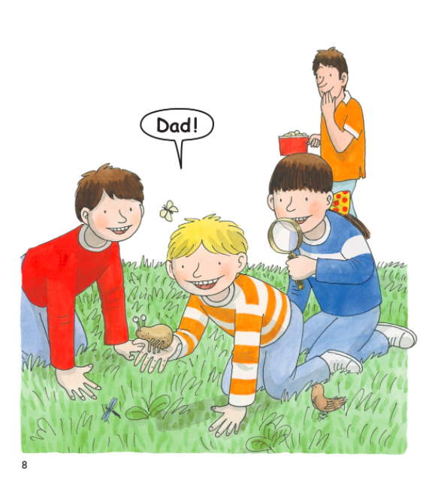

Questions:

Who had a bug in a cup?

________________________________________________

Where did Kipper have a bug?

________________________________________________

What was different about the bug at the end of the story?

_______________________________________________

Find three words that begin with the same letter.

________________________________________________

