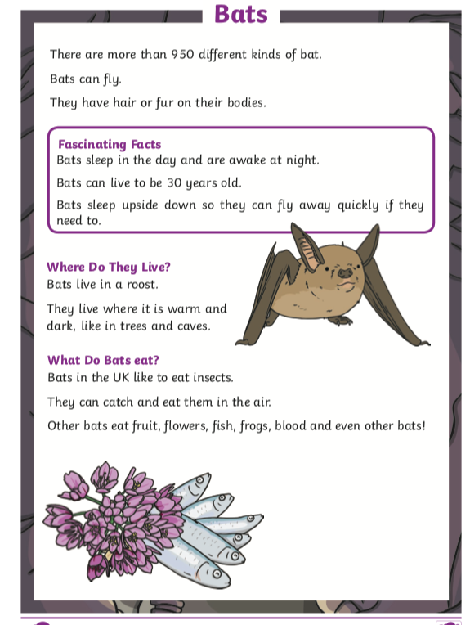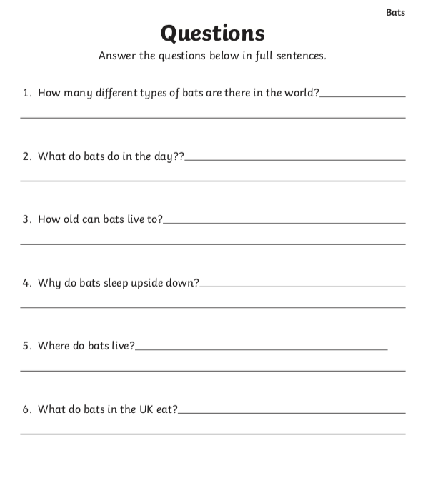

Don’t forget - you can click on this link to take you to the Oxford Reading Tree website. There you will find some free reading books to read online. They are just like the ones we read at school!
Click on ‘Levels’ then choose ‘Read, Write, Inc Level’. At school, you read the RWI Yellow Phonics books. Try these books first, then move on to the Blue level. Keep practising! You are doing so well!

https://www.oxfordowl.co.uk/home/reading-site/find-a-book/library-page?view=image&query=&type=book&age_group=&level=&level_select=&level_select=rwi+phonics+purple&book_type=&series=Read+Write+Inc.#

