
KS4

Fern House Literacy work pack 6
- Functional skills punctuation
- Functional skills
reading and writing
Make sure you are engaging in at least 10 minutes of story sharing every day!
This can be reading with an adult, exploring non-fiction texts, listening to audio books or online readings.

Recognising different sentence types
I can identify a question, statement, command and exclamation.

Statements - Statements are sentences which tell you something. They end with a full stop.

Questions - Questions are sentences that ask you something. They usually end with a question mark.

Commands - Commands are sentences that tell you to do something. They are often urgent or angry and can be very short.

Exclamations - Exclamations are sentences that begin with ‘what’ or ‘how’. They are full sentences, include a verb and end with an exclamation mark.

Label each or underline each sentence in the correct colour.
- Is it cold outside?
- How kind of him to do that!
- Climb up that tree.
- “What a nice young man!” shouted Anne.
- It is great fun going to the park.
- A puppy will grow up to be a dog.
- Should you really eat 7 chocolate bars?
- Get down from the roof!

Now have a go at creating your own. Make sure you label what it is (statement, question, command or exclamation).

Full-Stops, Exclamation Marks & Question Marks Revision
Punctuate the sentences using full stops, capital letters, exclamation marks and question marks.
You will also need to add capital letters for the starts of sentences and proper nouns! The first sentence is done for you!
- What are you going to do today, Kylie ?
(2) what an amazing goal
(3) i am going to go home if i finish my schoolwork on time
(4) i hate it
(5) when are you going to go shopping in birmingham
(6) stop that now
(7) who has left this mess on the table in my classroom
(8) do you attend galton valley primary school
(9) london is the capital city of england, in the united kingdom
(10) dr hussain works at city hospital on dudley road
(11) help help me i’m drowning
(12) our head teacher is called mrs cole
(13) my name is carly smith and i support liverpool f.c.
Task 2: Punctuate the paragraphs using full stops, capital letters, exclamation marks and question marks

- scotland is one of the most beautiful countries in the world have you ever been there i love it the main cities of glasgow and edinburgh are great some of the views of the countryside are stunning

- the last time i went into birmingham, it rained all day i forgot my umbrella, so i got soaked have you ever done that what an idiot next time i’ll remember it

- i felt ill so i had to go and see dr patel he works at the health centre i showed him my tummy and he said that he’d give me some medicine it tasted disgusting have you ever had to take medicine before

Read
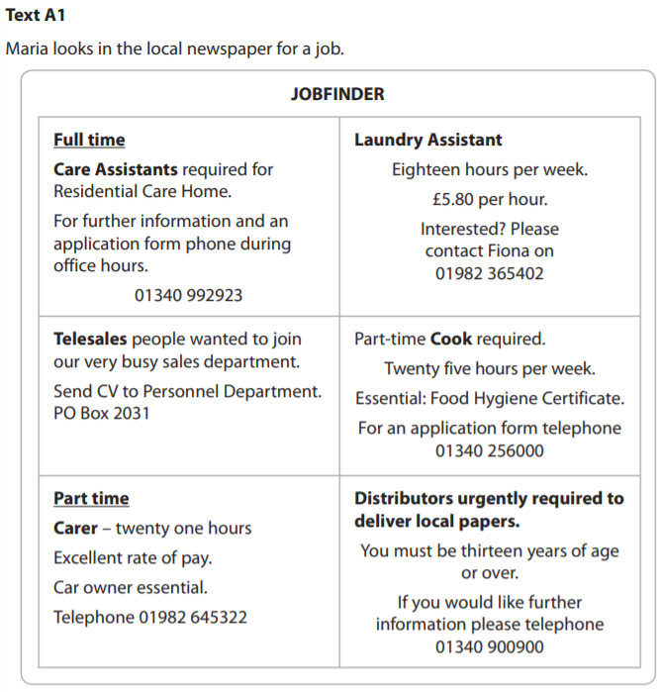

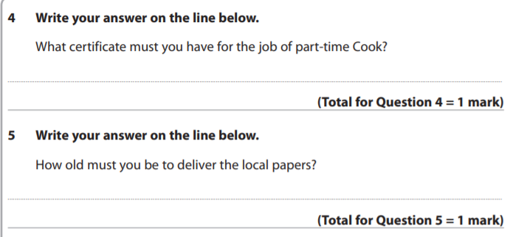
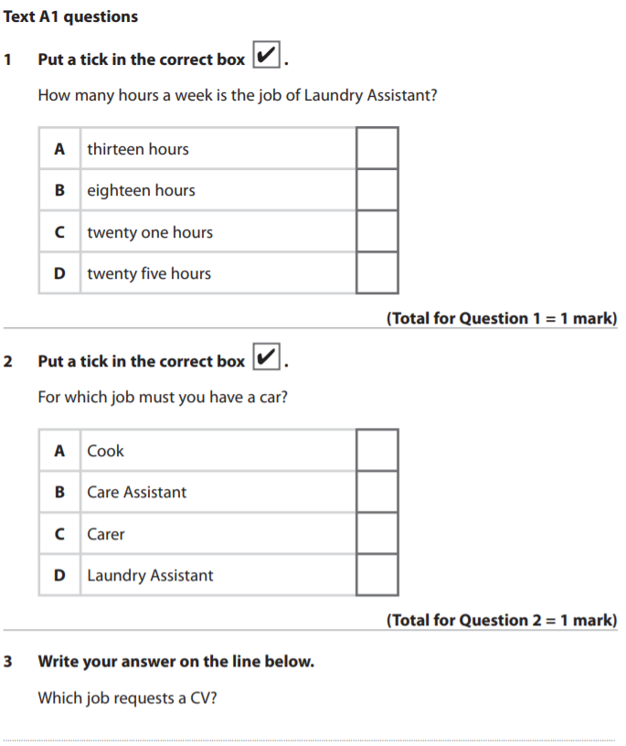
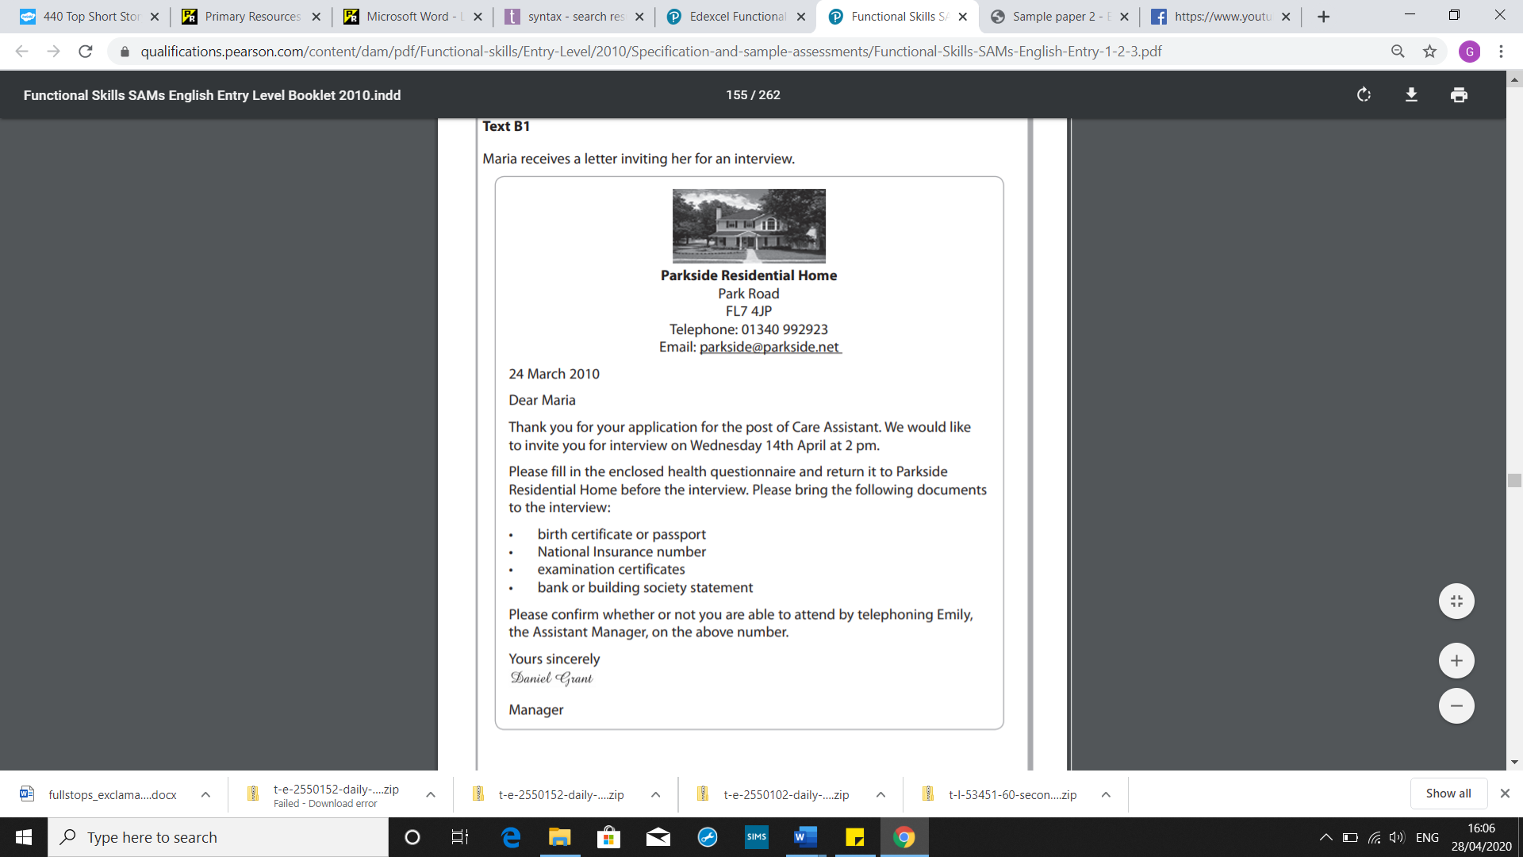
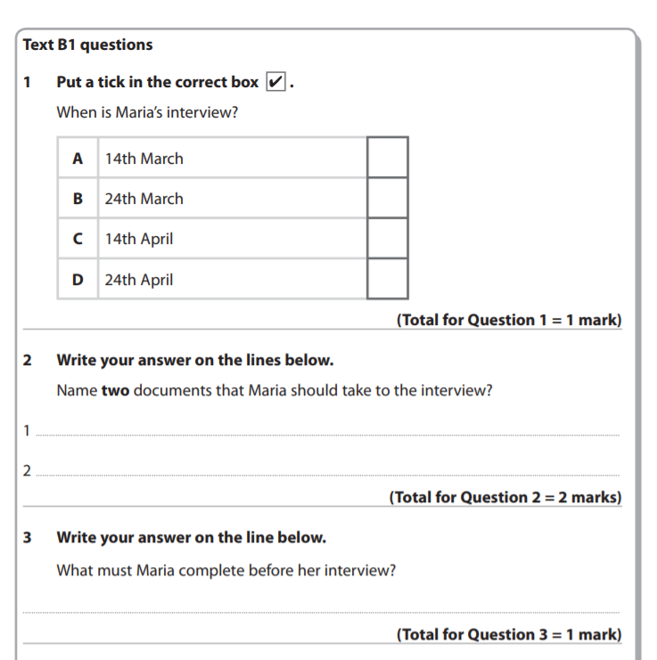
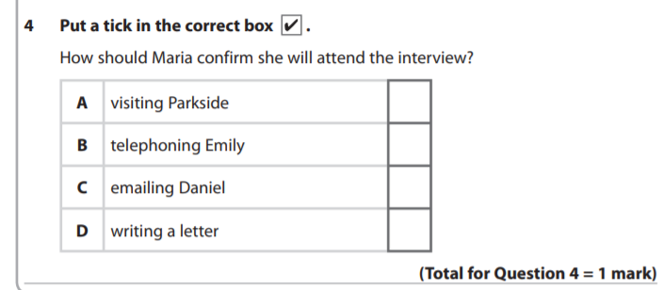
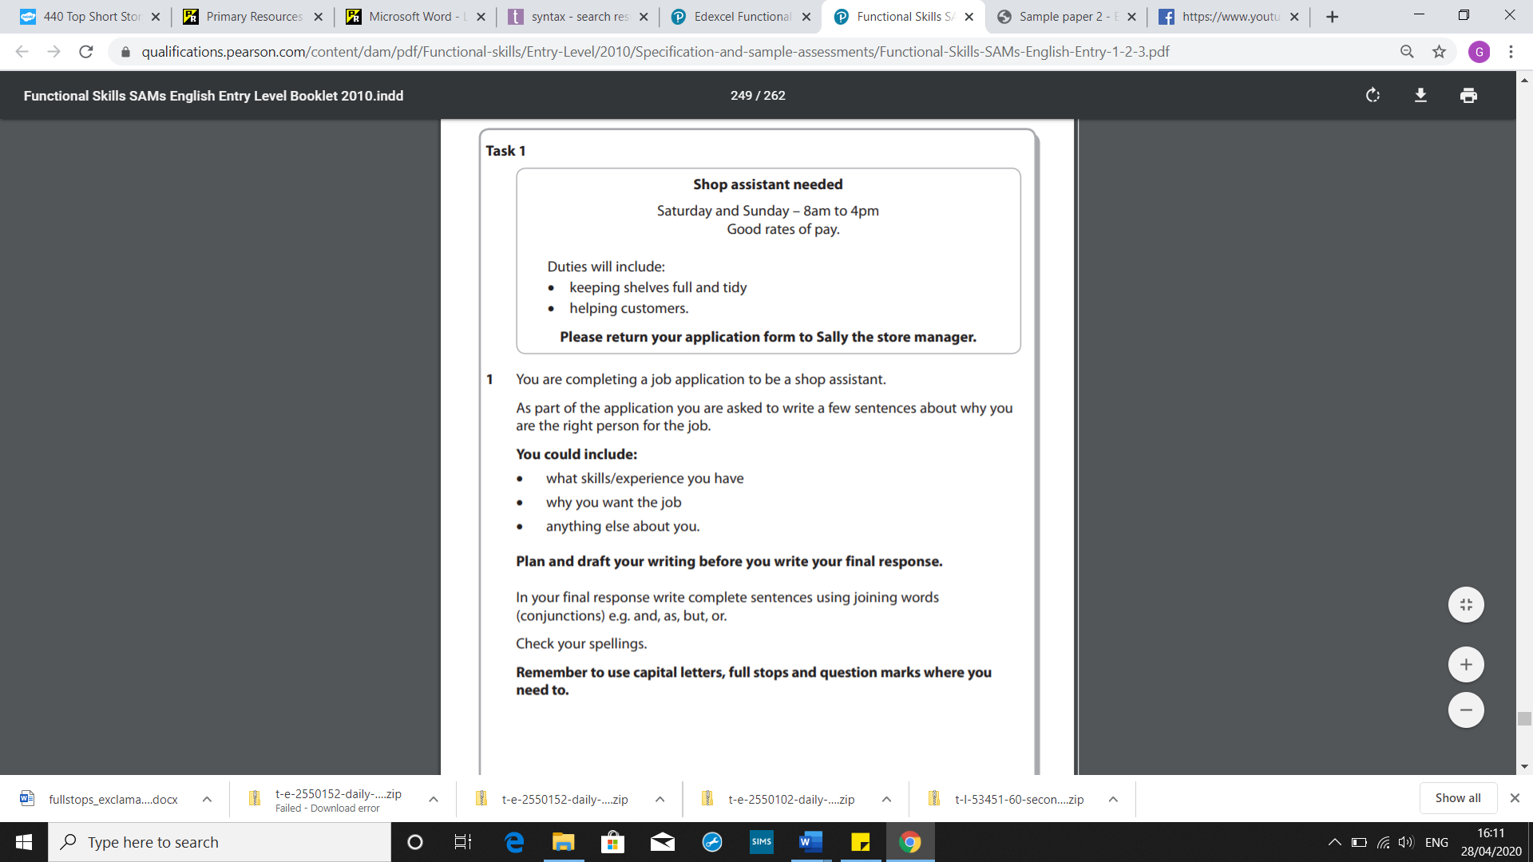
Writing



