
KS4

Fern House Literacy work pack 5
- Functional skills punctuation
- Functional skills
reading and writing
Make sure you are engaging in at least 10 minutes of story sharing every day!
This can be reading with an adult, exploring non-fiction texts, listening to audio books or online readings.

Full stops

- Full stops are used to separate sentences and ideas.
- Place full stops in the highlighted places below and read.
- After each full stop, place a capital letter to start the next sentence.

Tomorrow I am going to visit my Gran sometimes I eat apples in my bathroom is a big bath dogs are big or small hamsters eat seeds in my kitchen is a microwave

Add 10 full stops in the correct place.
The capital letters will help show the beginnings of each sentence.

After the bell rang the children went into the classroom They could not see the teacher In the cupboard there was a new box of pens Under the table was a rubber and a ruler Near the window was a hot mug of coffee In the biscuit tin was a new packet of chocolate biscuits The class hamster was in the cage The teacher came in He asked the children to sit down The lesson was all about dinosaurs

Where do the sentences start and end?
Add the full stops and capital letters.

Mrs Red has a cat smelly socks are not nice people are sometimes happy my foot is hurting the sheep is white and woolly crocodiles have lots of sharp teeth shoes sometimes have laces birds have a beak before assembly I read my book it is sunny today tomorrow it is Tuesday at the seaside I eat ice cream

Full-Stops, Exclamation Marks & Question Marks
Rewrite the following sentences with a full-stop (.), exclamation mark (!) or question mark (?).

- “Look out ()” shouted James to his brother ()

- “Would you like some cheese with your spaghetti ()” asked Tim’s mum ()

- The party was a success , everybody enjoyed themselves()

- “Do you know the time()” asked the teacher()

- It’s important that you always end a sentence with a full-stop ()

- “Ouch()” screamed Charlotte ()


Read the advert:

The Ship Café Tel: 05127 747 212
Morning Coffee All day snacks Lunch Evening meals

We serve meals and snacks everyday from 10 o’clock in the morning until 10 o’clock in the evening. Our prices are the best in town and the food is fresh every day. We have a special daily menu and meals for children under 12 are half price on Wednesdays and Thursdays.
You can eat inside or outside and watch the boats sail by on the river as you eat.

We welcome people of all ages, so bring your family and friends. There is a play area for children inside. Outside there is a garden and a stimulating play area for children of all ages. Sorry no dogs allowed.
To book a table
We are very busy at the weekend. To make sure there is a table for you, please book. When booking you will need to give your name, the date you want to book and the time you want the table.

Answer the questions about the advert.
1. List 2 reasons why this is a good place to take children.
2. Give two days when lunch is cheaper for children.
3. Give 1 reason why people need to book a table for the weekend.
4. Give three pieces of information you need to give to book a table.
5. Can you bring dogs to the café?

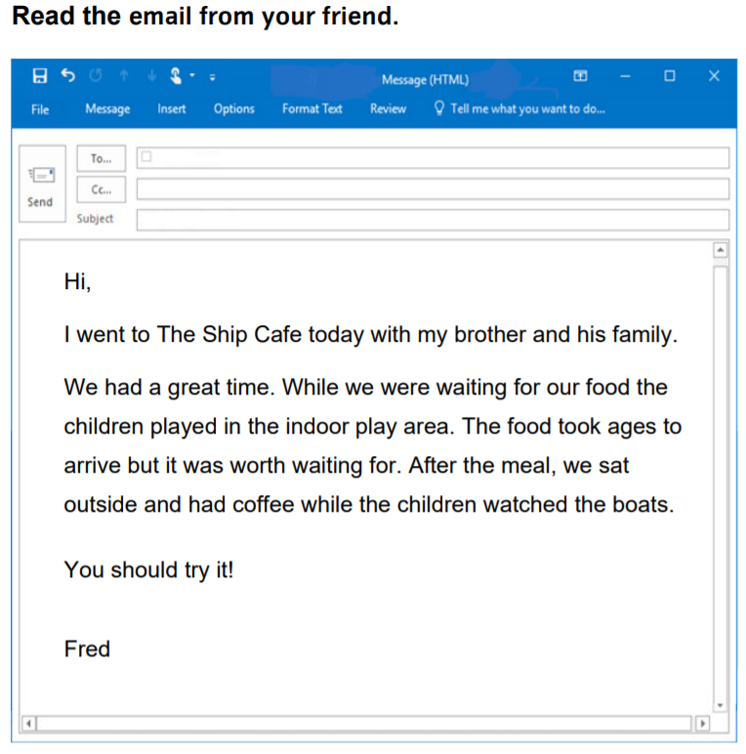

6. Who did Fred go to the café with?
7. What did the children do while Fred and his friends waited for the food?
8. What did the adults do after the meal?
Writing Task 1
You want to meet your friend for lunch. Write a text message to
• say you want to meet for lunch and why
• say where you want to meet for lunch
• say when you want to meet.

You must write at least 5 complete sentences.
You must use joining words (conjunctions) and, as, but, or
You must plan your ideas first.
Check your spelling, capital letters, full stops and question marks.

Writing Task 2
After lunch you complete a comments card. Write about:
• the meal • the staff • the restaurant.

You must write at least 5 complete sentences.
You must use joining words (conjunctions) and, as, but, or
You must plan your ideas first.
Check your spelling, capital letters, full stops and question marks.


