
KS4

Fern House Literacy work pack 4
- Functional skills syntax
- Functional skills
reading and writing
Make sure you are engaging in at least 10 minutes of story sharing every day!
This can be reading with an adult, exploring non-fiction texts, listening to audio books or online readings.

Syntax: Reorder the sentences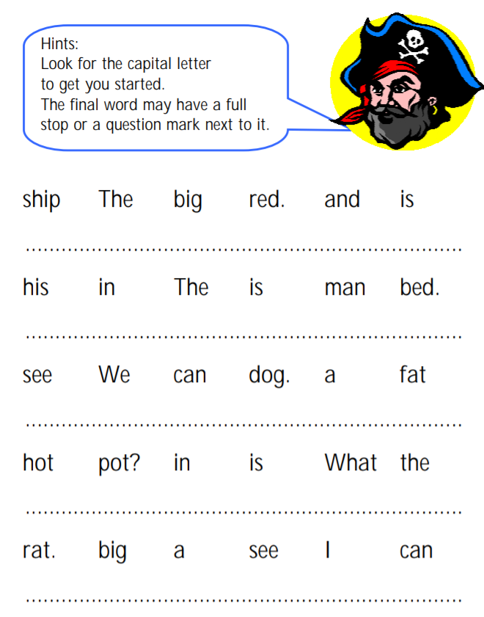
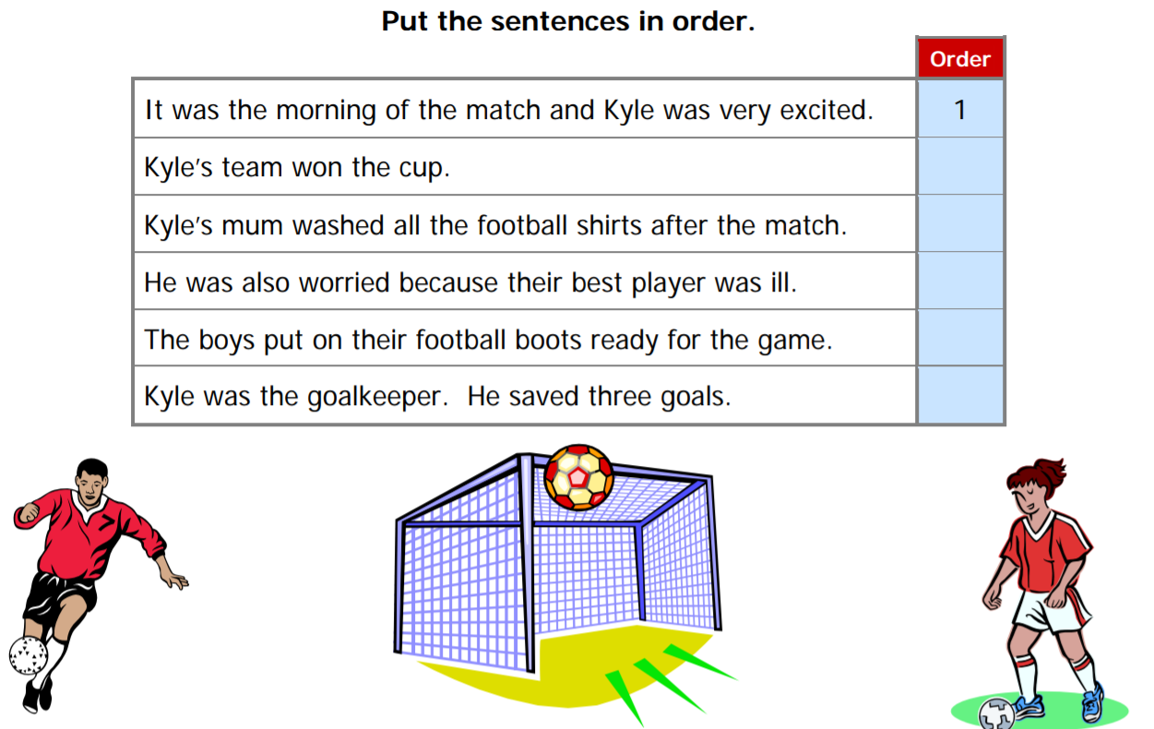

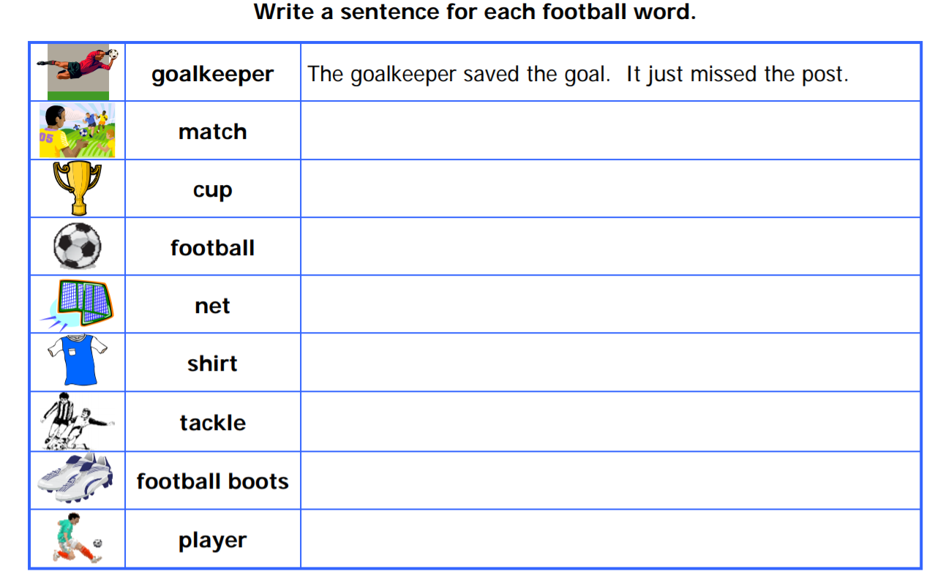

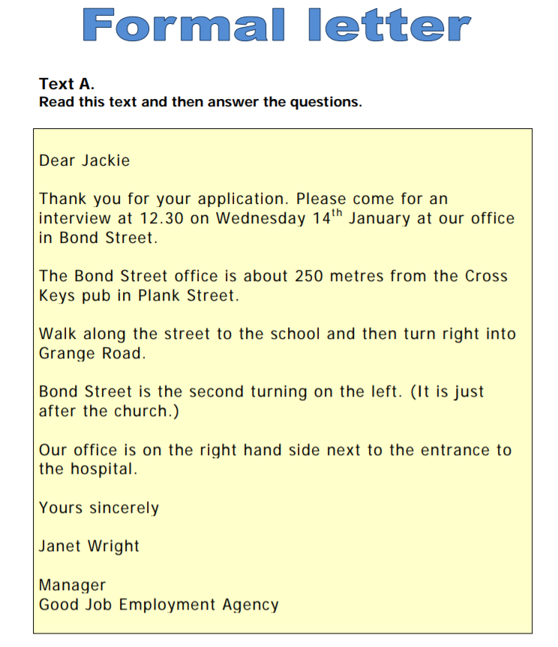

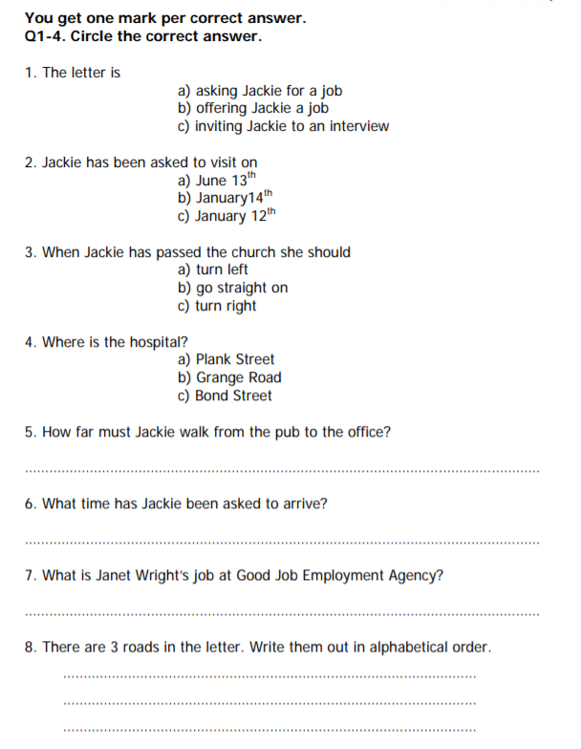
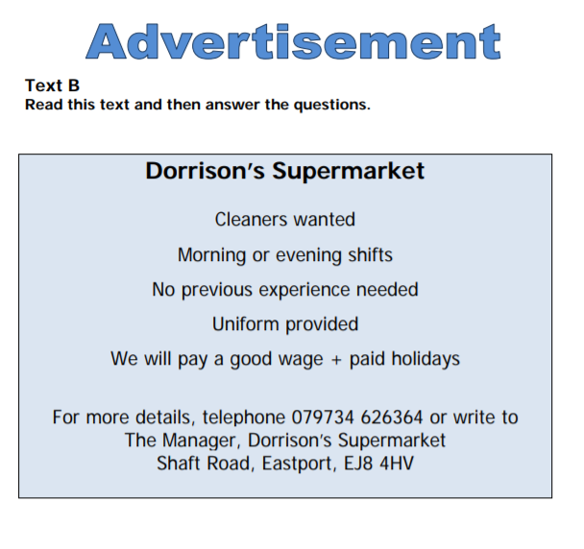

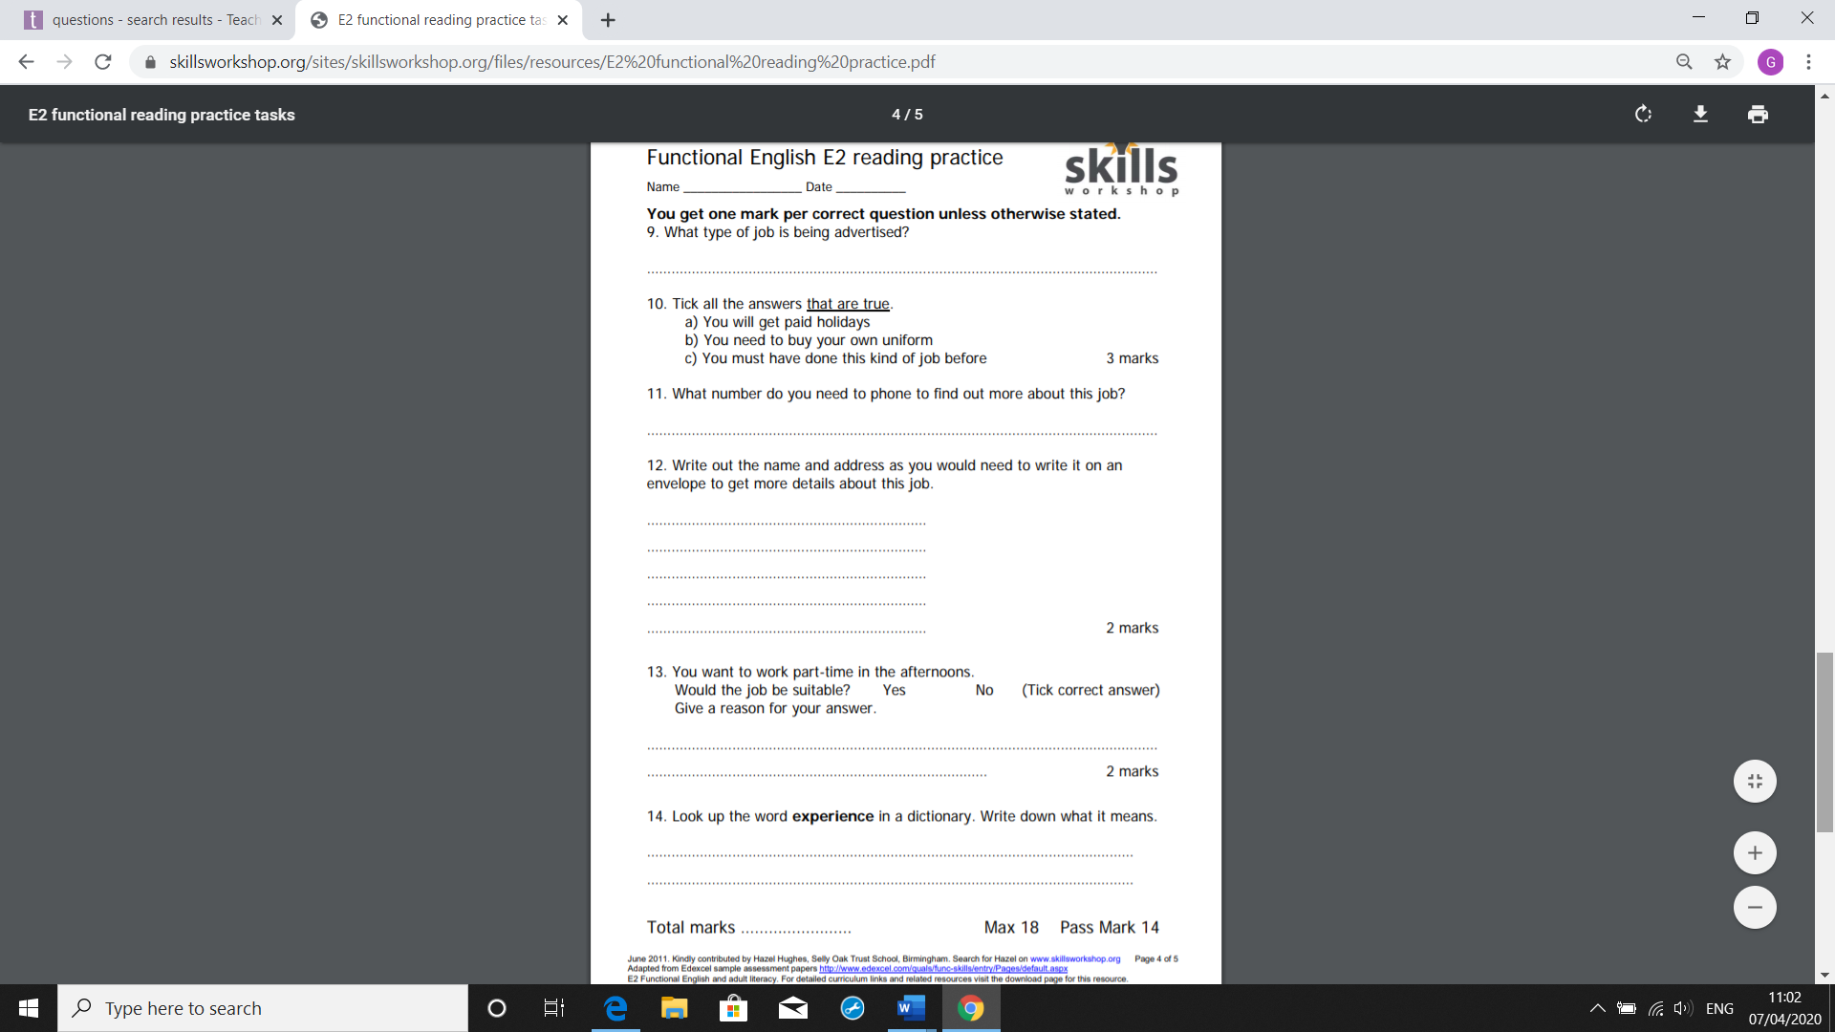
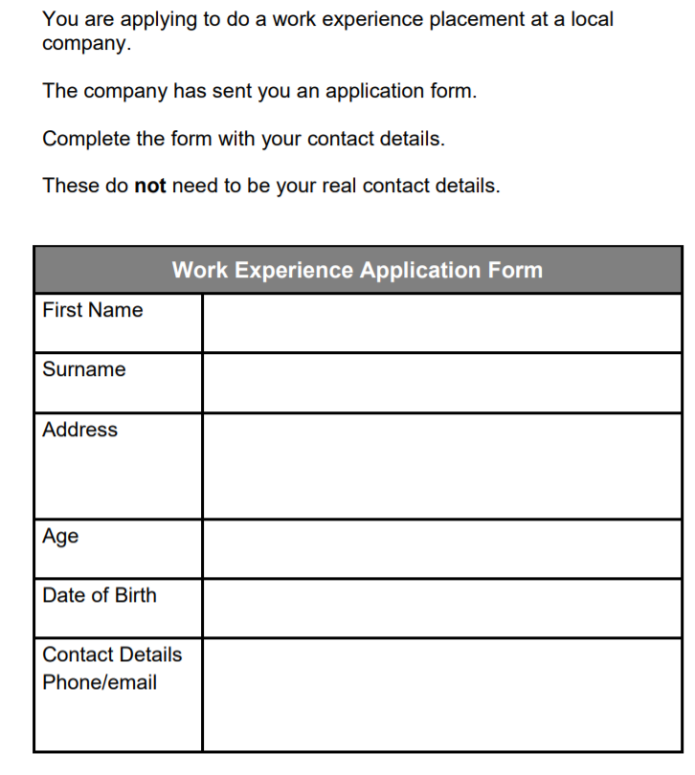
Writing Functional Skills

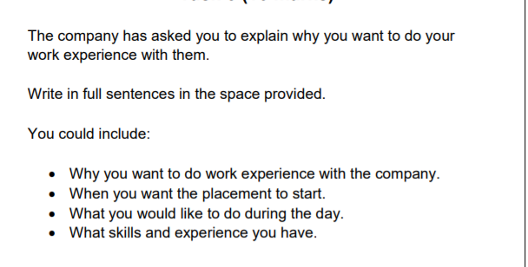

Top tips:
- Think of the name of the company you want to work for; is it a school/ shop/ mechanics?

- Remember to use full stops, capital letters and conjunctions . (and, but , so)

- Start your letter with To the Manager of (company name)

- You may want to plan and create a draft first.

