
KS4

Fern House Literacy work pack 3
- Functional skills spelling
- Functional skills
reading and writing
Make sure you are engaging in at least 10 minutes of story sharing every day!
This can be reading with an adult, exploring non-fiction texts, listening to audio books or online readings.

Spelling: Adding -ing
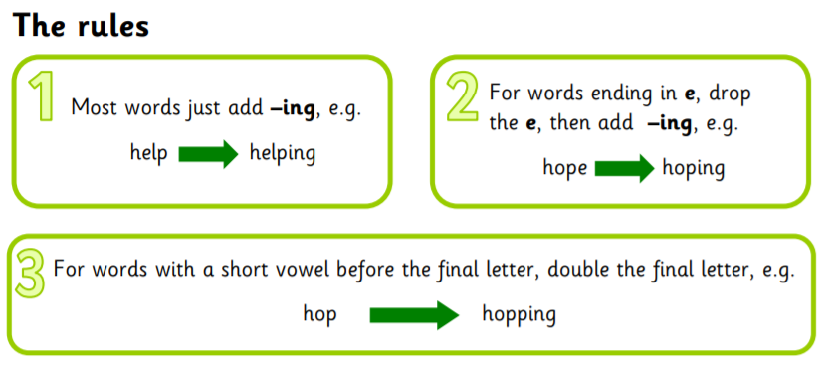
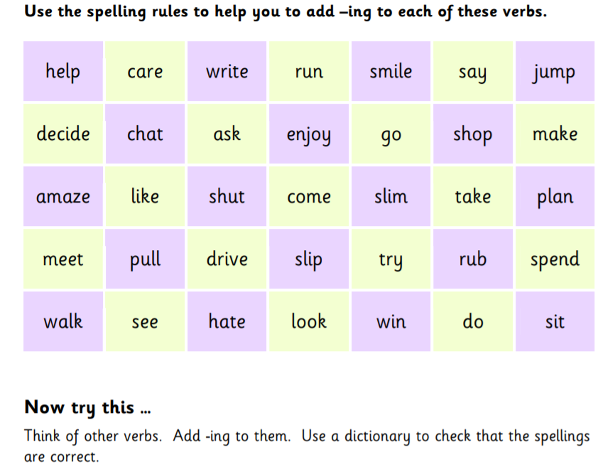
High Frequency Word Revision
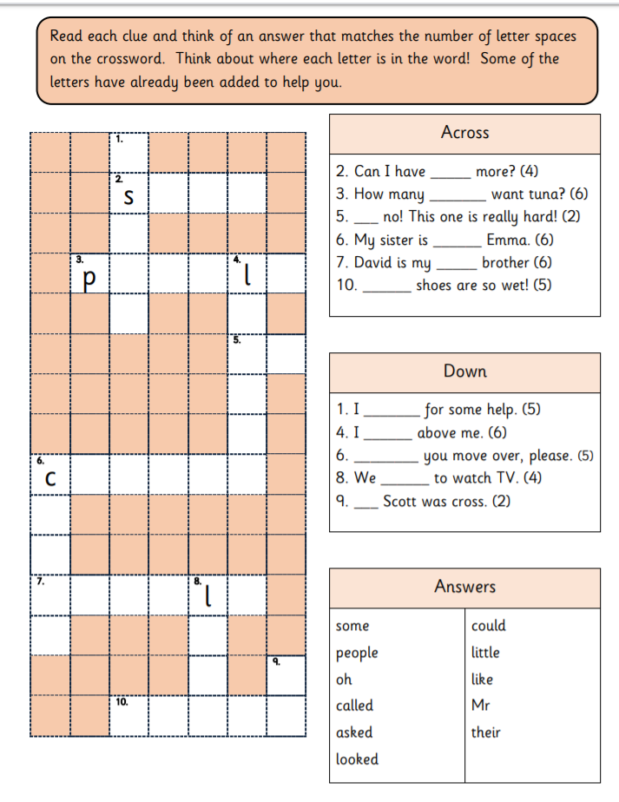

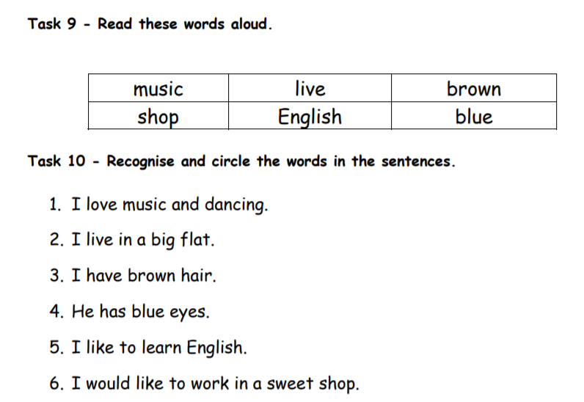
Spelling and word recognition
A

B

C
Create your own sentence for each of the words above.

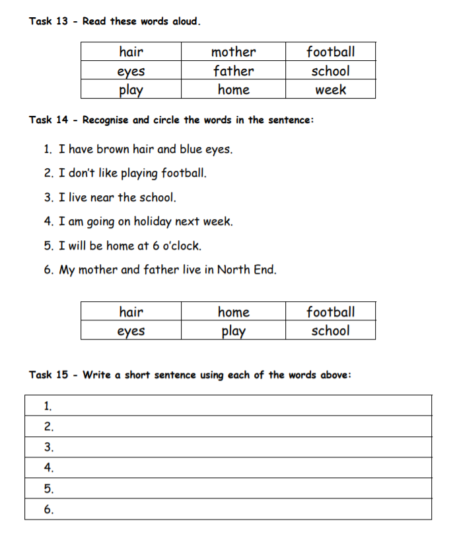
D
Functional skills reading and writing
F
E
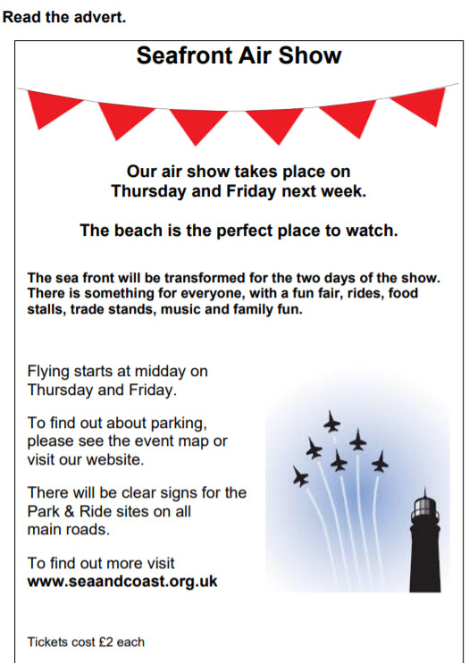
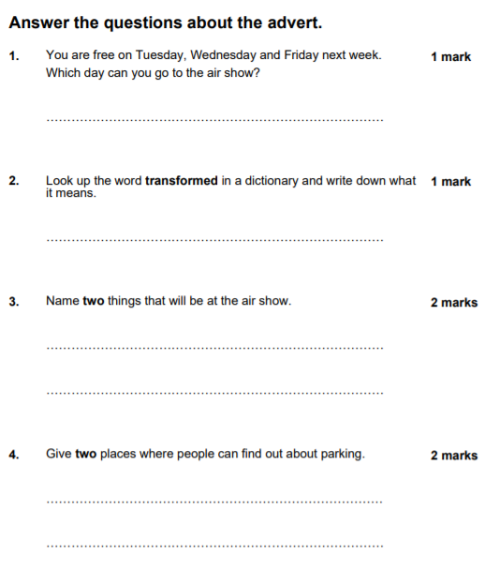

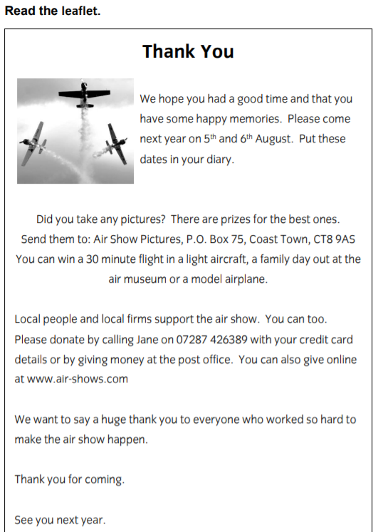

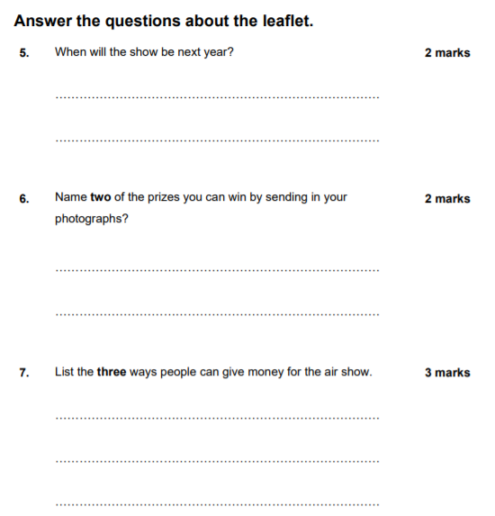

Writing task

You want to go to the air show next year on the 5th August.
You are going to write an email to friend inviting them to come with you.


You must include-
- Why you are writing
- When the Air Show is
- Where the Air Show is
- What you can both enjoy and see there

Top tips:
- Remember to use full stops, capital letters and conjunctions . (and, but , so)

- Start your email with Dear ____ ( put your friend’s name)

- You may want to plan and create a draft first.

