
KS4

Fern House Literacy work pack 2
- Functional skills spelling
- Functional skills
reading and writing
Make sure you are engaging in at least 10 minutes of story sharing every day!
This can be reading with an adult, exploring non-fiction texts, listening to audio books or online readings.

Commonly Confused Words 1

where 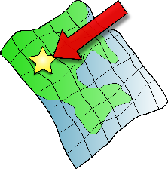 wear  were  we’re 
(we are)

Complete these sentences using the correct words.
1. Where are you going?
2. Do you know what we’re doing today?
3. Please can I wear your coat?
4. We were going to go swimming but it was closed.

5. That is _________ I used to live.
6. The children _________ very tired after their day out.
7. I like to _________ red shoes.
8. Hurry up, _________ going to be late.
9. She will always __________ her hair in pigtails.
10. _____________very excited.
11. Do you know ___________ I can find the dinner hall?
12. I am going to __________my new shoes.
13. The children ____________very well behaved on the school trip.
14. I wonder ______________this path will take us.
15. ______________leaving in ten minutes.
Commonly Confused Words 2

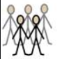
there  their  they’re
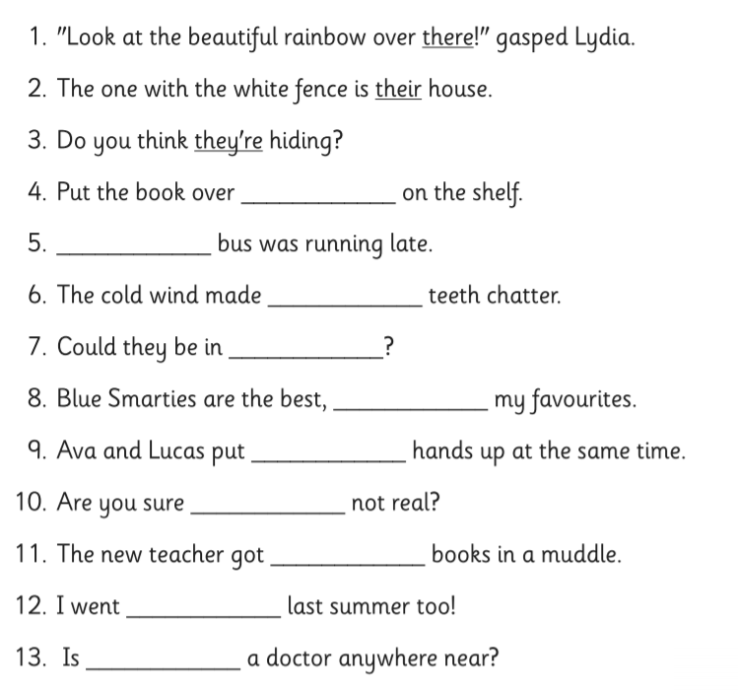

Functional skills reading
Read text 1 and then answer the questions that follow:

Bankton Park

My name is Elena. I live in Bankton. There is a park near my house. It is big. It has got a café. There are some trees and a lot of flowers there.
My friend is Marta. I meet Marta in the café in the park. She brings her baby, Sara. I drink coffee. Marta doesn’t like coffee. She has a cup of tea. Sara doesn’t drink tea. She drinks milk.
My husband’s name is Toni. He rides his bicycle in the park. My son is Juan. He plays basketball there. My daughter is Laura. She plays tennis in the park. We love the park.

Read with an adult if you need help. You might need a coloured pen or highlighter to locate answers.

- The does the title say the text is about
A Elena
B a park
C Bankton

- The writer of this text is
A Marta
B Toni
C Elena

- Which sentence is correct?
A Marta has got a baby.
B Marta doesn’t like tea.
C Marta meets Juan in the café.

- Match the correct activity to the person:

Laura
Juan
Sara
Toni
A drinks milk
B plays tennis
C plays basketball
D rides a bike

Functional skills reading
Read texts A-E and then answer the questions that follow:
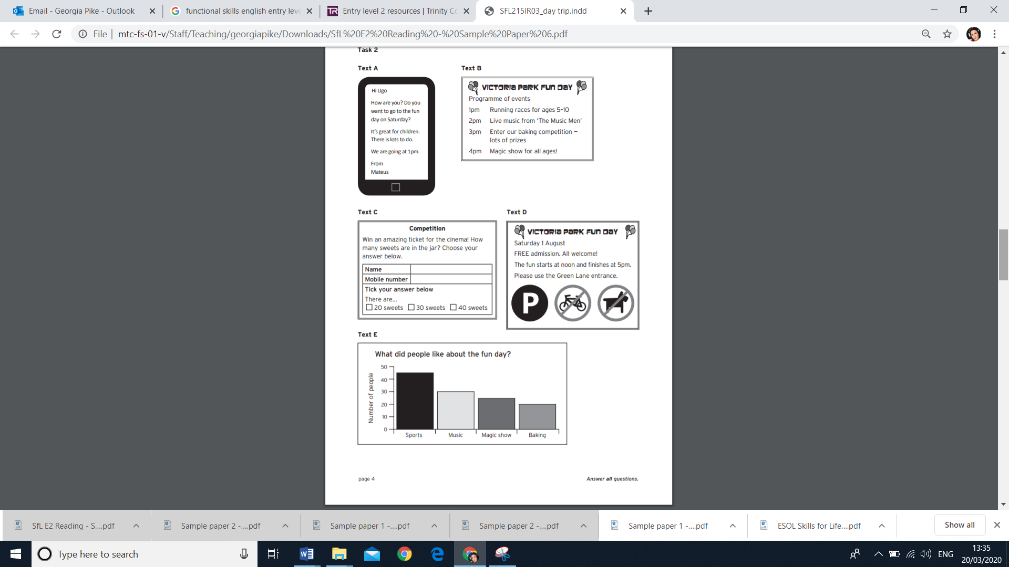

Which text from A- D shows: (circle the correct letter)
1. the start times of different events A B C D E
2. which activity people like best A B C D E
3. an invitation a friend A B C D E

- Which sentence is correct for text B?
A The races are from 5pm to 10pm.
B The baking competition starts at 3pm.
C ‘The Music Men’ are going to play all afternoon.

- In text C, the prize for the competition is
A some sweets
B a mobile phone
C a cinema ticket

- Mateus thinks there are 40 sweets in the jar. How does he complete the form in text C?
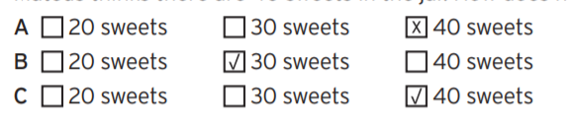

- In text D, Victoria Park allows
A cars
B dogs
C bikes

- In text E, what activity did people like more than music?
A Magic show
B Baking
C Sports

- How many people chose baking?
A twenty
B thirty
C forty
Functional Skills Writing

Jade and Simon want to know what activities people like to do for an after school club.
On the next page answer the questions that are shown below.

What do you like to do?

What activities do you like to do?
Do you spend any time outside?
Do you spend most of your time inside or outside?
Please put your name on your reply.

Thanks
Jade & Simon

Write in sentences.
Use full stops where they are needed. Check your spelling.

What I like to do
Hi Jade & Simon
______________________________________________
______________________________________________
______________________________________________
______________________________________________
______________________________________________
______________________________________________
______________________________________________
______________________________________________
______________________________________________
______________________________________________
From:

