
KS4/5

Mrs Ferro’s Literacy work pack 1
- Functional skills spelling
- Functional skills
reading and writing
Make sure you are engaging in at least 10 minutes of story sharing every day!
This can be reading with an adult, exploring non-fiction texts, listening to audio books or online readings.
Homophones are words which sound the same but are spelt differently and have different meanings. Match the pictures to the words.

1  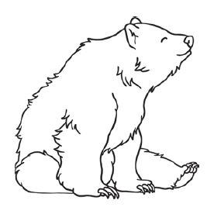 | 2  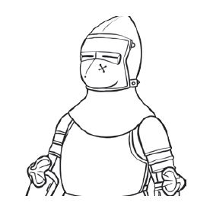 | 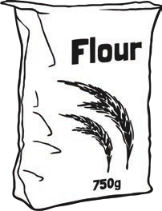  3 | 4  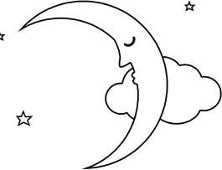
5  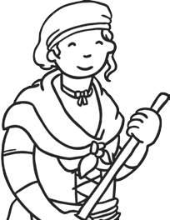 | 6  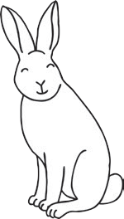 | 7  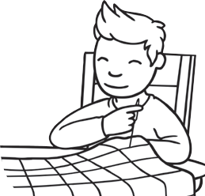 | 8  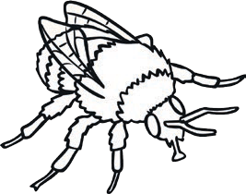
9  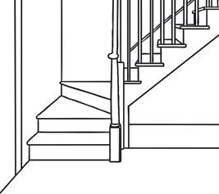 | 10  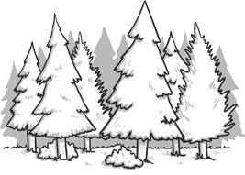 | 11  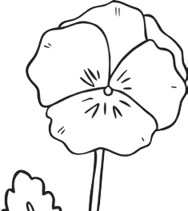 | 12  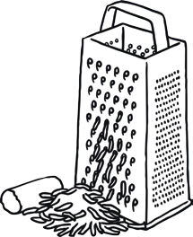

 | bare |  | bear |  | maid |  | would
 | wood |  | grate |  | knight |  | hare
 | flower |  | stair |  | night |  | bee
 | sew |  | be |  | so |  | flour
 | great |  | hair |  | made |  | stare

Complete the sentences by neatly crossing out the incorrect homophone.

- Last knight/night I went for a walk in the moonlight.

- Blue/blew is my favourite colour.

- If you want to go on holiday, you’ll have to catch a plane/plain.

- I brush my hare/hair every day.

- The lion had huge paws/pours.

- Thomas couldn’t wait to meat/meet the new teacher.

- Bernard got mud on his new/knew shoes.

- I’m over here/hear!

- Benny’s hiding over they’re/there/their.

- Suzanne scraped her knee and now it’s really saw/sore
These words are all homophones. Try to define what each one means.

sale: sail:

here: hear:

tail: tale:

pail: pale:

pour: poor:

male: mail:

Functional Skills reading and writing

Ask someone in your house what time they would typically do the following activities and record their answers . For example:
A: What time did you wake up yesterday?
B: I woke up at 6:30.

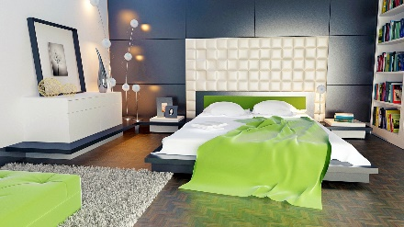  1 | 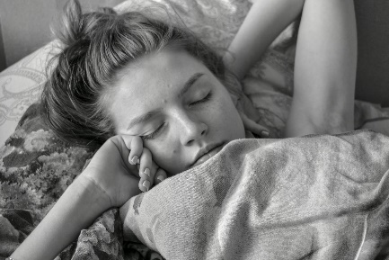  2
  3 | 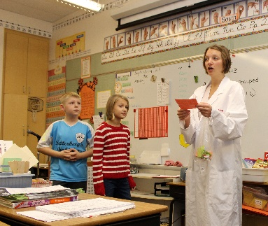  4  Work-
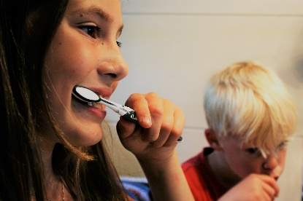  5 | 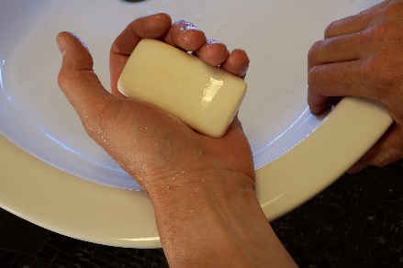  6
7  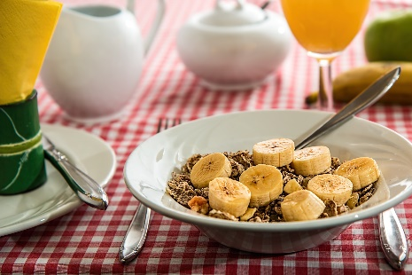 |   8

Swap with someone in your house. Let them ask you what time you would typically do the following activities and answer their questions.
A: What time did you go to bed yesterday?
B: I went to bed at 22:00.

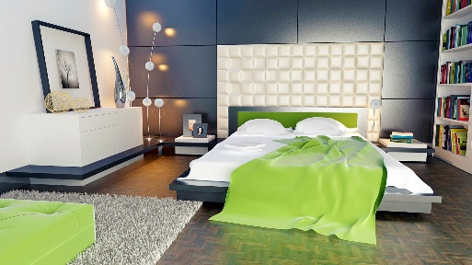  1 | 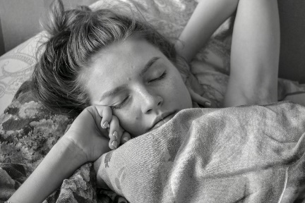  2
  3 | 4 Your choice
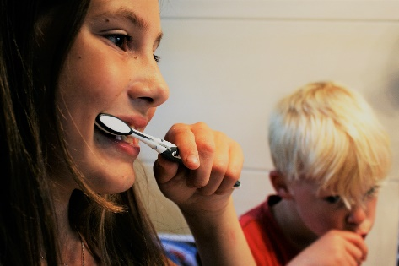  5 | 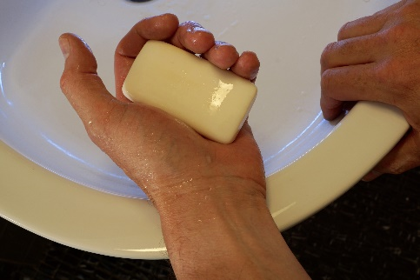  6
7  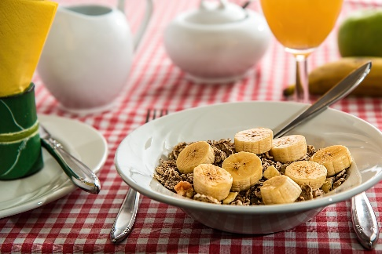 |   8
Now write a full sentence giving the times you did the following activities yesterday:
woke up | had your breakfast | went to school | had a wash
went to bed | went on the computer | cleaned your teeth | had dinner

1 I woke up at 7.30.

2 I had my breakfast ______________________________

3 I _________________________________________

4 __________________________________________

5 ___________________________________________

6 ___________________________________________

7 ___________________________________________

8 ___________________________________________

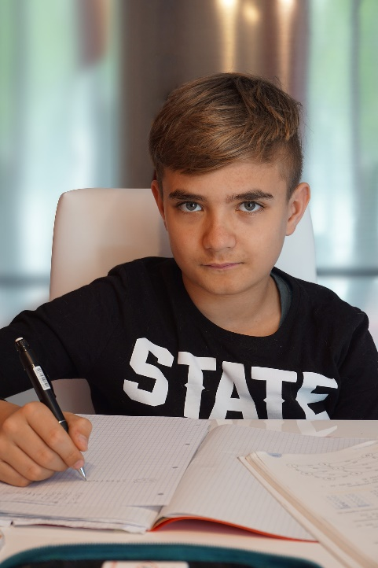
Extract from John’s diary
Monday 6th November
This morning I got up early, at seven o’clock, and I had tea and toast for breakfast. I arrived at school at half past eight. I had P.E. first lesson, which I really enjoy because I like sport.
At lunchtime I went to the canteen and I talked to my friends. I had a small pizza and some hot chips. In the afternoon I had History, which I found difficult to understand as the teacher talks very quickly however my friend helped me out by explaining what I should do!
After school I went to the park with my friends until half past five and then we went home. After tea I watched television but I was really tired so I decided to go to bed early.

Activity
- Read John’s diary
- Underline all the past tense verbs in red
- Underline all the time connectives in blue
- Underline all the adjectives in green

Writing your own diary – some ideas…
- Think about the sentence you want to write, say it out loud and then write it down
- Describe what you have done in the day
- Write about what you have enjoyed and why
- Describe what you have found difficult and why
- Draw pictures

Diary writing frame
Date: ____________________
Dear Diary,
Today was…

3rd paragraph (in the afternoon)
After lunch I…

1st paragraph (before school)
This morning I…

2nd paragraph (in the morning)
Later I…

4th paragraph- (in the evening)
Finally I…

