Contents
Working with Ratio 2
Working with Formulae 4
Working with Averages 4
Working with Area and Volume 5
Circumferences 7
Angles in Parallel Lines 7
Pythagoras’ Theorem 8
Volume 9
Simultaneous Equations 11
Similar Shapes 12

Working with Ratio
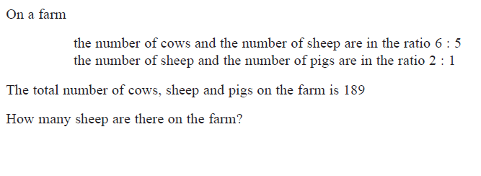

__________________________________________________________________________
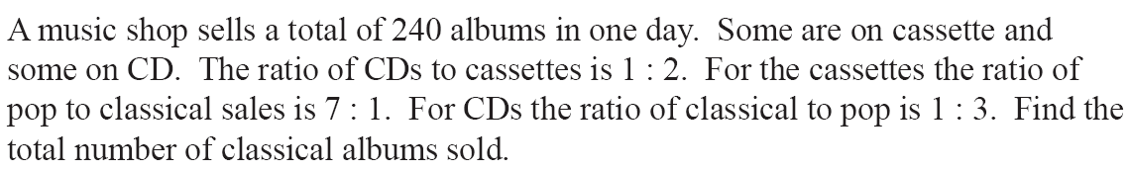

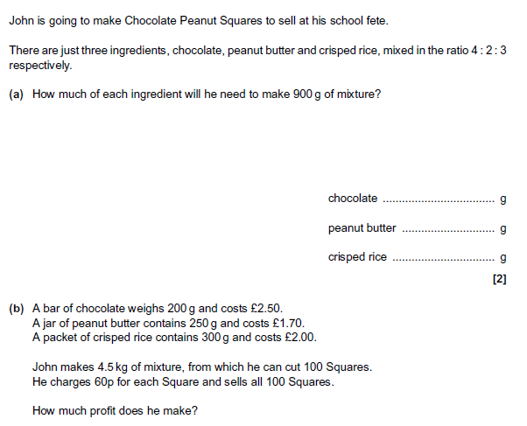

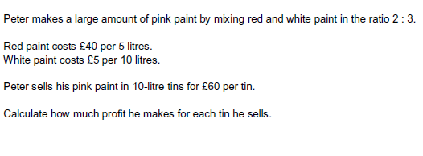__________________________________________________________________________

In a company, the ratio of the number of men to the number of women is 3 : 2

40% of the men are under the age of 25
10% of the women are under the age of 25

What percentage of all the people in the company are under the age of 25?

…………………..%
__________________________________________________________________________

Working with Formulae
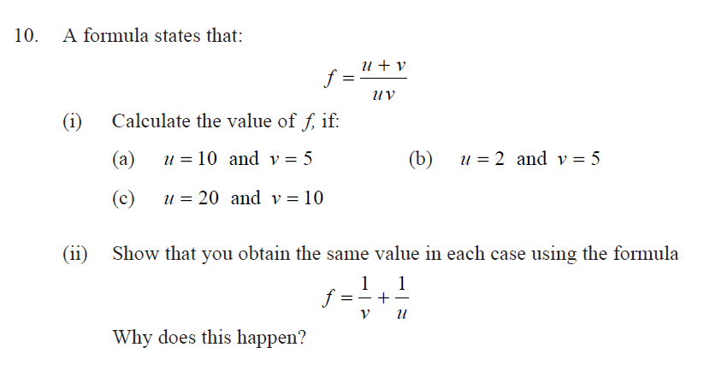

Working with Averages

- The grouped frequency table shows information about the number of hours worked by each of 210 headteachers in one week.
a) Calculate an estimate of the mean.
b) Which class does the median lie in?
c) State the modal class.
Number of hours  worked (t) | Frequency
0< t ≤ 30 | 0
30< t ≤ 40 | 4
40< t ≤ 50 | 18
50< t ≤ 60 | 74
60< t ≤ 70 | 79
70< t ≤ 80 | 35

Francesca says that the mean is unreliable as an average here, do you agree?

Melanie did a survey to record the number of pets her classmates had in their household.
Number of pets | 0 | 1 | 2 | 3 | 4 | 5 | 6 | 7 | 8 | 9
Number of households | 3 | 7 | 4 | 6 | 5 | 2 | 2 | 1 | 3 | 3

- Stephen says that the average number of pets per household is 1. Explain how he reached this conclusion and demonstrate why this might be unreliable.
- Joanna then states that she has not been included in the survey. She counts each of her fish individually as a pet. The mean number of pets per household is now 4.54. Calculate the new range.

Working with Area and Volume

Cylinder A and cylinder B are mathematically similar.
The length of cylinder A is 4 cm and the length of cylinder B is 6 cm.
The volume of cylinder A is 80 cm3.
Calculate the volume of cylinder B.

………………………… cm3

Diagram NOT accurately drawn
Two prisms, A and B, are mathematically similar. The volume of prism A is 12 000 cm3. The volume of prism B is 49 152 cm3. The total surface area of prism B is 9728 cm2.
Calculate the total surface area of prism
............................... cm2

Circumferences
Find the perimeters of the shapes below.
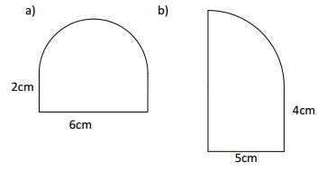

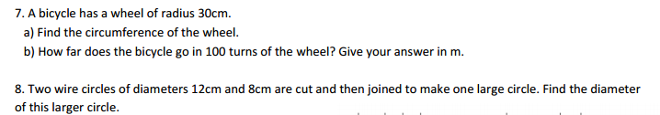

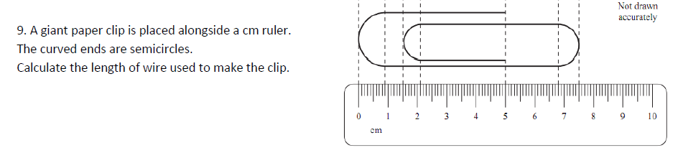

Angles in Parallel Lines
Find the missing angles:
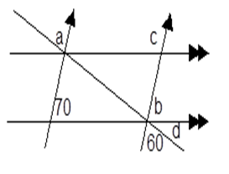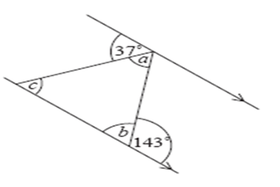
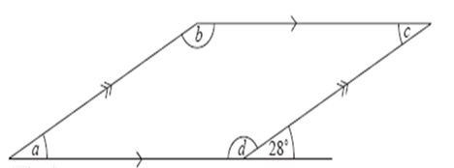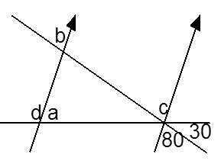

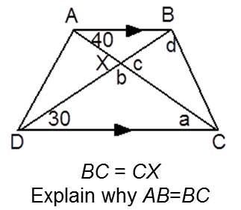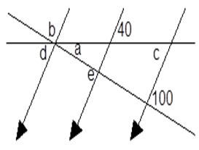

Pythagoras’ Theorem
- To wash a window that is 8 metres off the ground, Ben leans a 10 metre ladder against the side of the building. To reach the window, how far from the building should Ben place the base of the ladder?

- A rectangular swimming pool is 21 metres wide and 50 metres long. Calculate the length of the diagonal to 1 decimal place.

- Miss Barker is teaching a 5th grade class. She is standing 12 feet in front of Jim. Francisco is sitting 5 feet to Jim’s right. How far apart are Miss Barker and Francisco?

- A triangle has sides with lengths of 10 metres, 16 metres and 20 metres. Is it a right angled triangle? Explain your reasoning.

- Find the length of the diagonal of a square of side 4cm to 2 decimal places.

Volume
CHALLENGE
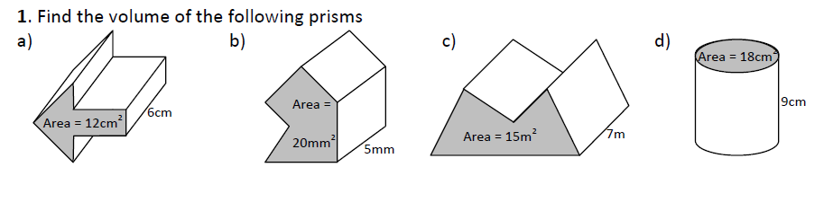
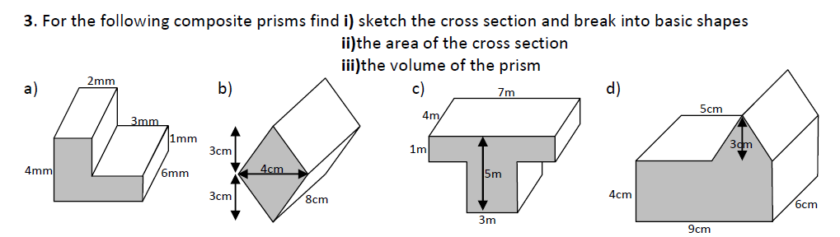

18 cm
5 cm
6 cm
14 cm

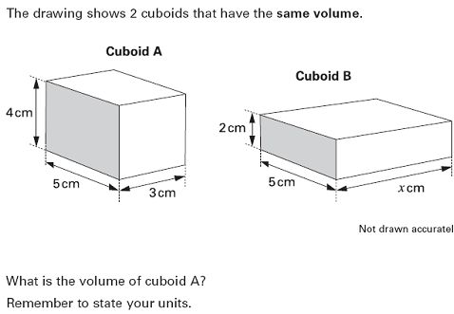

Simultaneous Equations
Find the values of X and Y

g) |  | h)

Similar Shapes
By drawing both triangles separately, work out the missing lengths in these diagrams.
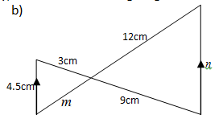
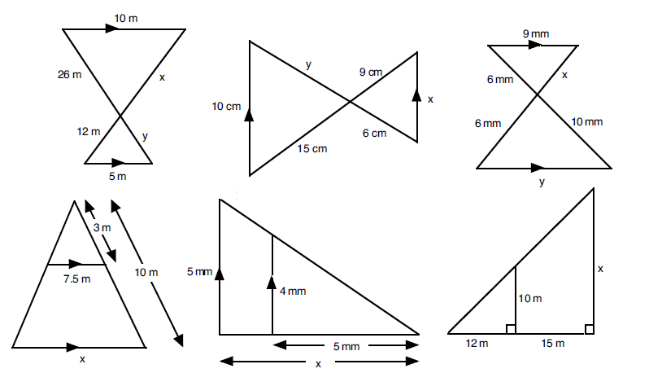

By drawing both triangles separately, work out the missing lengths in these diagrams.

