Contents
Working with Number Operations 2
Working with Ratio 3
Working with Time Series Graphs 4
Forming Expressions 5
Substituting into Formulae 7
Working with Two Way Data Tables 7
Working with Recipes 9
Working with Proportion 10
Working with Frequency Tables 11
Working with Probability 12
Problem Solving with Reverse Operations 13
Working with Algebra in Shapes 15
Inequalities 16
Working with Fractions 18
Increasing and Decreasing with Fractions 19
Working with Volume 20
Dividing into Ratios 21
Factorising 22
Missing Angles Practice 23
Percentages 24
Averages 26

Working with Number Operations
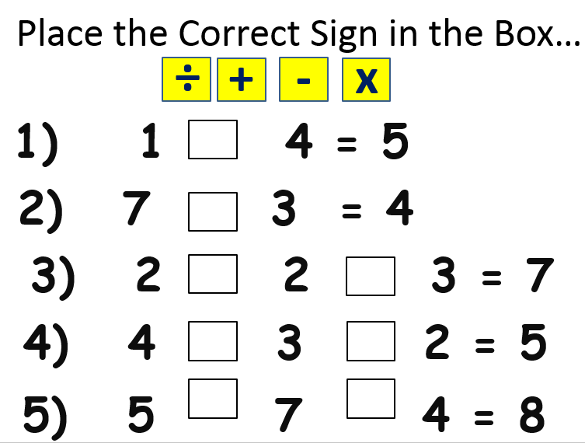

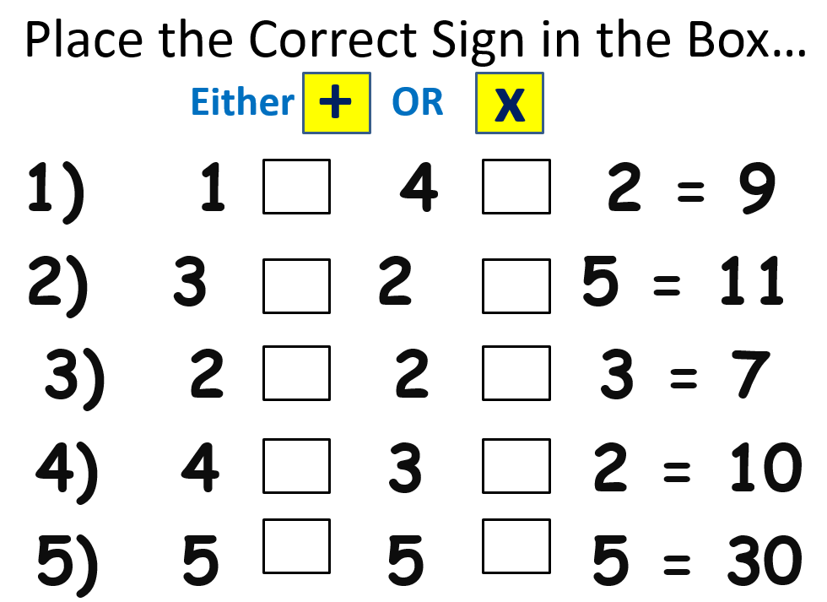

Working with Ratio
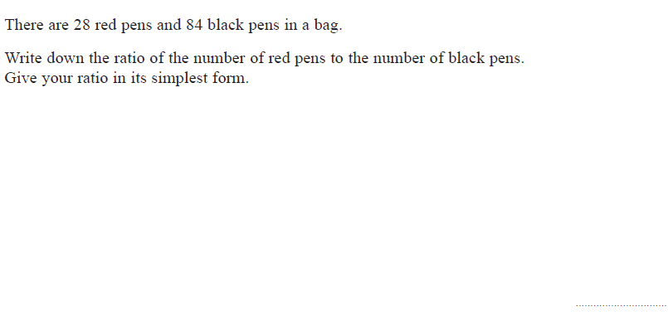

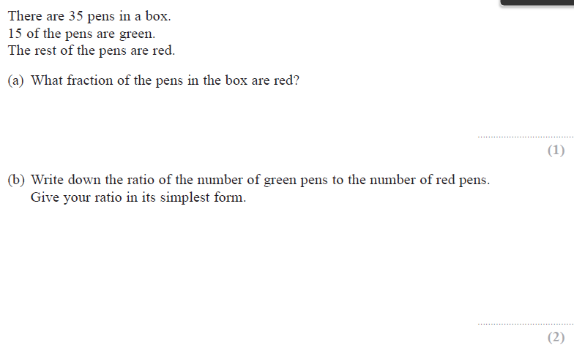

Working with Time Series Graphs
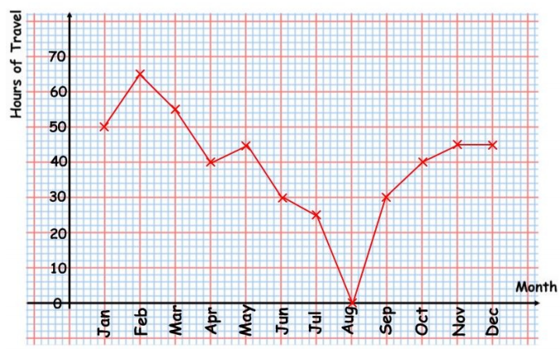
In which month was the highest hours of travel?

In which month was the lowest hours of travel?

What was the difference between the hours of travel in April and in November?

Can you describe what happened to the hours of travel over the year?
………………………………………………………………………………………………………………………………………………………
………….………………………………………………………………………………….………………………………………………………
………………………….………………………………………………………………………………….………………………………………
………………………………………….………………………………………………………………………………….……………………..

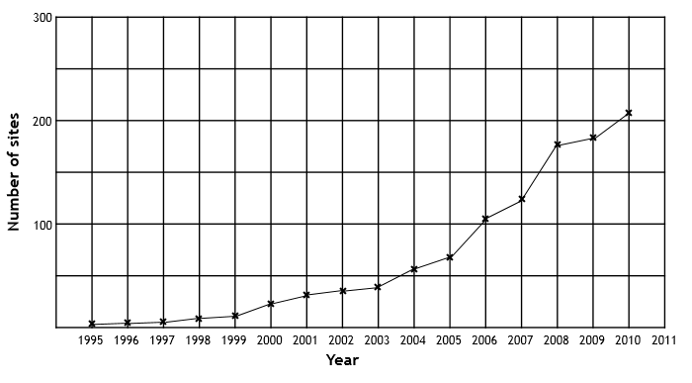
Which was the biggest year for number of sites?

Approximately how many sites were there in 2005?

Between which years did the number of sits go up the most?

Can you describe the pattern on the graph?
………………………………………………………………………………………………………………………………………………………
………….………………………………………………………………………………….………………………………………………………
………………………….………………………………………………………………………………….………………………………………
………………………………………….………………………………………………………………………………….……………………..

Forming Expressions
Can you write an algebraic expression for each of these:
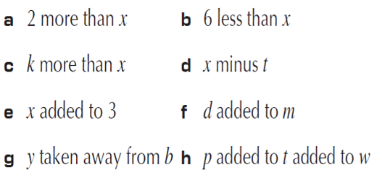
Now try this:
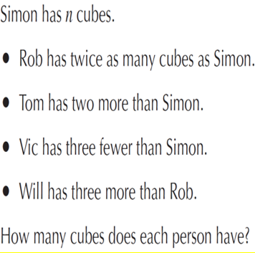

Substituting into Formulae
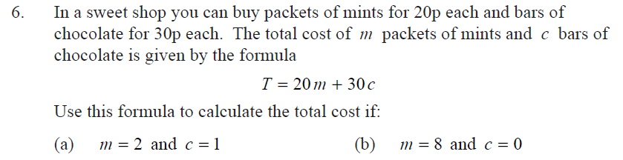

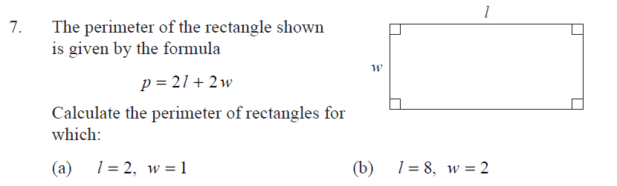

Working with Two Way Data Tables
Bob asked 100 adults which one type of music they enjoyed.
They could choose Jazz or Rock or Classical or Folk music.
The two-way table shows some information about their answers.
 | Jazz | Rock | Classical | Folk | Total
Men | 12 |  | 19 | 4 | 52
Women |  | 23
Total | 21 |  |  | 11 | 100
(a) Complete the two-way table.

(b) How many women did not choose Classical music?

..........................

60 students were born in England, Scotland or Wales.
The two-way table shows some information about these students.
 | England | Scotland | Wales | Total
Female |  |  | 4 | 40
Male |  | 7
Total | 42 | 12 |  | 60
(a) Complete the two-way table.

One of the students is picked at random.
(b) Find the probability that this student is male and not born in England.

.....................................

Working with Recipes
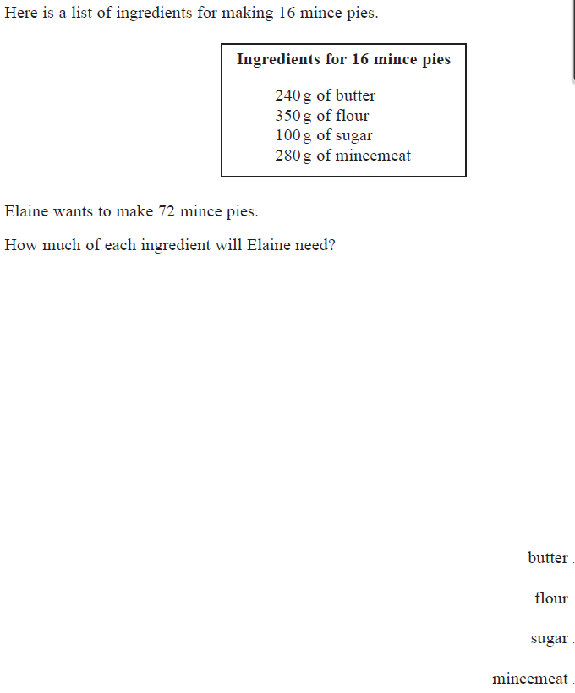

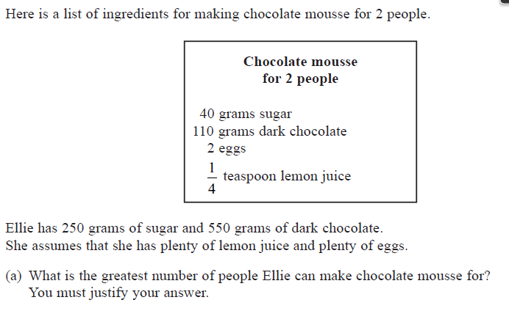

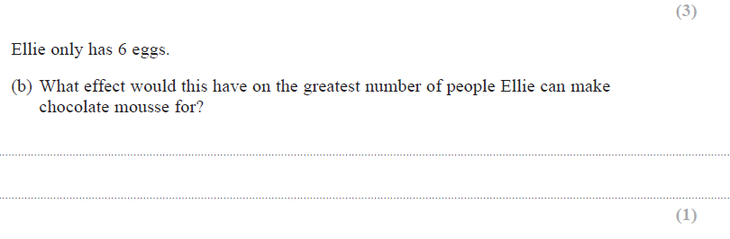

Working with Proportion
7 apples cost £1.40  1 apple costs:  2 apples cost: | 8 footballs cost £32  5 footballs cost: | 9 frisbees cost £4.50  6 frisbees cost:
I jog 4 miles in 30 minutes, how long would it take me to go 6 miles (if I kept up the same pace)? | 5 cakes weigh 155lb, how much would 8 cakes weigh? | A plasterer takes 20 minutes to plaster half a wall, how long would it take him to do 4 walls?

Working with Frequency Tables
Green class wanted to find out which was the most popular pet. They asked a group of people what pets they had. Each person had one pet. The results are shown below.

R = rabbit D = dog F = fish C = cat G = Guinea pig

G D R G C R R G C F
D G F R D C D C G F
G R D C G R G C F R

Pet | Number of people
Rabbit
Dog
Fish
Cat
Guinea Pig

What was the total number of people asked about their pets? __________

What was the most popular pet? ___________

What was the least popular pet? ___________

How many more people had rabbits than fish? ____________

How many more people had guinea pigs than dogs? ____________

Working with Probability
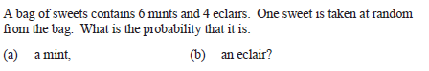

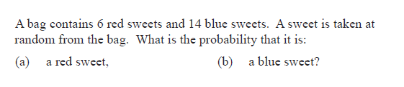

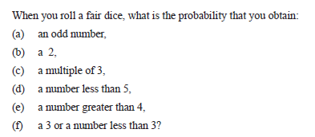

Problem Solving with Reverse Operations

I think of a number. I double it and my answer is 30. What was my number?

I think of a number. I treble it and my answer is 18. What was my number?

I think of a number. I halve it, then add 9 and my answer is 15. What was my number?

I think of a number. I halve it, then take away 4 and my answer is 6. What was my number?

I think of a number. I double it and add 10 and my answer is 14. What was my number?

I think of a number. I add 20, double it and subtract 25. My answer is 75. What was my number?

Working with Algebra in Shapes
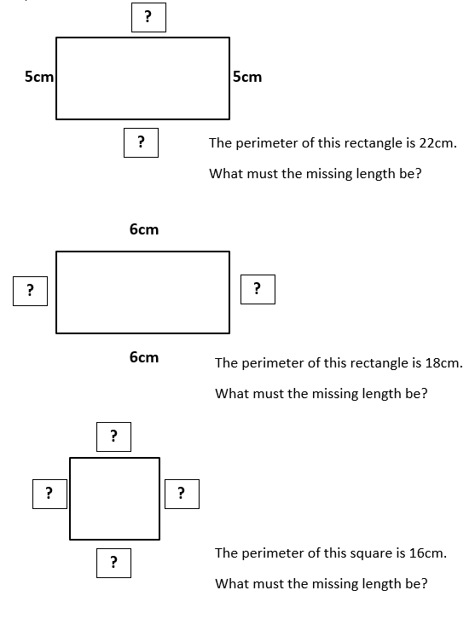

Inequalities
Put the correct sign between these numbers: < or >
<
4 ….... 7

9 ……... 7

1 ……... 7

0.6 ……... 6

9 ……... 11

540 ……... 545

50.5 ……... 49.5

-2 ……... 0

-3 ……... -5

Write down three examples for what number X could be in each of these inequalities. Write one that it can’t be.
X > 3 x could be ……, ……, or …… . It can’t be …….

X < 10 x could be ……, ……, or …… . It can’t be …….

X < 35 x could be ……, ……, or …… . It can’t be …….

X > 3.5 x could be ……, ……, or …… . It can’t be …….

10 > X > 3 x could be ……, ……, or …… . It can’t be …….

19 > X > 12 x could be ……, ……, or …… . It can’t be …….

Working with Fractions
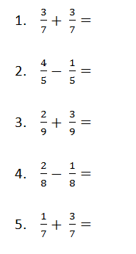
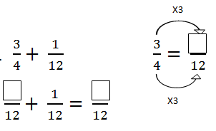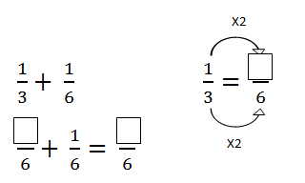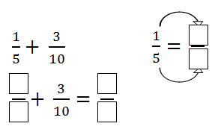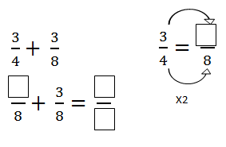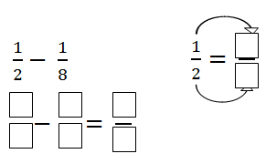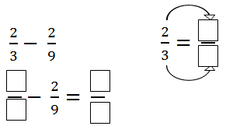

Increasing and Decreasing with Fractions
- Increase 10 by 1/5.
- First find 1/5 of 10 using boxes:

- Then add on the amount of 1 box to 10:
10 increased by 1/5 is ……………..
- Increase 30 by 1/3.
- First find 1/3 of 30 using boxes:

- Then add on the amount of 1 box to 30:
30 increased by 1/3 is ……………..
- Increase 35 by 1/7.
- First find 1/7 of 35:
- Then add on the amount of 1 box to 35:
35 increased by 1/7 is ……………..

- Increase 80 by 1/4.
- First find 1/4 of 80 using boxes:

- Then add on the amount of 1 box to 80:
80 increased by 1/4 is ……………..
- DECREASE 150 by 2/5.
- First find 2/5 of 150 using boxes:

- Then take away the amount of 2 boxes from 150:
150 decreased by 2/5 is ……………..

Working with Volume
Calculate the volume of the following prisms.
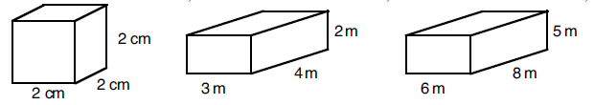
Cross section =

Volume =
Cross section =

Volume =
Cross section =

Volume =

Dividing into Ratios
- Jack and Chloe divide £50 into the ratio 1 : 4
Chloe
Jack

50 split between five boxes. How much goes in each box?
Jack gets £
Chloe gets £

- Sarah and Liam divide £48 into the ratio 3 : 1
Sarah
Liam

48 split between four boxes. How much goes in each box?
Sarah gets £
Liam gets £

Draw a diagram for the following to help you:
- Divide £100 in the ratio 2 : 3
- Divide 360cm in the ratio 2 : 4
- Divide 550g in the ratio 3 : 2

Factorising
Can you fill in the boxes to make these correct?

2 ( x + ) = 2x + 16

4 ( x + ) = 4x + 12

5 ( a + ) = 5a + 10

3 ( + 8 ) = 3y + 24

2 ( + ) = 6x + 8

5 ( + ) = 10b + 35

( + ) = 8a + 10
( + ) = 12y + 14

Missing Angles Practice
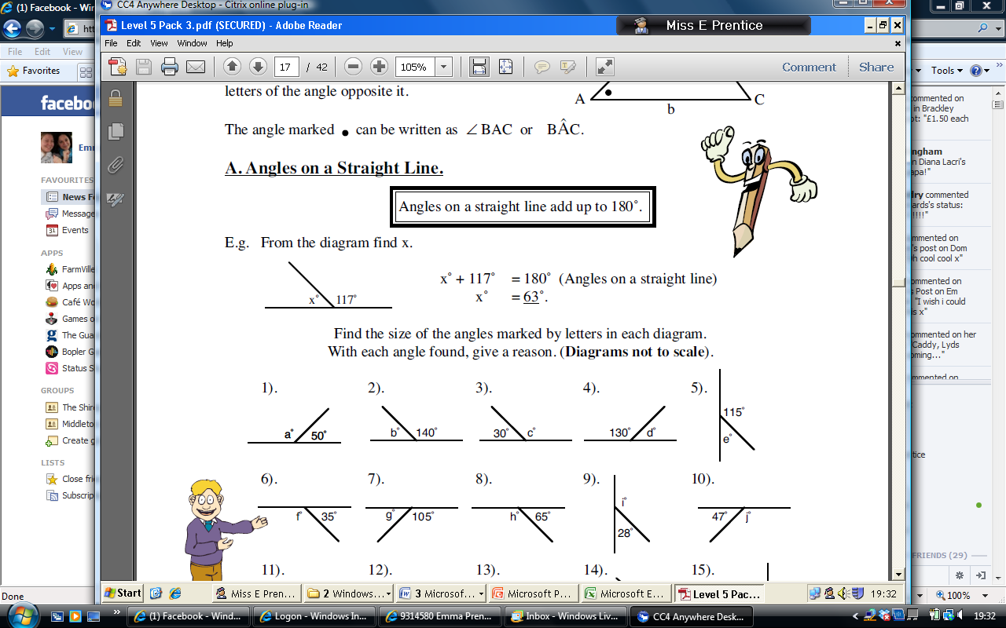
Angles on a straight line add up to 180º. What must the missing angle be?
HINT: Count up in 10s from 50 if you are struggling!

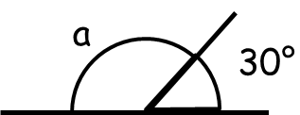
Remember, angles on a straight line add up to 180º. What must the missing angle be?
HINT: Count up in 10s from 30 if you are struggling!

Remember, angles on a straight line add up to 180º. What must the missing angle be?

What must the missing angle be?
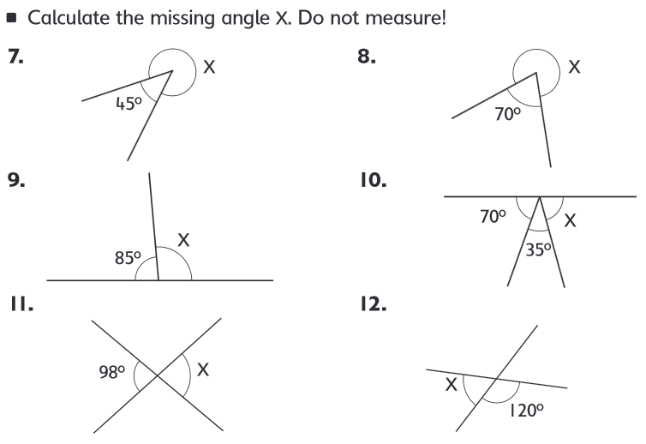

Percentages
Remember: to find 50% of something we must halve it.
For example 50% of 50 is 25, because half of 50 is 25.

Try these:
Can you find 50% of 200? ………………..
Can you find 50% of 40? ………………..
Can you find 50% of 8? ………………..
Can you find 50% of 800? ………………..

Remember: to find 10% of something we must divide it by 10.
For example 10% of 50 is 5, because 50 ÷ 10 = 5.

Try these:
Can you find 10% of 200? ………………..
Can you find 10% of 40? ………………..
Can you find 10% of 80? ………………..
Can you find 10% of 600? ………………..

20% = 2 x 10%
30% = 3 x 10%
40% = 4 x 10%
50% = 5 x 10%
60% = 6 x 10%
70% = 7 x 10%
80% = 8 x 10%
90% = 9 x 10%
Example Find 30% of 200
Step One: Find 10% of 200
200 ÷ 10 = 20
Step Two: Find 30% using 10%
30% = 3 x 10%
3 x 20 =60
So, 30% of 200 is 60
Now try these:
- Find 20% of 70

Find 10% of 70

70 ÷ 10 = So, 20% of 70 is ___________

20% = 2 x 10%

2 x =

- Find 30% of 90

Find 10% of 90

30% = 3 x 10%

- Find 40% of 600

- Find 80% of 20

- Find 60% of 40

Averages
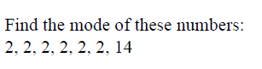
HINT: Mode is the most common value.
MODE =
HINT: Range is the difference between the biggest value and the smallest value.
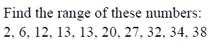
RANGE =

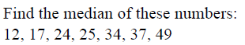
HINT: Median is the middle value when all the data is placed in order.

MEDIAN =

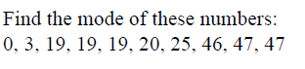
MODE =

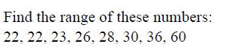
RANGE =
RANGE =
MODE =
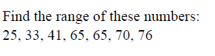 RANGE =
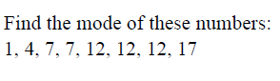 MODE =
MEDIAN =
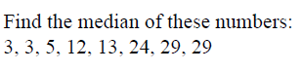 MEDIAN =
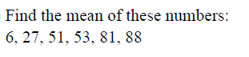
MEAN =
HINT: Mean is the sum of all the numbers, divided by how many there are.
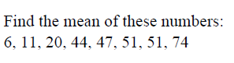 MEAN =
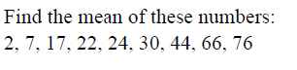 MEAN=

