Name:


Maths Workbook
Topics Covered:


Area and Perimeter
Co-ordinates
Revision of prior topics

Lesson 1 – Area and Perimeter
Finding the area and perimeter with different measurements
Learning Objectives
- Revise the meaning of area and perimeter
- Revise how we find the area and perimeter of squares, rectangles, trapezia, parallelograms and triangles
- Understand why all units of measurement matter and revise conversions
- To be able to convert unites of measurement prior to finding the area and perimeter
Starter
The perimeter of any shape is the distance __________________. We can imagine Mr Crawford walking around the outside of the shape, it’s the total distance she walks. We can find this by adding up all the sides of a shape.
The area of a shape is the _________________
The area of a triangle is: ____________________
The area of a rectangle/square is: _________________
The area of a trapezium is: __________
Please read back over your notes to find the area and perimeter of the shapes below
2m
>
>
>
>>
10m
8mm
4cm
5mm
7mm
3cm
10m
5cm
3cm
5cm

>
>>
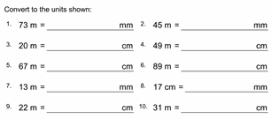
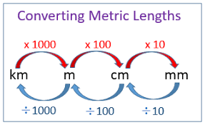
Use your conversion helper in your blue books to do these questions

Units of measurement are vital to us, they let us know exactly how big something is. For example, 2mm is really small, it might be the width of a mini-whiteboard you use in school! But 2m is huge and is around the height of a tall man!

Before we do anything with a shape, we must make sure all the information is in the same unit of measurement. For example:
These are both different! I’m going to change them both to cm, but it doesn’t matter which unit you choose to convert them to.

60cm
1.2m

$$1m=100cm \\ 1.2m=120cm \\ Area of a rectangle=w ×l \\ 120cm ×60cm=7200cm^{2}$$
Have a go at the sheets below, remember to convert if needed before doing anything.
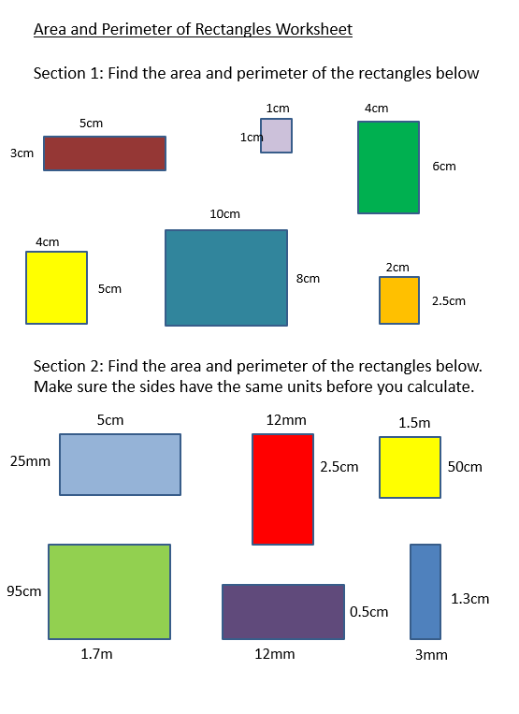
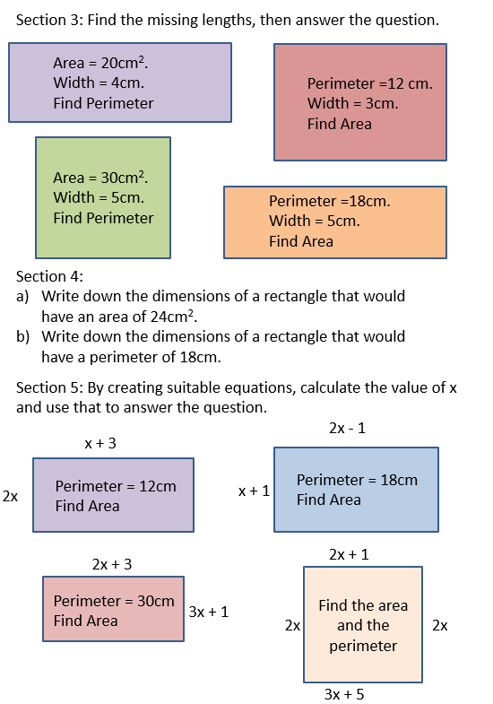
Lesson 3 – Co-ordinates NEW TOPIC
Plotting Co-ordinates
Learning objective
- Talk about what we remember of co-ordinates, axes, graphs and what we use them for
- Talk about how we plot co-ordinates
- Confidently plot positive co-ordinates, including decimals!
Thinking Activity
Fill in this thought Jacuzzi with ideas about co-ordinates… think about where you use them, how you plot them, what you plot them on, can you sketch an example?

Video link as an introduction to co-ordinates: https://bit.ly/33p0tlv
Co-ordinates

What is a co-ordinate?
It is a value of x and y which tell us exactly where something is! They don’t have to be whole numbers.

Where we find co-ordinates
We plot co-ordinates on a set of axes. There are two axes we look at in year 7, the ‘y’ axis and the ‘x’ axis. These are like two number lines, the x axis is our horizontal number line and the y axis is our vertical number line. Our axis must have the same scale (e.g. going up in ones), and be labelled either x or y.

For example:

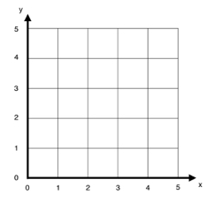

Same scale
Labelled

How to plot a co-ordinate –
To plot a co-ordinate we always go ALONG the x axis and then UP the y axis:
E.g. the coordinate (4,1) would be 4 along the x axis and 1 up the y axis.
$(x , y)$
Miss Perrin’s Tip!
Shade all the x’s blue and the y’s red. It’ll help you remember which one goes where!
X
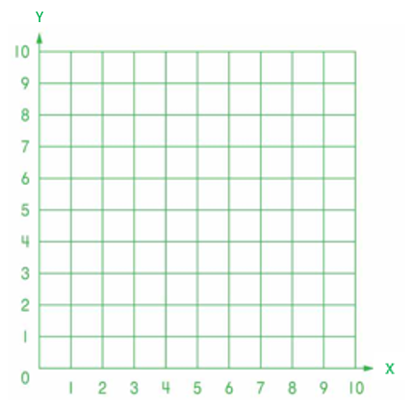

( 2 , 2 )
( 2 , 8 )
( 8 , 8 )
( 8 , 2 )

( 3 , 2 )
( 5 , 9 )
( 7 , 2 )

( 2 , 5 )
( 1 , 7 )
( 3 , 8 )
( 5 , 7 )
( 4 , 5 )

( 2 , 3 )
( 2 , 9 )
( 5 , 9 )
( 5 , 3 )

( 5 , 3 )
( 3 , 6 )
( 5 , 9 )
( 7 , 6 )

( 6 , 6 )
( 5 , 8 )
( 6 , 10 )
( 8 , 10 )
( 9 , 8 )
( 8 , 6 )

Lesson 4 – Co-ordinates
The Four quadrants
Learning Objectives
- To confidently plot all positive coordinates (in the first quadrant)
- To plot positive and negative coordinates
- To draw axes and label them correctly
New vocabulary
- Quadrants: QUAD – meaning four.
- Scale: the number on your axis
- Axes – plural of axis, the x and y lines on the grid
Starter
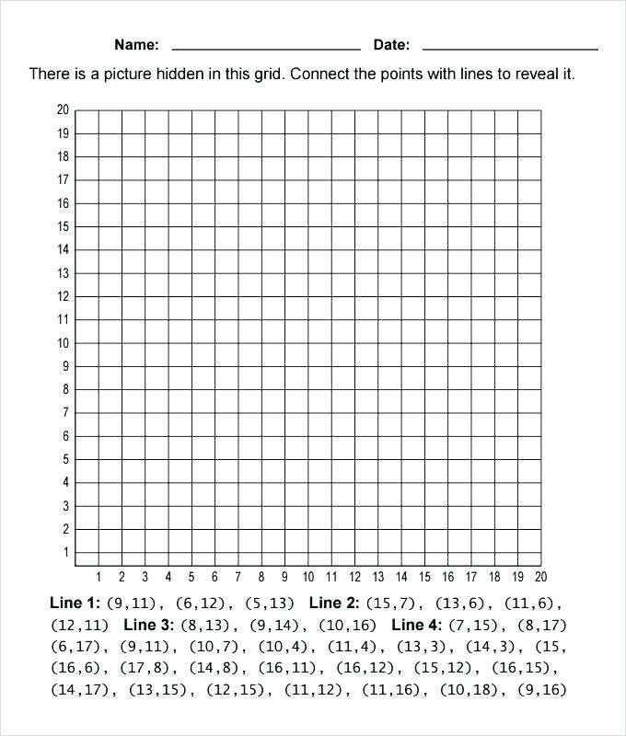
Sketching the perfect axes
All axes need to be absolutely perfect for Mr Crawford to be happy. This means:
- Label your x and y axes
- Put arrows at the end of your axis lines
- Use the same scale throughout the axes
- LABEL THE SCALE ON YOUR AXES
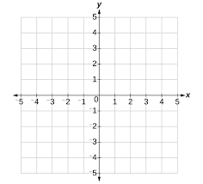
Same scale throughout
Labelling the axes with arrows
Plotting a co-ordinate – notes for blue book
Fill in the blanks with x or y:
When plotting co-ordinates, we first plot the _____ co-rdinate and then the ____ co-ordinate. We plot co-ordinates using an X.
With these co-ordinates we can tell people where things are EXACTLY, have you ever played the game battleships? See if someone in your house will play battleships with you, there are loads of apps that have it on your phone.
Be very careful with your negatives. I advise you always colour in the co-ordinates. Shade the x axis blue and the y axis red. Then shade all x co-ords blue and all the y co-ords red this will help us remember.

Plot the following co-ordinates, what shape do they make?
- (-3 , 5) c) (0 , -1)
- (-3 , -1) d) (0 , 5)
It makes a rectangle!
X
X
`
X
X

Plotting Co-ordinates in four quadrants
Question 1
Plot the following co-ordinates on your grid. (remember to use a ruler!)
A (5, 2)
B (4, 4)
C (-1, 2)
D (-2, -3)
E (2. -5) Join E back to A
What is the name of this shape?
__________________________

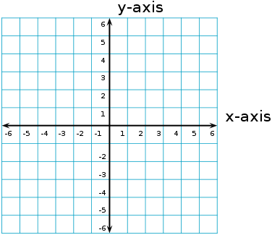
Question 2
Plot the following co-ordinates on your grid. (remember to use a ruler!)
A (3, 5)
B (0, 6)
C (-3, 5)
D (0, -5) Join D back to A
What is the name of this quadrilateral? _______________
Question 3
Plot the following co-ordinates on your grid. (remember to use a ruler!)
A (-2, 5) B (2, 5)
C (4, 3) D (4, -1)
E (2,-5) F (-2, -5)
G (-4, -1) H (-4, 3)
Join H to A
What is the name of this shape? ___________________________

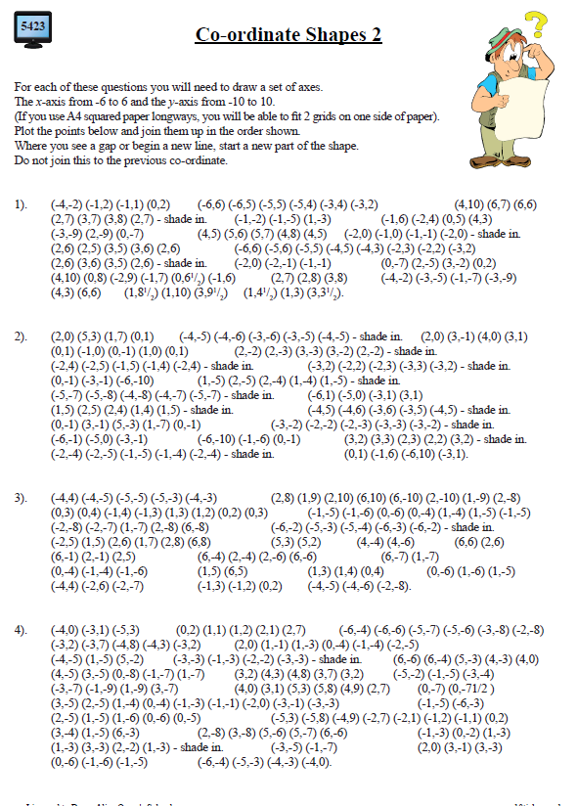

Lesson 5 – Co-ordinates
Finding the Midpoint
Learning Objectives
- To be able to confidently plot co-ordinates on a set of axes
- To draw a set of axes correctly with correct scale and labels
- To find the midpoint between two sets of co-ordinates
Starter
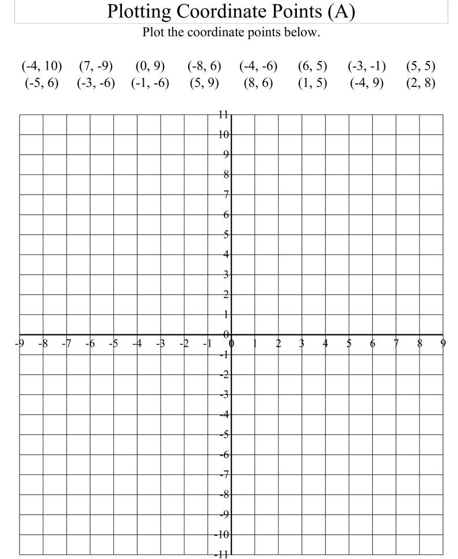
New Vocabulary
Midpoint – The middle of two points.
Line AB – the line connecting points A and B. (the Line DF is the line connecting points D and F) etc…
Co-ordinates – the way we determine where something is. (x , y). Along the coridoor and up the stairs, we plot x then y

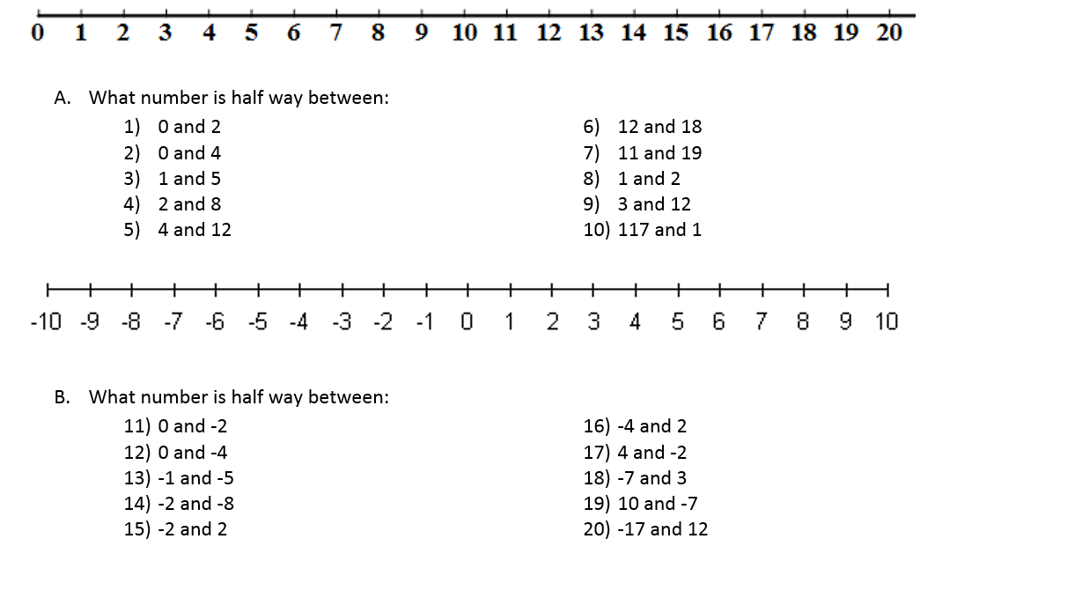
Pre-learning Activity

(Answers: 1,2,3,5,8,15,15,1.5,7.5,59. -1,-2,-3,-5,0,-1,1,-2,1.5,-2.5)
Notes in Blue Book
To find the midpoint of two co-ordinates:
- Visually we can count to the middle of the point
- Mathematically we use the following method
We find the middle of the x co-ordinates and the middle of the y co-ordinates by:
- Add the x coordinates together and divide by two
- Add the y coordinates together and divide by two
$(\frac{(first x+second x)}{2}$ , $\frac{(first y+second y)}{2})$
Second x co-ord
First x co-ord
E.g 1. Find the midpoint of the line AB where point A(4,-5) is and Point B(-2, -1)
First y co-ord
Second y co-ord
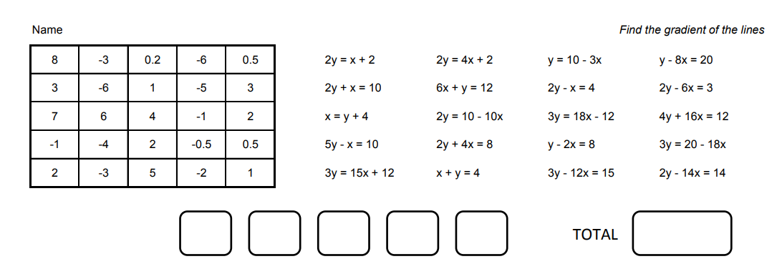
$(\frac{(4+ -2)}{2}$ , $\frac{(-5+-1)}{2})$ = $(\frac{(4-2)}{2}$ , $\frac{(-5-1)}{2})$ = $(\frac{(2)}{2}$ , $\frac{(-6)}{2})$= (1, -3)
E.g.2. Find the midpoint of (2,3) and (0,11)
$(\frac{(2+ 1)}{2}$ , $\frac{(3+10)}{2})$= $(1.5, 6.5)$
Activity for the lesson

Midpoints 1 – Horizontal and Vertical Lines
- A) Plot the following points and find the point half way between them (the midpoint)

a) (5,2) (9,2) |  | b) (3,6) (11,6)
c) (1,1) (1,5) |  | d) (2,2) (2,6)
e) (-10,3) (-6,3) |  | f) (5,-4) (7,-4)
g) (-3,-2) (1,-2) |  | h) (-8,-1) (-8,5)
i) (-4,-1) (-4,5) |  | j) (10,-1) (10,-3)

- A) Without drawing calculate the midpoint of the following points (be careful with the negative ones)
a) (10,1) (10,5) |  | b) (1,5) (9,5)
c) (2,-6) (6,-6) |  | d) (-5,-2) (-5,-4)
e) (4,3) (-2,3) |  | f) (-7,4) (-7,-4)

B) Now, check your answers by plotting the points!
Midpoints 2 – Sloping Lines
- Find the midpoint of the following points. You can do this either by plotting them (level 5a) or by using a method you have discovered without plotting (level 6)

a) (2,3) (4,5) |  | b) (1,8) (9,2)
c) (0,11) (12,11) |  | d) (3,15) (13,3)
e) (6,6) (0,0) |  | f) (15,9) (3,3)
g) (1,5) (5,6) |  | h) (3,3) (4,0)
i) (4,5) (0,0) |  | j) (1,3) (8,1)

Midpoints 3 – Sloping Lines in Four Quadrants
- Now we’re going to do the same in all four quadrants. Find the midpoint of the following points. You can do this either by plotting them (level 5a) or by using a method you have discovered without plotting (level 6)

a) (6,6) (2,2) |  | b) (-6,-6) (-2,-2)
c) (-10, 5) (-6,3) |  | d) (12,-4) (6, -2)
e) (-2,3) (2, -3) |  | f) (-3,5) (-7,-1)
g) (8,1) (-2,-7) |  | h) (4,-2) (-3,6)
i) (-7,-7) (-4,6) |  | j) (18, -27) (-1,-22)

Challenge Extension:
Work out the end point of a line segment which has:
1) an endpoint of (4,2) and a midpoint of (6,0)
2) an endpoint of ( -4,1) and a midpoint of (-1,3)
4) an endpoint of (-3,6) and a midpoint of (-4,4)
5) an endpoint of (6,-10) and a midpoint of (-1,2)
6) How did you work out the end points? Answer in a full sentence:
__________________________________________________________________________________________________________________________________________

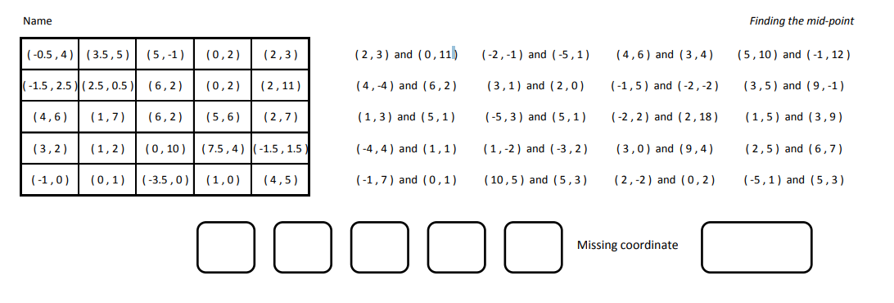
Space for workings

Lesson 6 – Co-ordinates
The equation of a line
Learning Objectives
- Recall the important requirements for making a perfect set of axes
- Understanding that coordinates connect the x and the y values together
- Understand that a line is just a set of co-ordinates all connected by a function machine
- Confidently plot a basic line
Starter – recap function machines
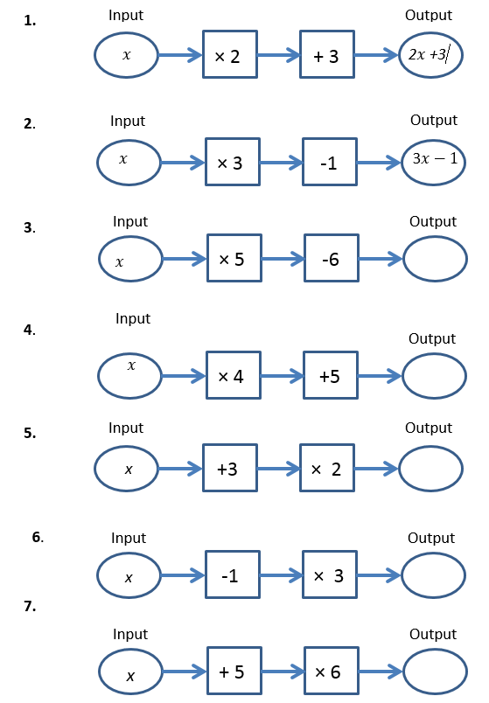
Plotting a line
When we look at plotting a line, it’s a bit like a function machine: the x value goes in and a y value comes out. What do you notice about the line below?
Can you give me some coordinates on that line?
( , ) ( , ) ( , ) ( , )
What do you notice about all the y values? They are all 2!
We call this line: y = 2 as all the y values are 2, despite the x values.
What do you think we call this line?
Can you find some co-ordinates on that line? What do you notice about the x co-ordinates?
This is the line of $x=6$ as all the x values are 6 no matter the y values.
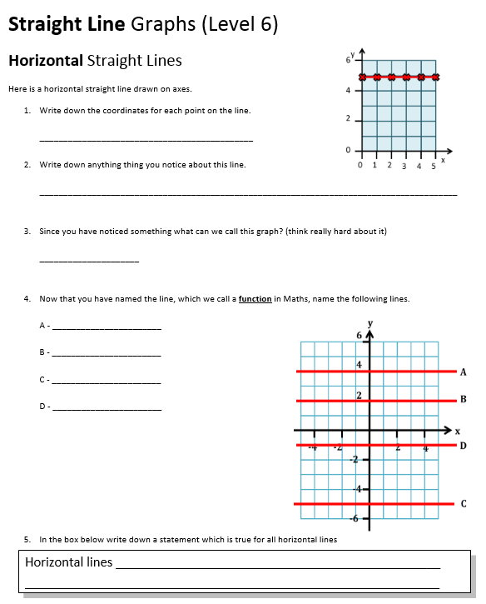

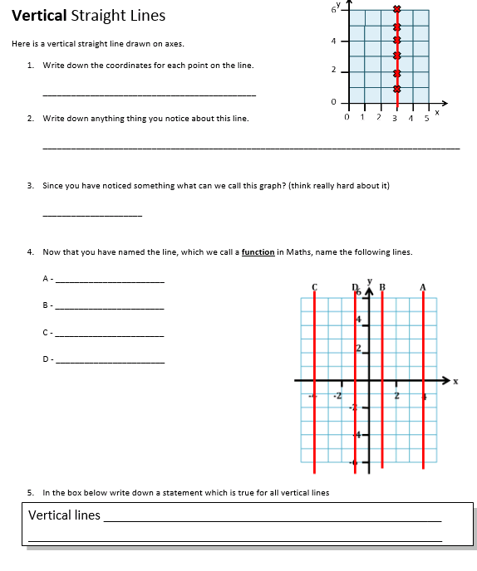

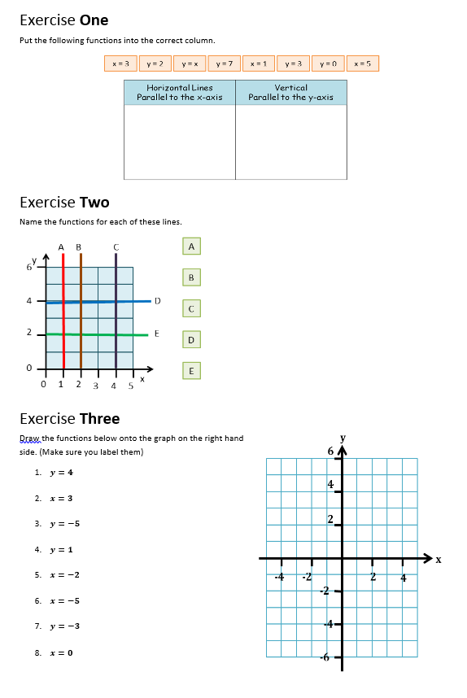
Lessons 7 and 8 – Coordinates
Plotting straight lines
Learning Objectives
- To recall how to accurately plot coordinates
- To recall that a line is just a function machine, x values go in and a y value comes out
- Plot coordinates and join them up to make a line
Starter
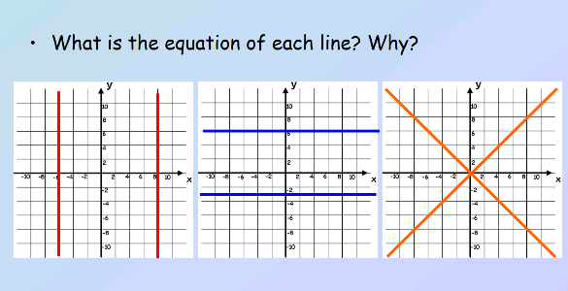
Main learning
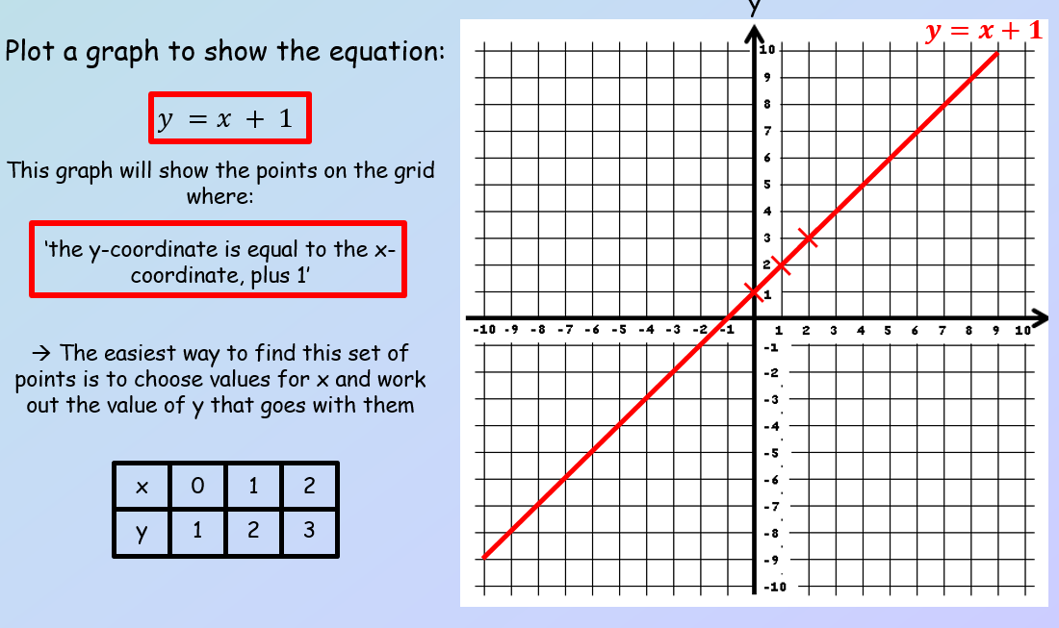
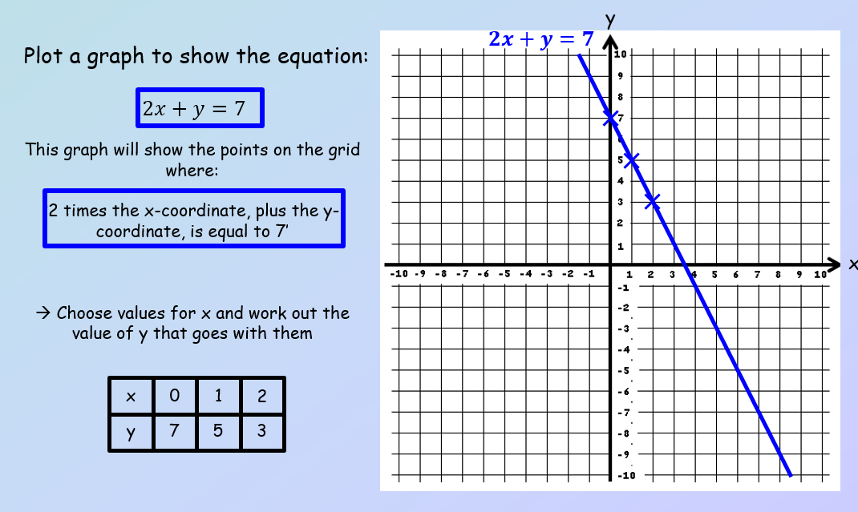

To plot a straight line we use a table of values. This is ESSENTIAL, it tells us the coordinates to plot. We then join the line up.
Steps to a perfect straight line graph
- Draw a perfect set of axes, labelled and scaled
- Draw a table of values identical to this one:
$$x$$ | 0 | 1 | 2
$$y$$
- Using a function machine, find the values of y from the equation given
- Plot the three coordinates
- Draw a line to connect the three coordinates
- Label the line (ensure it goes to the edge of the axes, remember these lines go on forever!)
Video on plotting straight lines - https://bit.ly/2U9i50O You can practise on mymaths for interactive software!
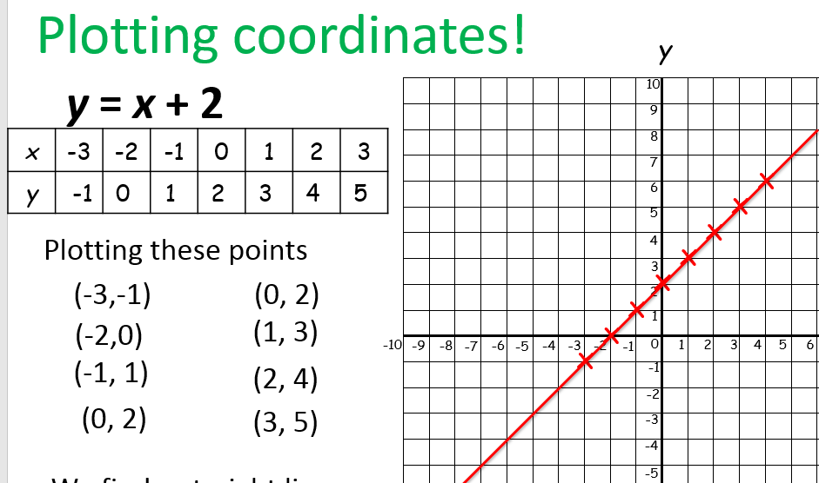
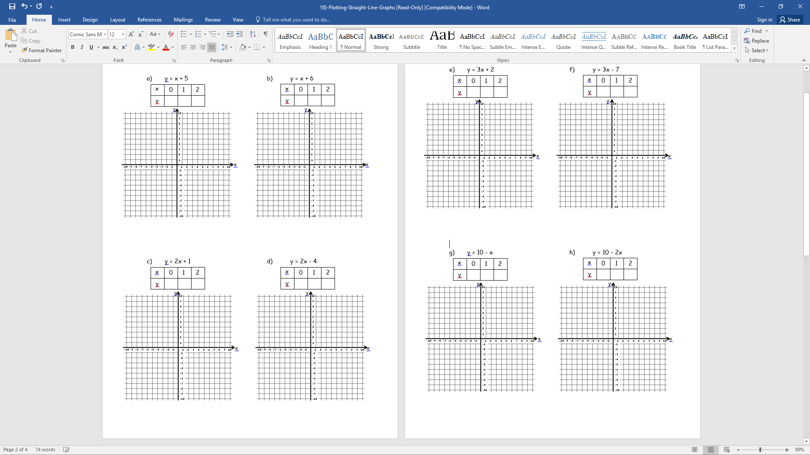

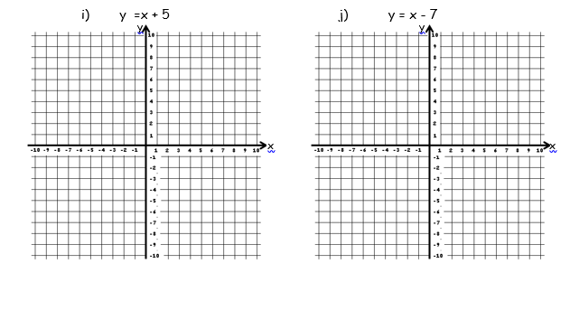
The equation of a line – [Extension learning for interest!]
y coordinate
Y intercept (where the line crosses the y axis)
$$y= mx+c$$
X coordinate
Gradient

Gradient – how steep something is. If you see a really steep hill we say that has a positive gradient. If you see a massive slope downwards, that’s a negative gradient.
Y intercept – where the line crosses the y axis
*** This is all something you will cover later on, but if you’re interest go through the mymaths lessons! It’s really fascinating!!!! ***

Lesson 9 – Coordinates
Plotting inequalities on a graph
Learning Objectives
- To revise inequalities
- To feel confident with plotting basic lines on a graph
- To be able to plot an inequality on a graph, and understand which section to shade
Pre-lesson learning
Read back through your inequalities notes, these will be necessary for this lesson. If you’re lacking in confidence, have a go at some my maths questions or finishing the worksheets in your book.
Starter
Complete the following inequalities on the number line! Remember, if it’s equal to we fill in the dot!
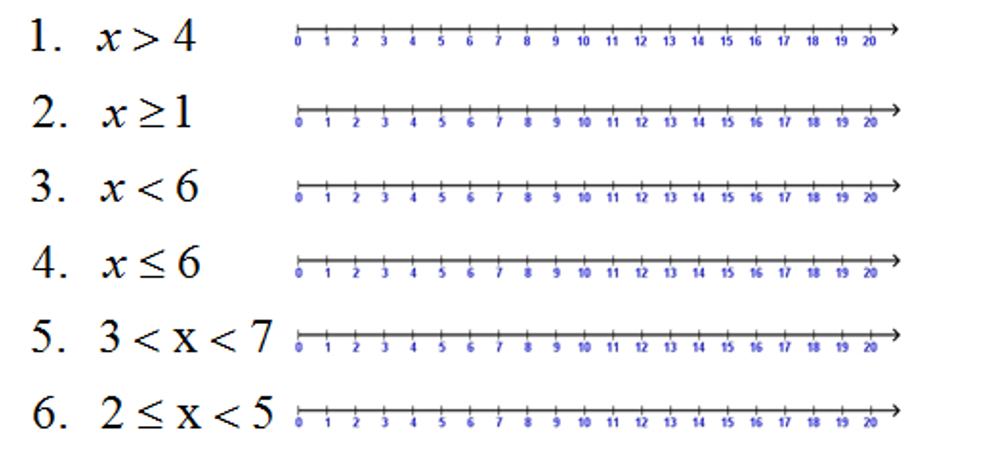
Recap
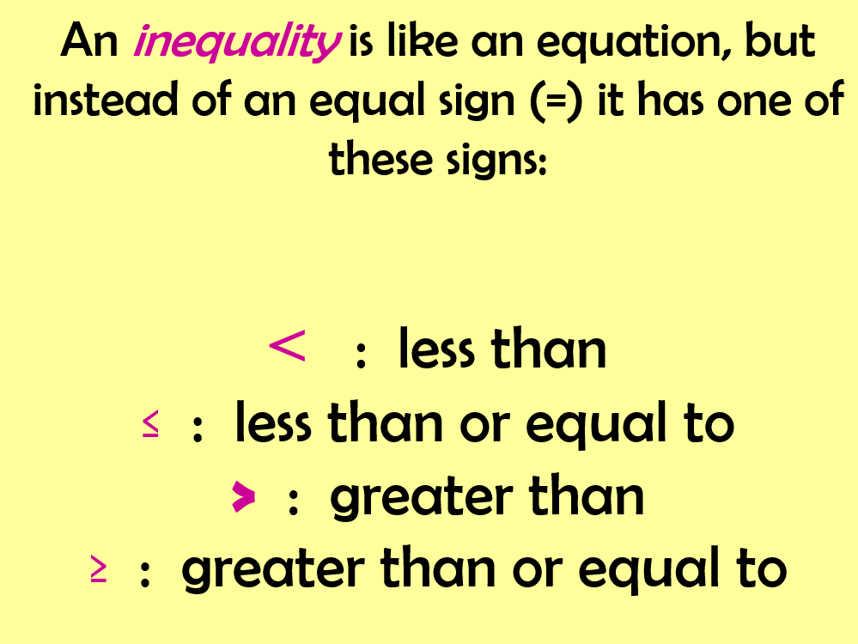

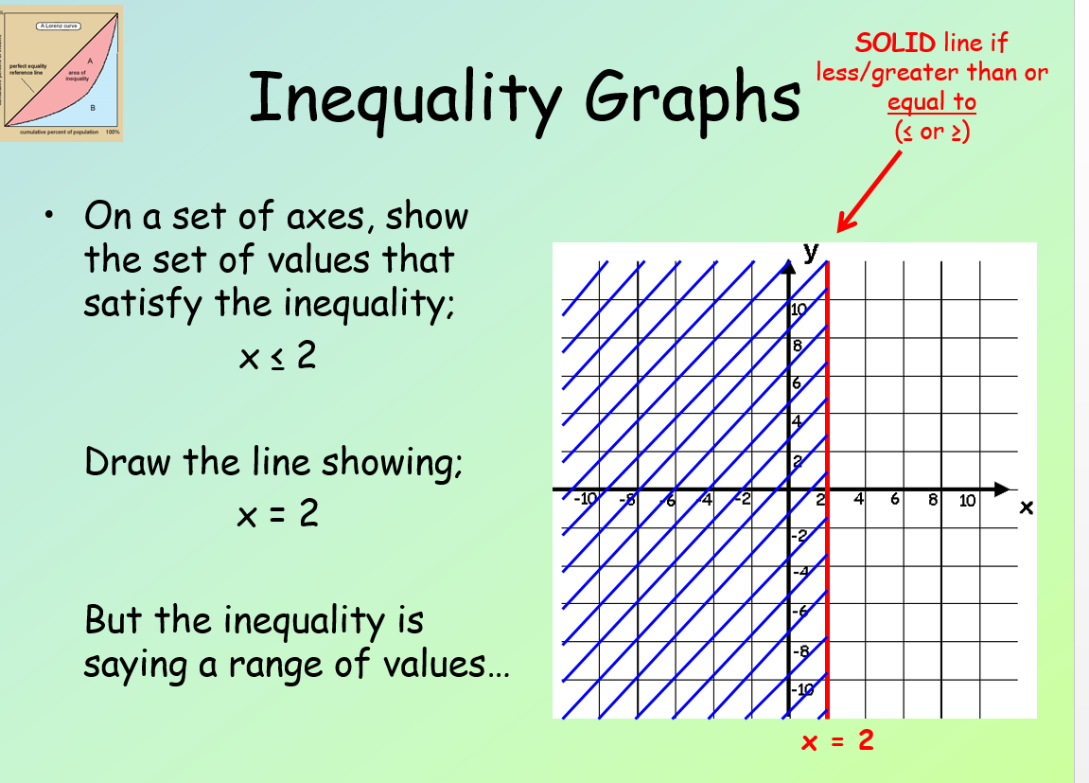
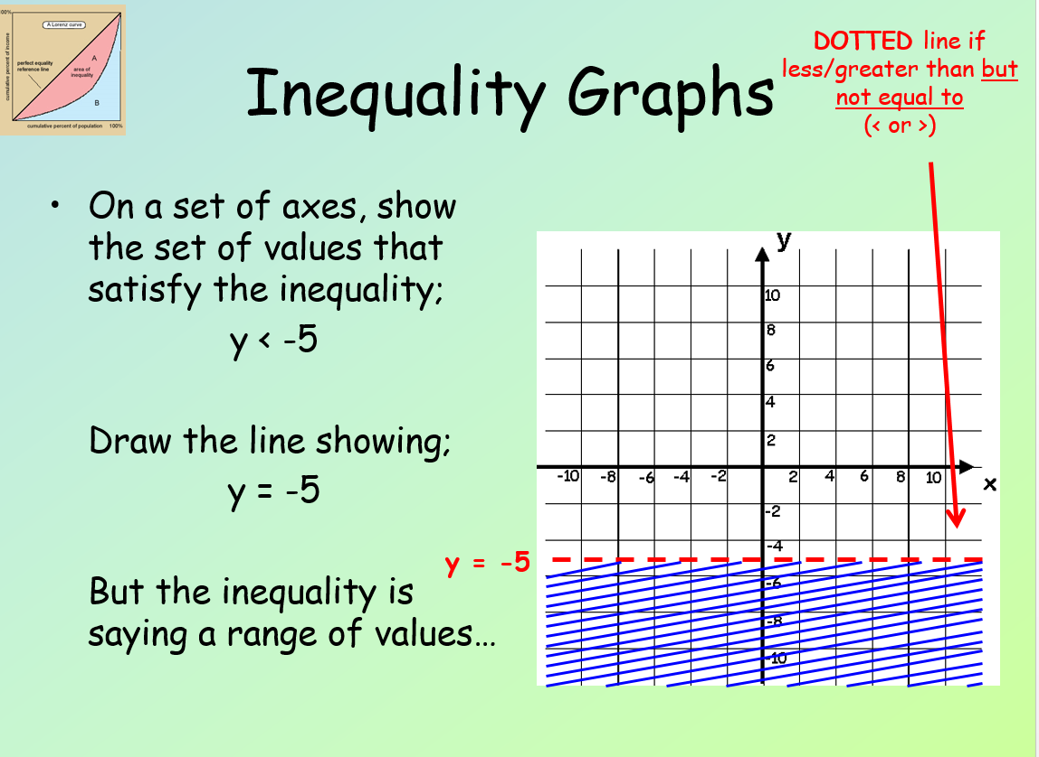

When a line is equal to an inequality we use a full line, if not we use a dotted line.
To plot an inequality graphically (meaning to plot it on a graph):
- Plot the line as I have already learned, as if it was =
- Work out if it is going to be dotted or filled in.
- Work out if I’m looking at the numbers greater or less than the line I’ve drawn
Video to show you an example: https://bit.ly/3d6Oaif
Remember, you can have more than one line on a set of axes!
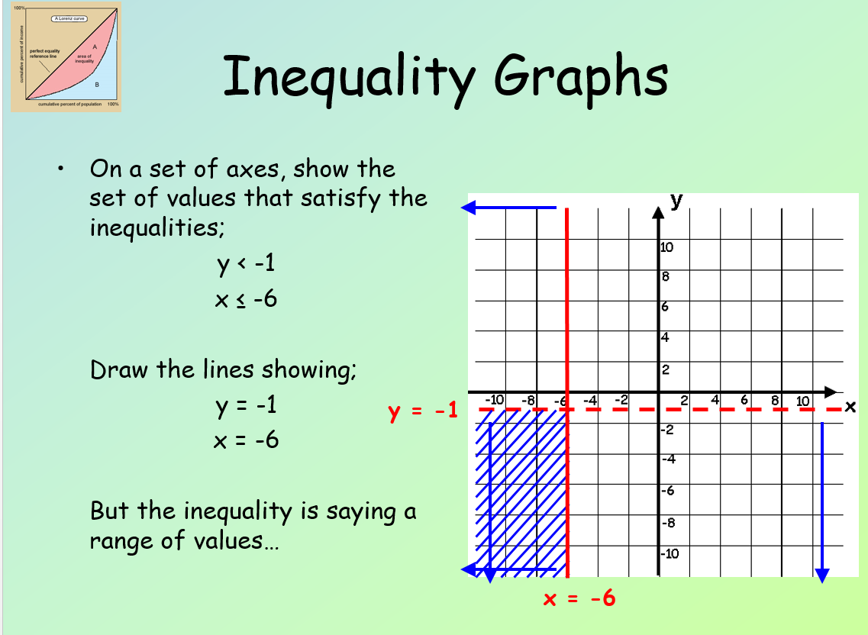
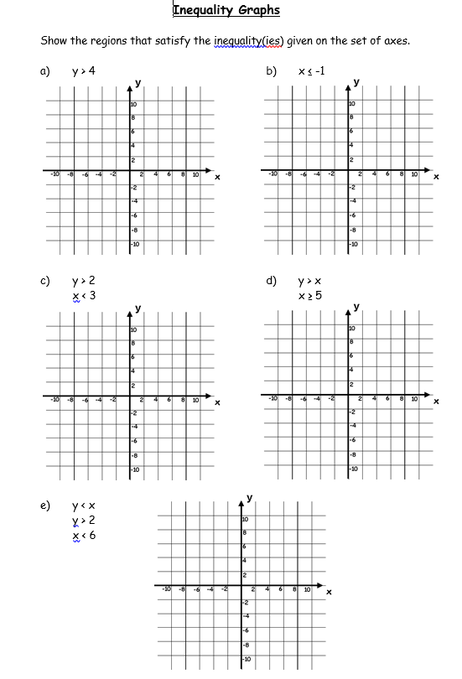
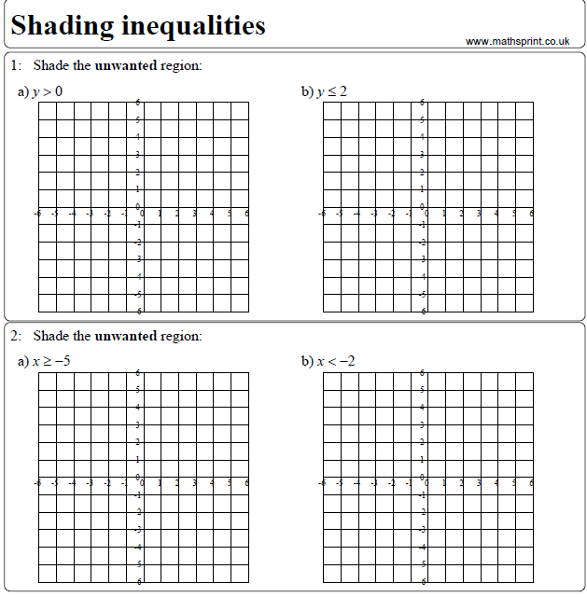
Extra questions should be attempted from the textbook: Chapter 16; Part Chapter 18

