Rainforest Food Web
Leaves
Flowers
Fruit
Wood
Seeds; nuts

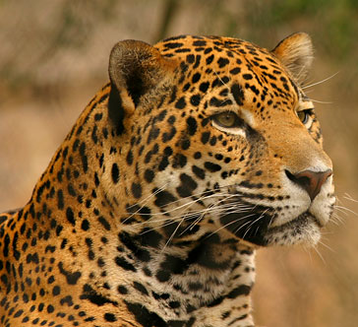  Tiger – One of the largest members of the cat family. Hunts for prey both in the canopy and on the forest floor | 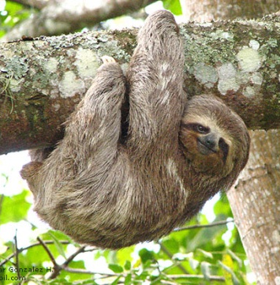  Sloth – Hangs from branches by its long, curved claws. Feeds on leaves. | 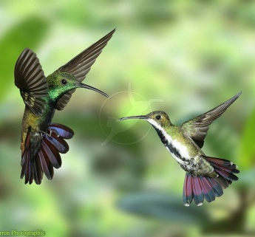  Hummingbirds – Long, cured beak probes inside flowers for nectar. Wings make a humming noise during flight. Hovers in mid-air while feeding on nectar
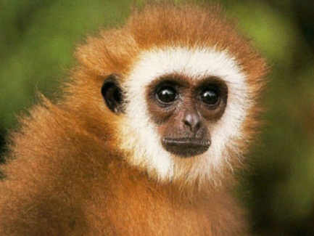  Monkey – Feeds on fruit, sap from trees and other small animals | 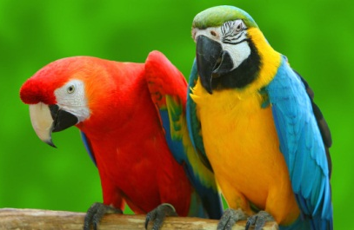  Parrots – Strong beak can crack open seeds and nuts. Claws are also used to covey food in to the mouth | 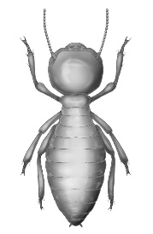  Termites – Feed on dead wood and other plant matter

Rainforest Food Web
Leaves
Flowers
Fruit
Wood
Seeds; nuts

Tiger – One of the largest members of the cat family. Hunts for prey both in the canopy and on the forest floor | Sloth – Hangs from branches by its long, curved claws. Feeds on leaves. | Hummingbirds – Long, cured beak probes inside flowers for nectar. Wings make a humming noise during flight. Hovers in mid-air while feeding on nectar
Monkey – Feeds on fruit, sap from trees and other small animals | Parrots – Strong beak can crack open seeds and nuts. Claws are also used to covey food in to the mouth | Termites – Feed on dead wood and other plant matter

