Tutankhamun
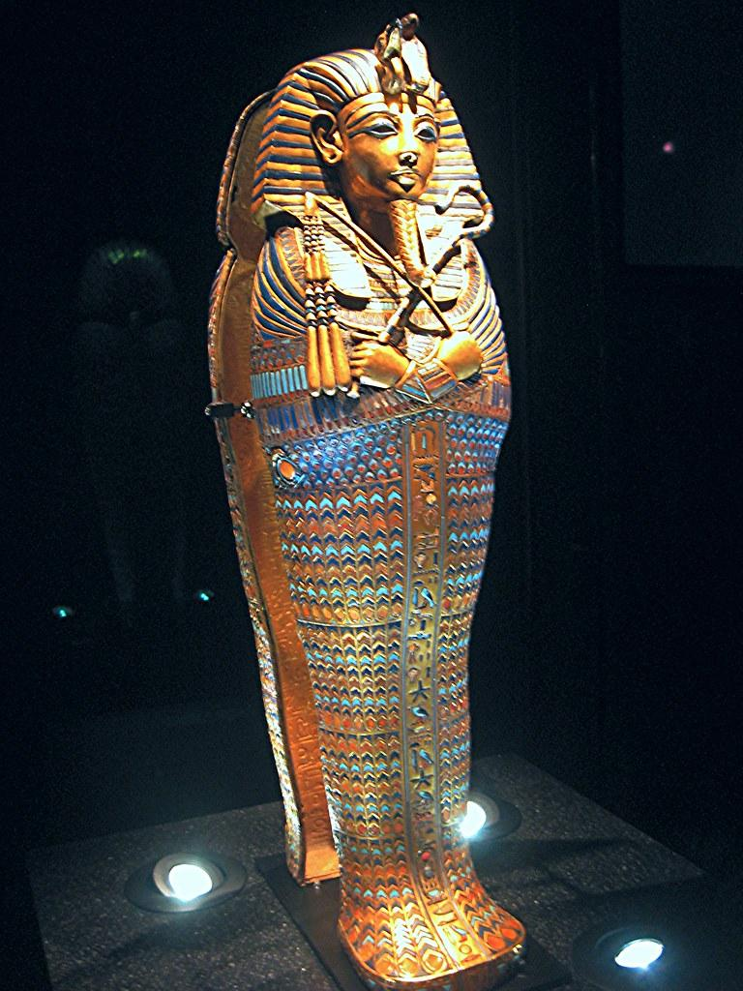

This week, we are going to learn about a very famous Ancient Egyptian - Tutankhamun.

Look at the PowerPoint and watch the 2 videos on this page - https://www.bbc.co.uk/bitesize/topics/zg87xnb/articles/zvmkhbk

Then complete the activity on the next page.



