Multiplying

Activity 1 

If you are not confident with your times tables up to
12 x12, this week you should spend time practising the times tables you don’t know yet.

There are lots of ways to do this. The Top Marks website has lots of games you can play:
https://www.topmarks.co.uk/maths-games/7-11-years/times-tables

This website has links to different websites that teach you tricks to learn different times tables:

https://www.teachwire.net/news/8-of-the-best-times-tables-tricks-for-teachers

You could challenge someone to a times tables quiz - roll 2 dice and see who can multiply the numbers together the quickest.

Or, see if you can complete the times tables grid below.

A little bit of practise every day this week can really help you to improve!

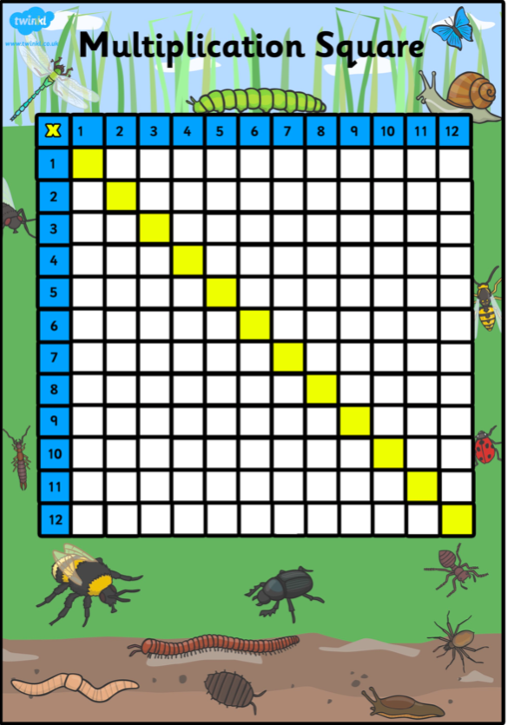

Activity 2

If you already feel confident with your times tables up to 12 x 12, this week you can learn how to multiply bigger numbers using a column method.

Watch the video to explain how:
https://www.youtube.com/watch?v=eO8rJRBZzAQ

Then, have a go at using this method to answer the questions:

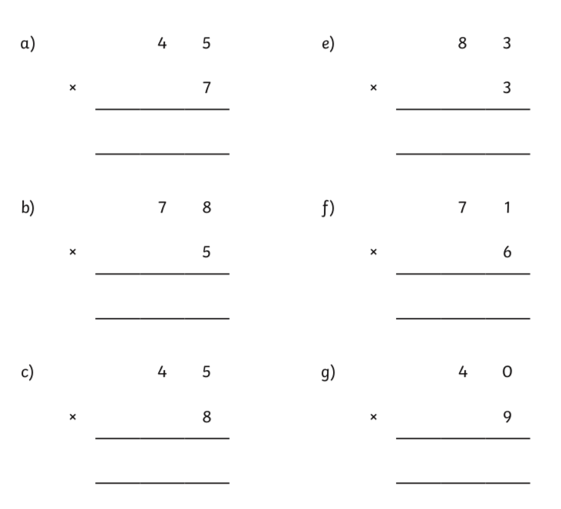
Now, try some of your own.
Activity 3

If you can already multiply a two-digit number by a one-digit number, you can use this knowledge to help you to answer the division problems below:



